**Windows Server & Azure Hybrid Identity Implementation for Enterprise Environment**

**Project Objective**

The objective of this project is to design, deploy, and manage a hybrid identity infrastructure that integrates on-premises Windows Server Active Directory with Microsoft Azure Entra ID (Azure AD).

This project demonstrates real-world skills required for:

* IT Support & System Administrator
* Azure Administrator (AZ-104)
* Windows Server Hybrid Administrator (AZ-800 / AZ-801)
* Endpoint Administrator (MD-102)

**Project Background**

Many organizations operate in a hybrid environment, where:

* Legacy systems remain on-premises
* Cloud services are hosted in Azure
* User identities must work seamlessly across both

CloudKhan Solutions is transitioning from a pure on-premises Active Directory to a hybrid identity model using Azure.

As a Hybrid Cloud Administrator, your responsibility is to:

* Deploy Windows Server infrastructure
* Configure core directory services
* Synchronize identities to Azure
* Enforce security and policies centrally

**Project Scope**

**Included in Scope**

* Windows Server deployment
* Active Directory Domain Services (AD DS)
* DNS configuration
* Group Policy Objects (GPOs)
* Azure Entra ID (Azure AD)
* Azure AD Connect
* Hybrid identity with password hash sync
* User and device management

**Project Architecture & Technical Design**

**Overview**

This section documents the system architecture and technical design patterns implemented in the hybrid identity solution, providing visual representation of component relationships and data flows.

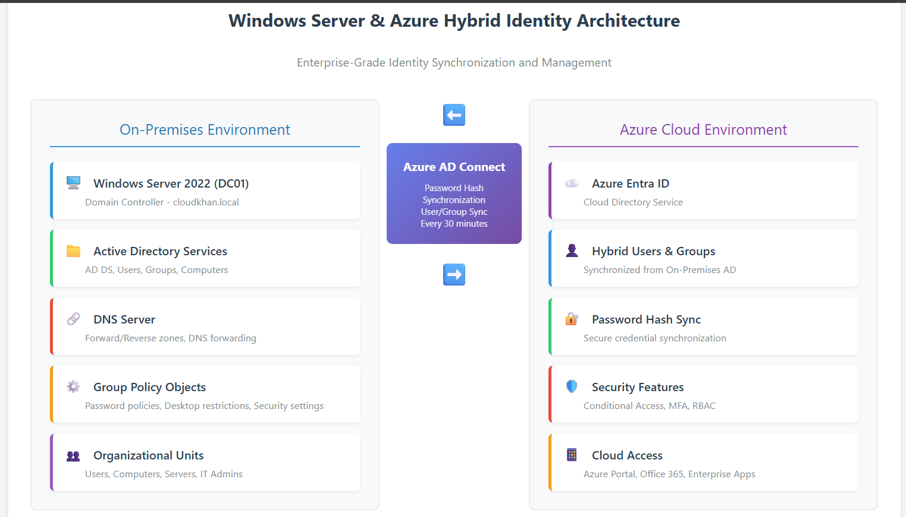

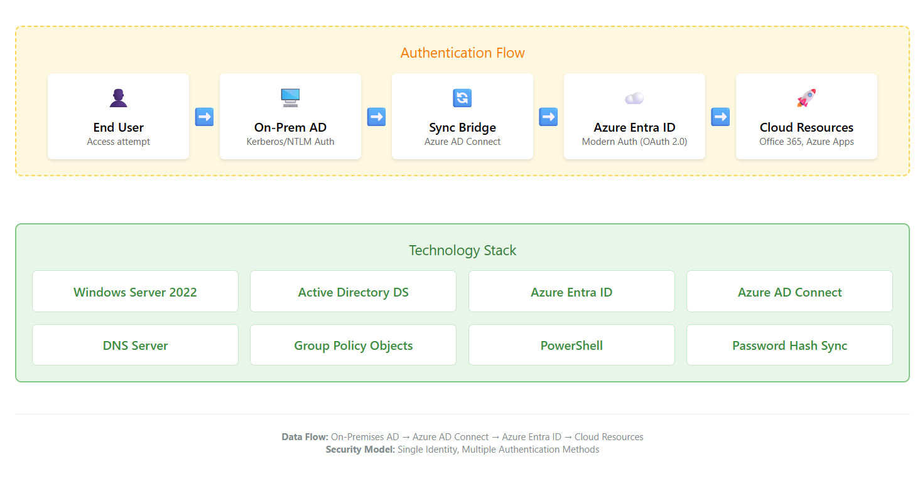

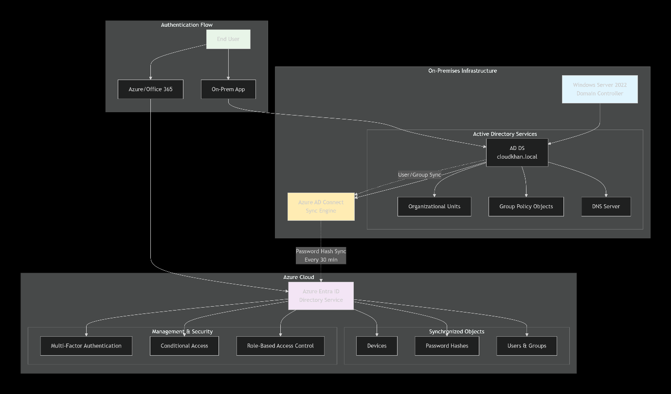

## Project Tasks & Implementation Steps

## Task 1: Windows Server Installation

### Tasks

* Install **Windows Server 2022** (VMware, Hyper-V, or Azure VM)
* Assign:
  + Static IP address
  + Proper hostname (e.g., DC01)
* Configure time zone and updates

## Task 2: Active Directory Domain Services (AD DS)

### Tasks

* Install **AD DS role**
* Promote server to **Domain Controller**
* Create a new forest and domain:
  + Example: cloudkhan.local
* Verify:
  + NTDS service
  + SYSVOL replication

## Task 3: DNS Configuration

### Tasks

* Install **DNS Server role**
* Configure:
  + Forward lookup zones
  + Reverse lookup zones
* Set DNS forwarding to public resolvers
* Verify domain name resolution

## Task 4: Organizational Units (OUs) & User Management

### Purpose

Structure Active Directory for scalability and policy control.

### Tasks

* Create OUs:
  + Users
  + Computers
  + Servers
  + IT Admins
* Create users:
  + Normal users
  + IT administrators
* Assign group memberships

## Task 5: Group Policy Objects (GPOs)

### Tasks

* Create GPOs for:
  + Password policy
  + Account lockout policy
  + Desktop restrictions
  + Windows Update settings
* Link GPOs to appropriate OUs
* Test policy application using gpresult

## Task 6: Azure Entra ID (Azure AD) Preparation

### Purpose

Prepare Azure for hybrid identity integration.

### Tasks

* Create Azure tenant
* Verify custom domain (optional)
* Assign Azure AD roles:
  + Global Admin
  + Hybrid Identity Admin

## Task 7: Azure AD Connect Installation

### Tasks

* Download **Azure AD Connect**
* Install on Windows Server
* Choose:
  + **Password Hash Synchronization**
  + Single forest configuration
* Configure:
  + OU filtering
  + User sign-in method

## Task 8: Hybrid Identity & Password Sync

### Tasks

* Verify synced users in Azure AD
* Reset password on-prem and confirm Azure sync
* Validate sign-in via:
  + portal.azure.com
  + Microsoft 365 (optional)

**Certifications This Project Supports**

|  |  |
| --- | --- |
| Certifications | Coverage |
| AZ-104 | Azure identity, hybrid admin |
| AZ-800 | |  | | --- | |  |  |  | | --- | | Windows Server core services | |
| AZ-801 | |  | | --- | |  |  |  | | --- | | Hybrid identity & governance | |
| MD-102 | |  | | --- | |  |  |  | | --- | | Identity & access foundations | |
| IT | |  | | --- | |  |  |  | | --- | | AD, DNS, GPO, troubleshooting | |

Paste you screenshots here…

## Task 1: Windows Server Installation

* Install **Windows Server 2022** (VMware, Hyper-V, or Azure VM)
* Assign:
  + Static IP address
  + Proper hostname (e.g., DC01)
* Configure time zone and updates

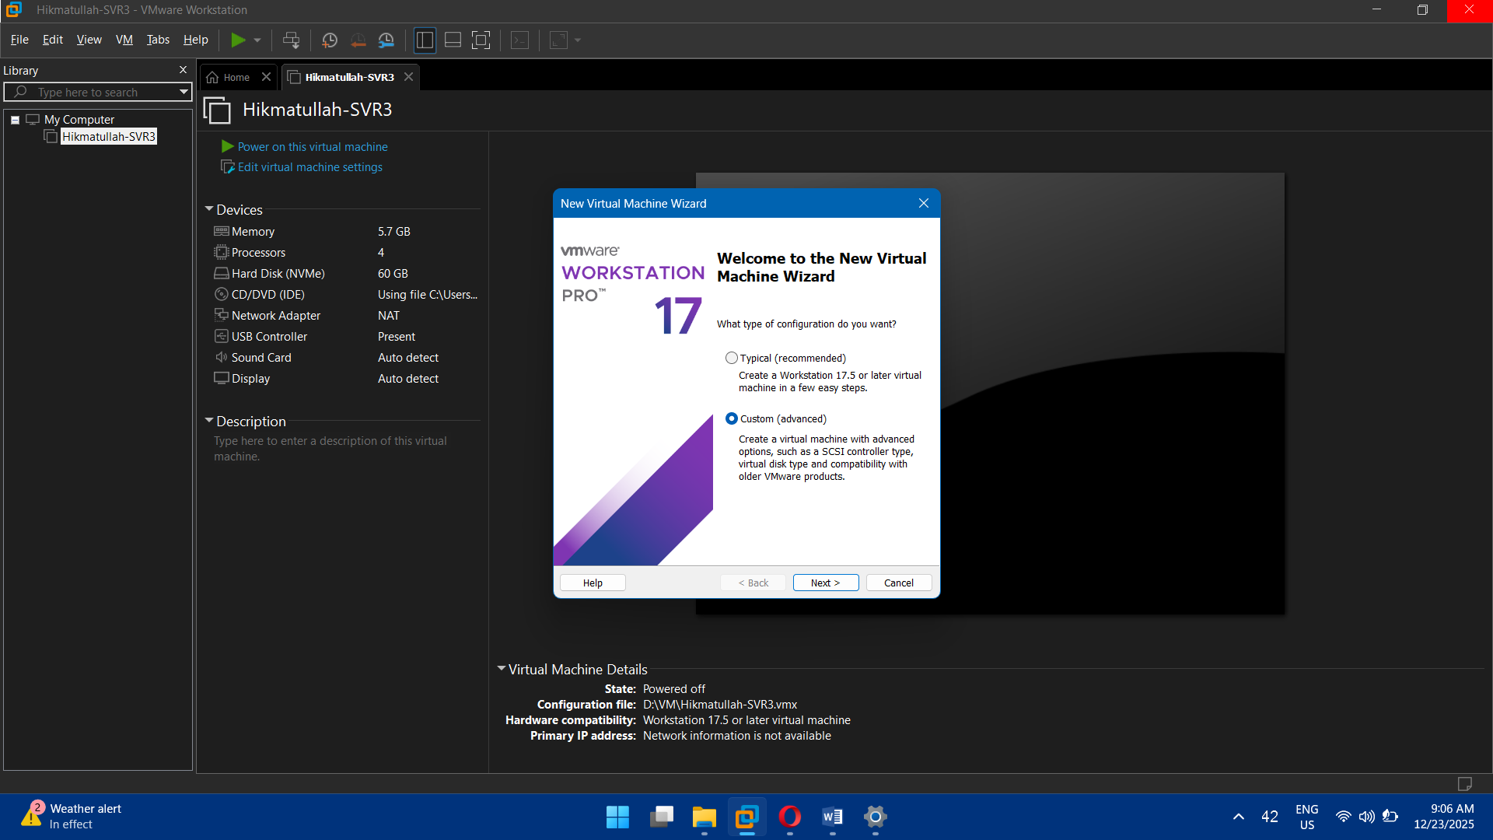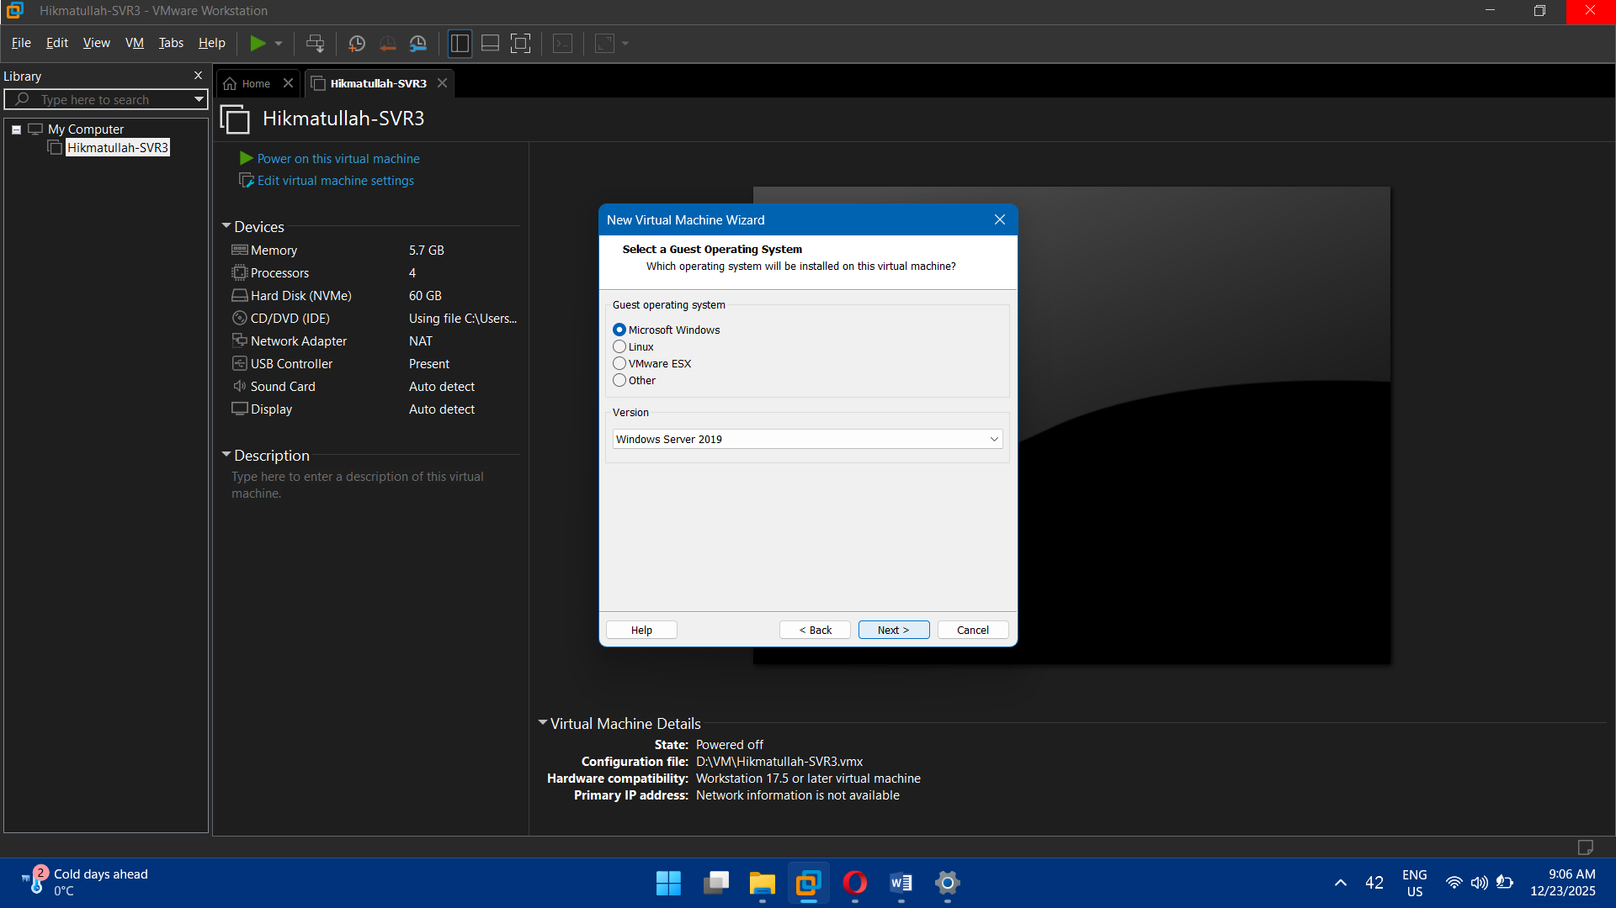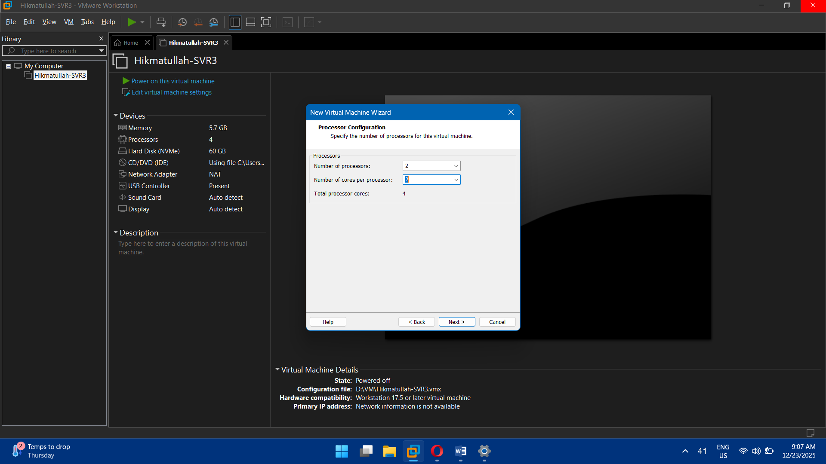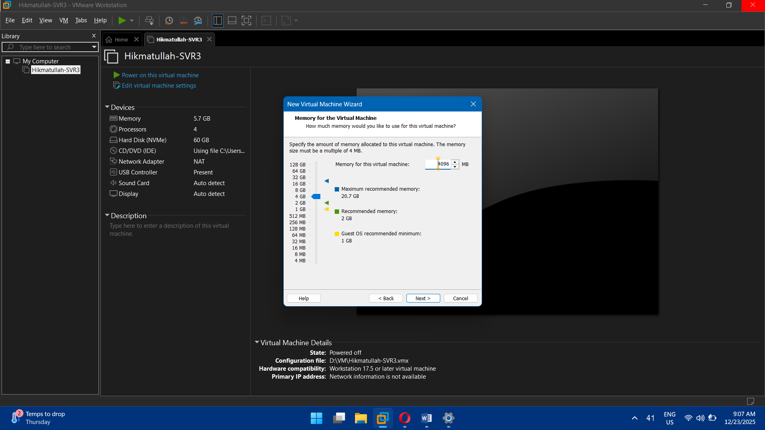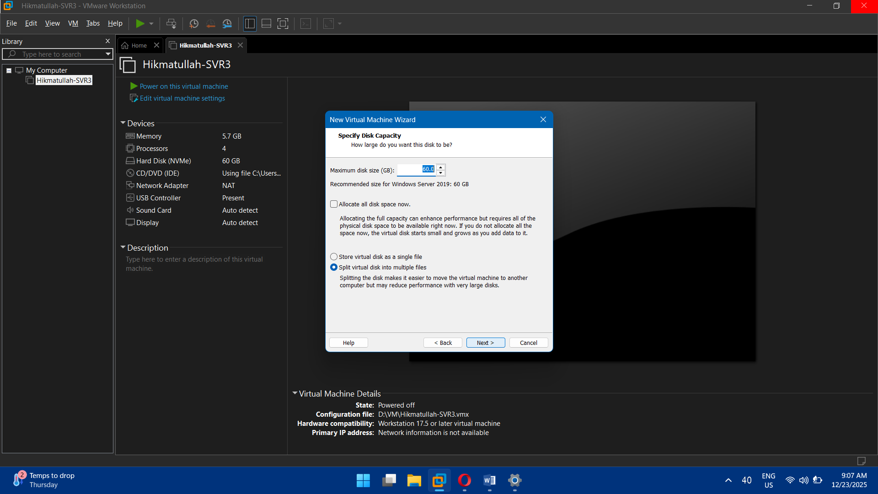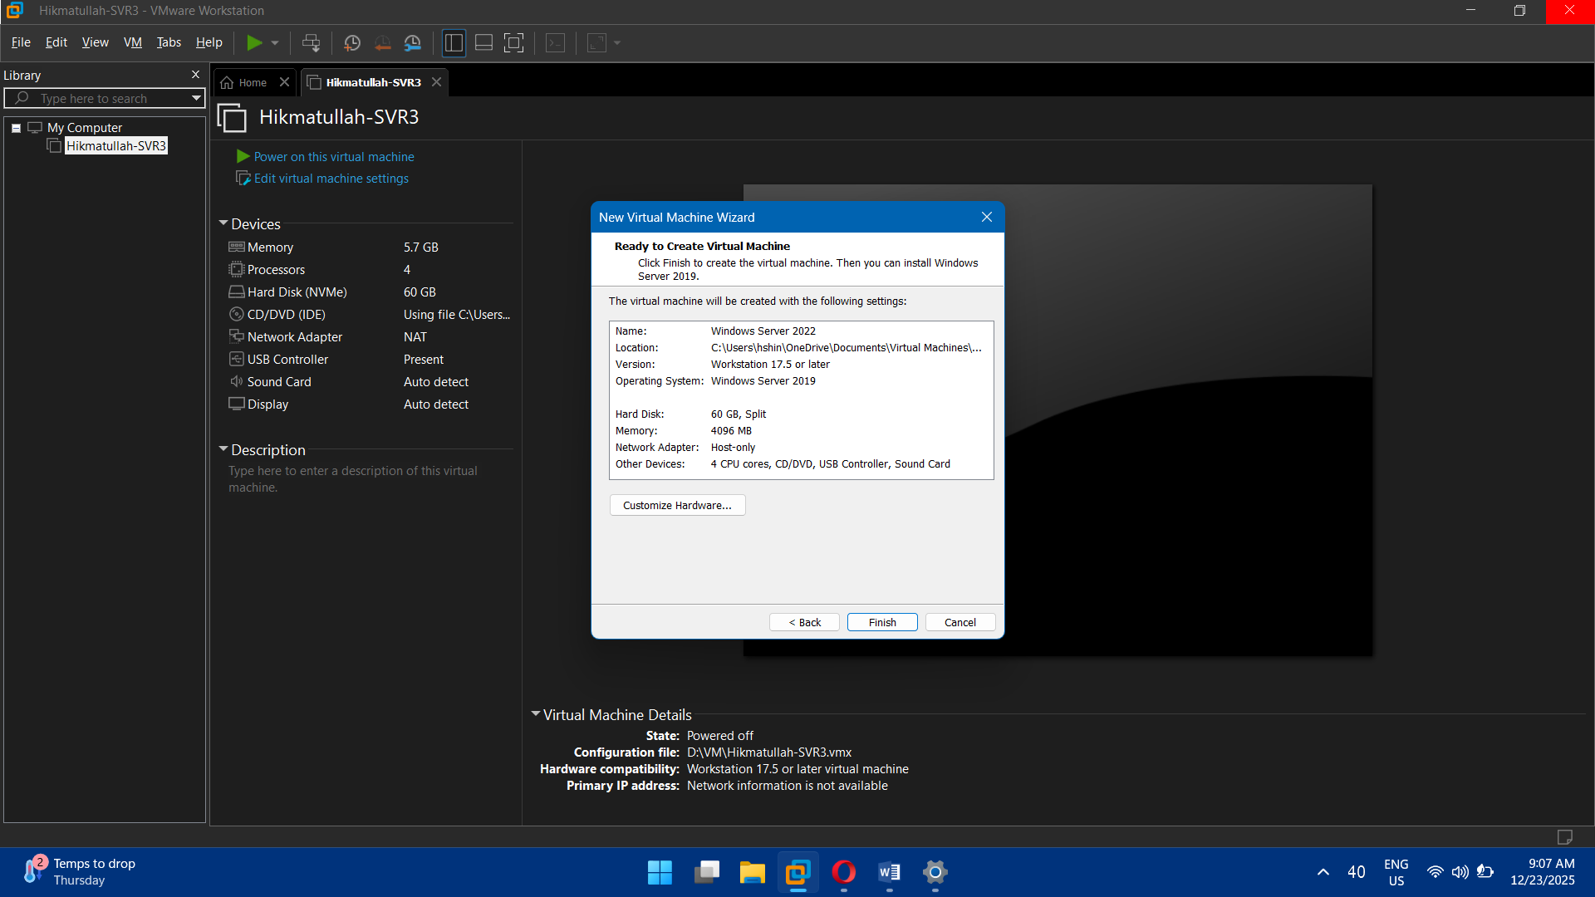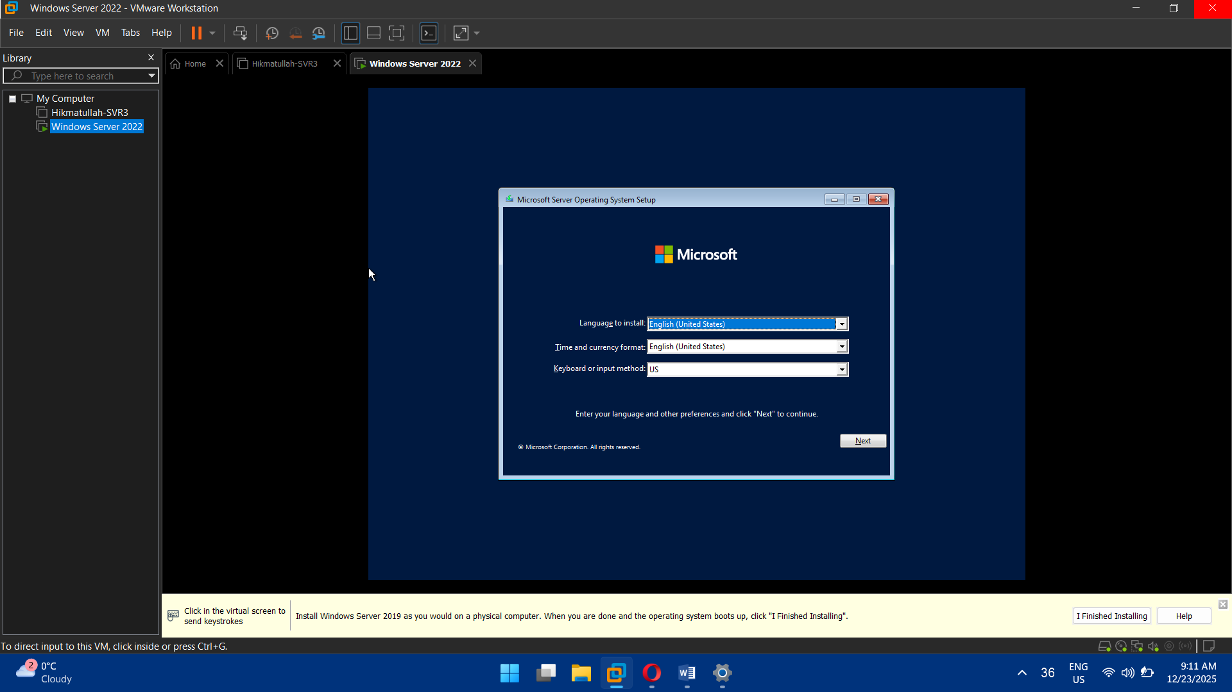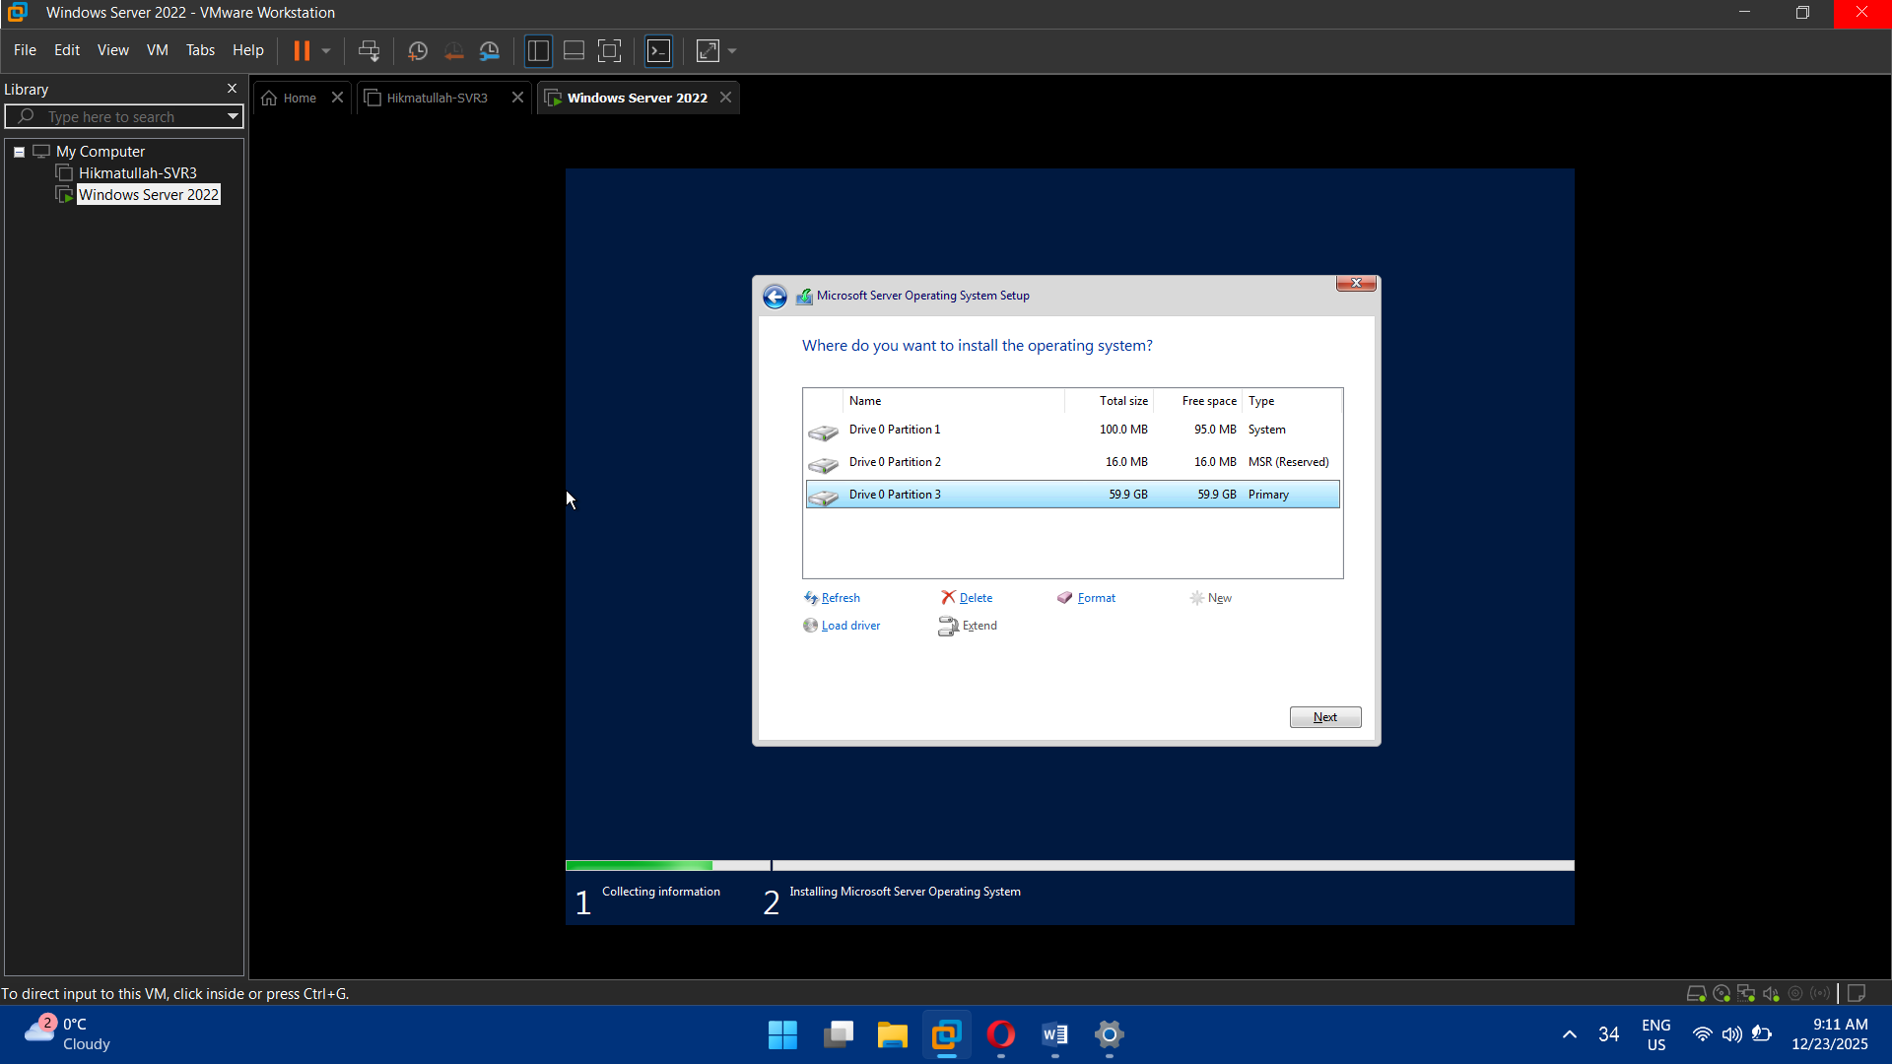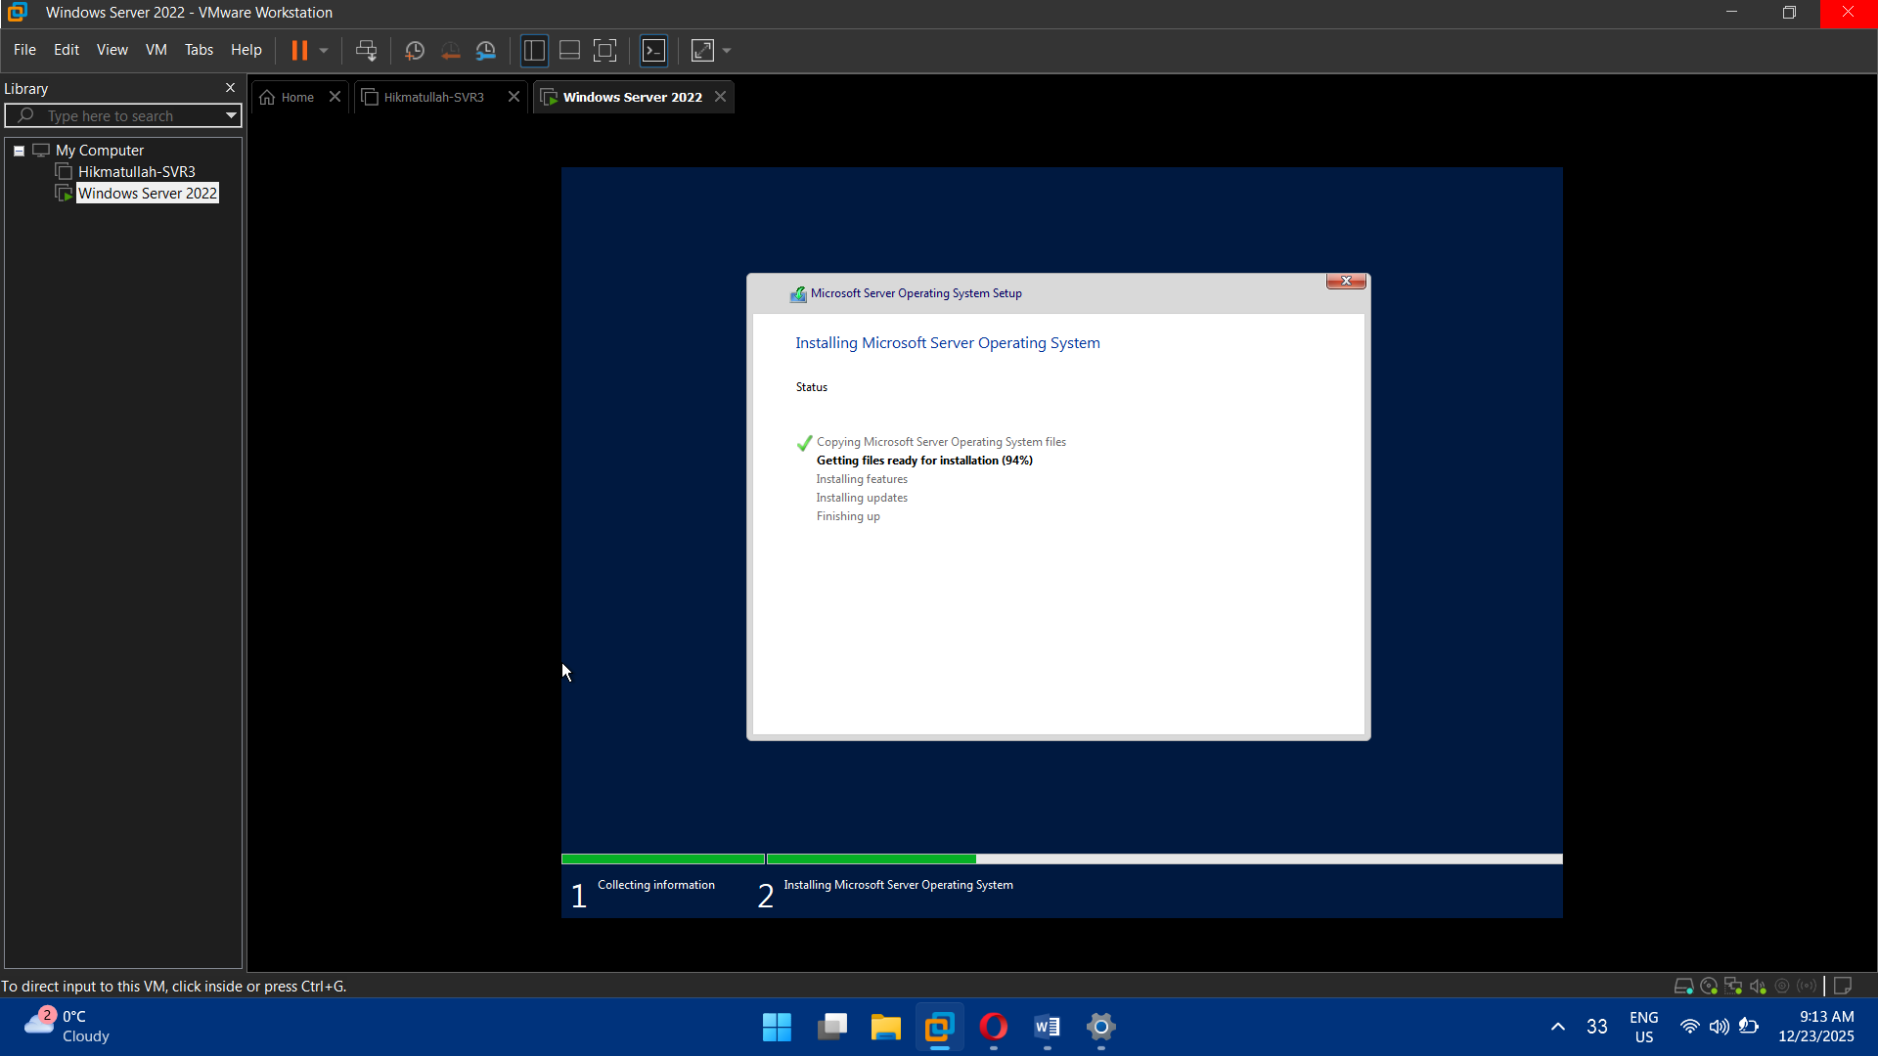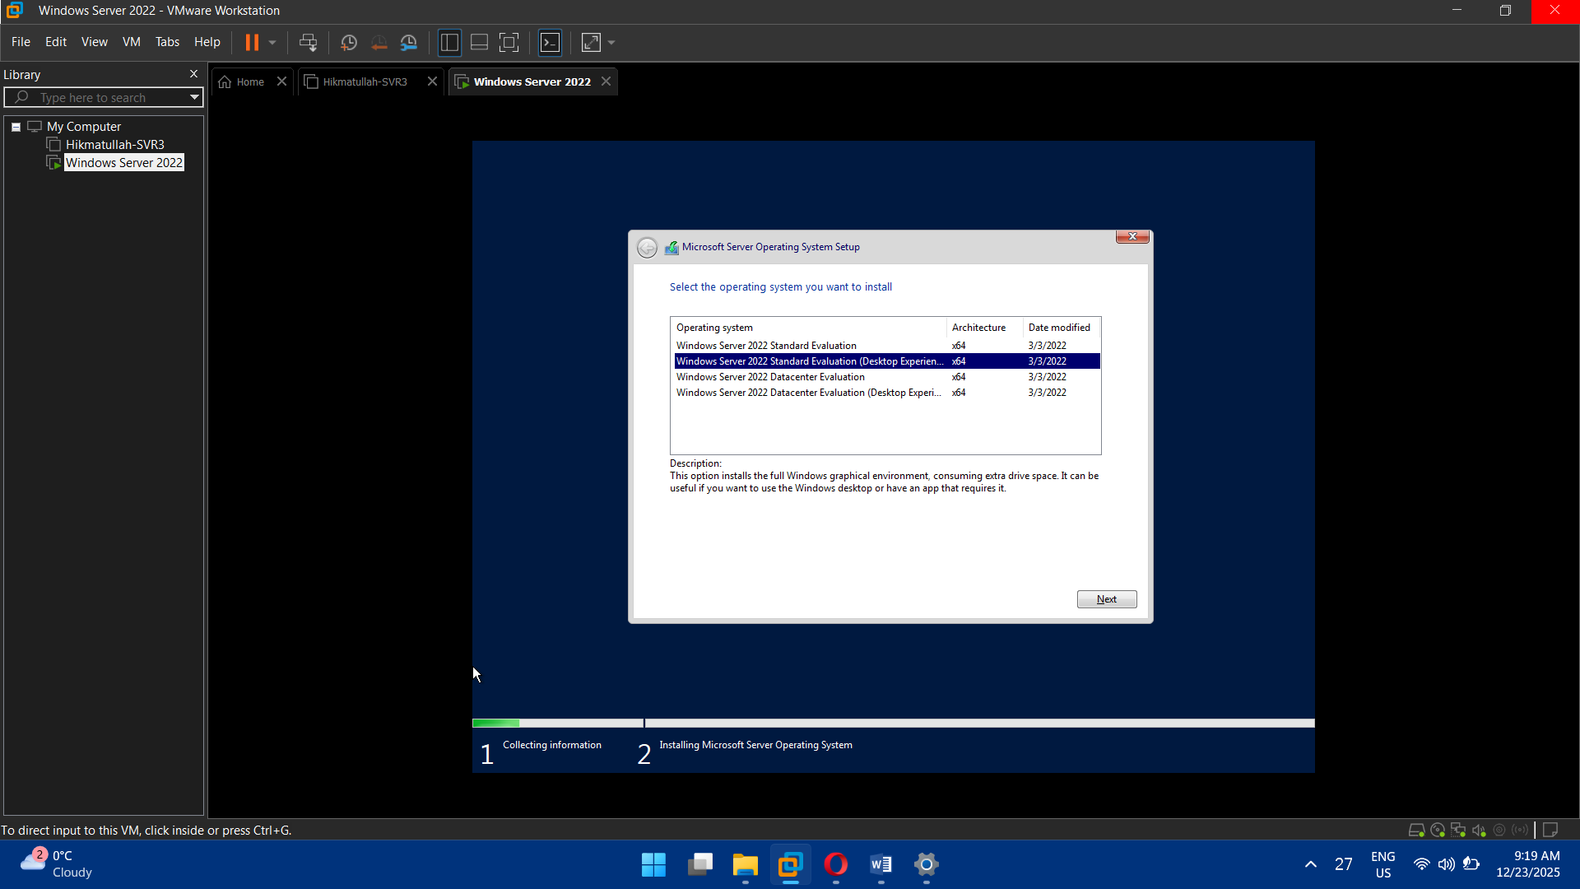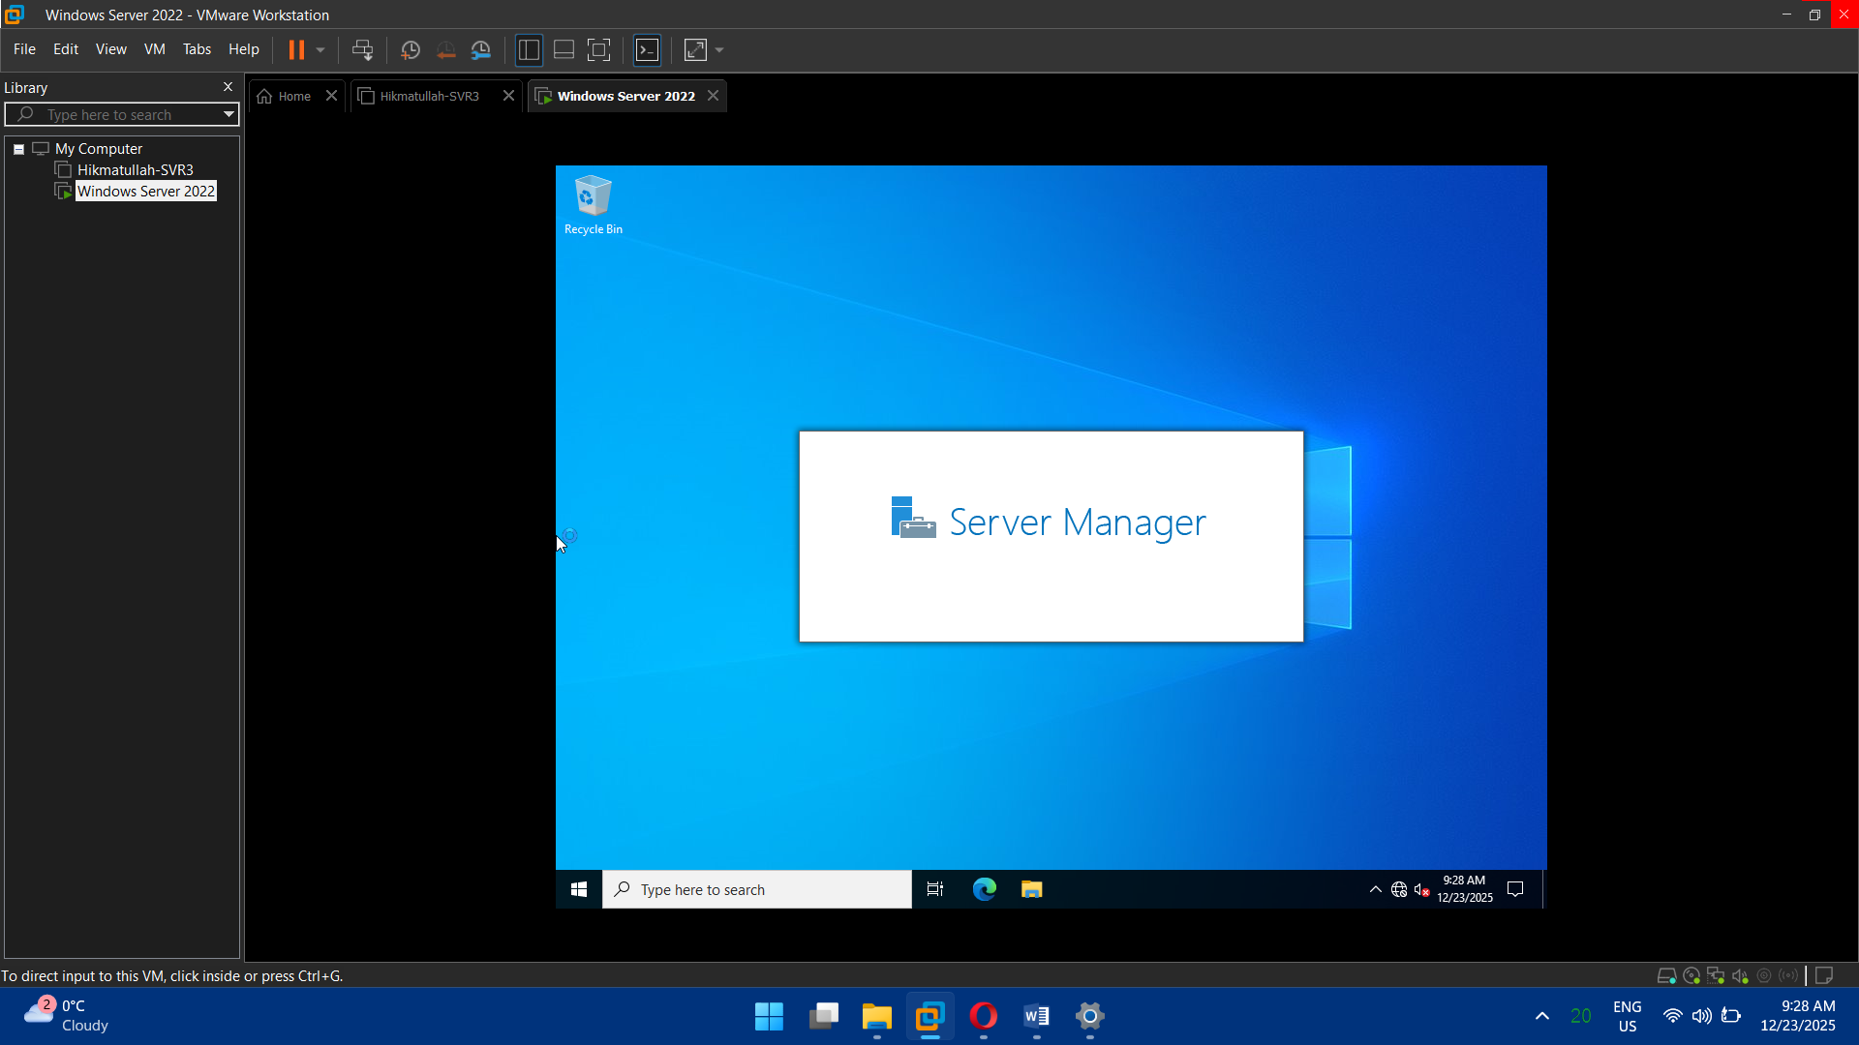

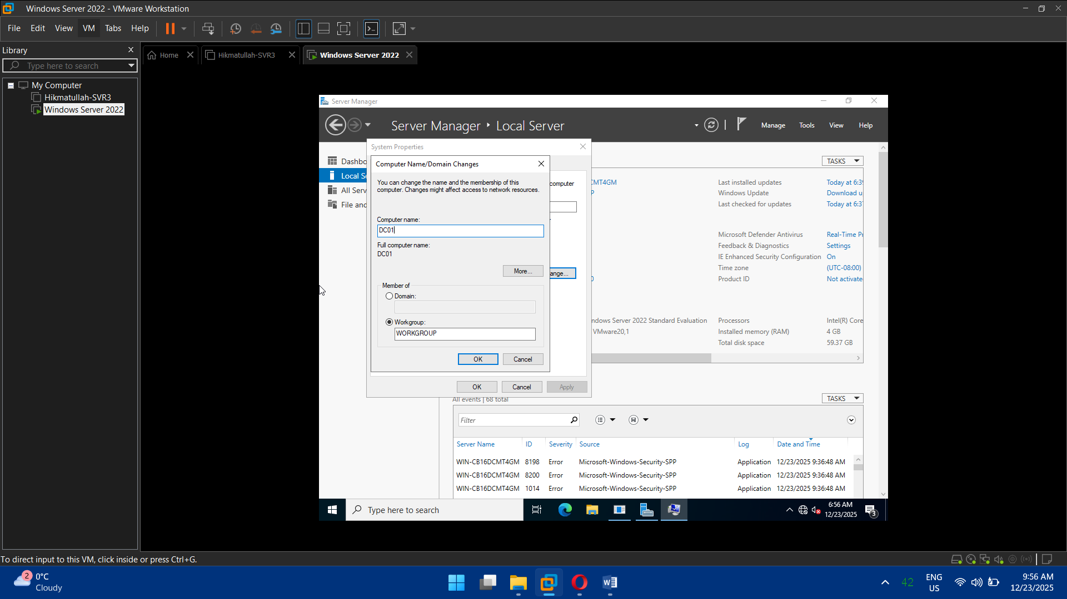

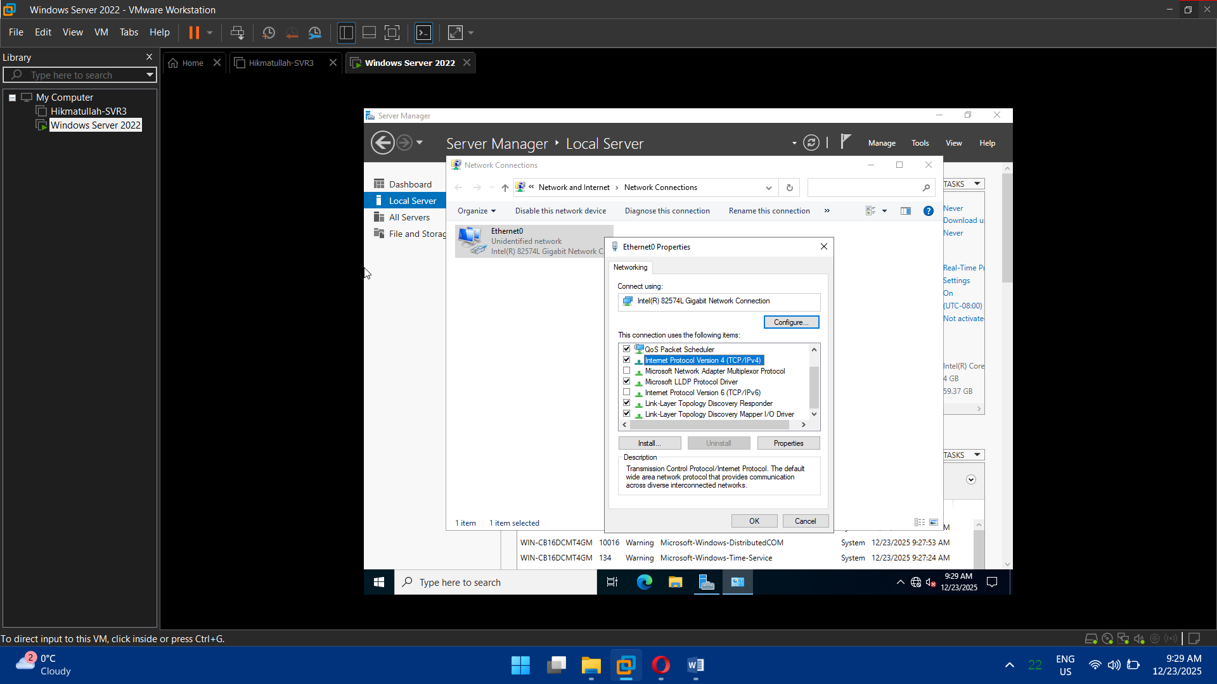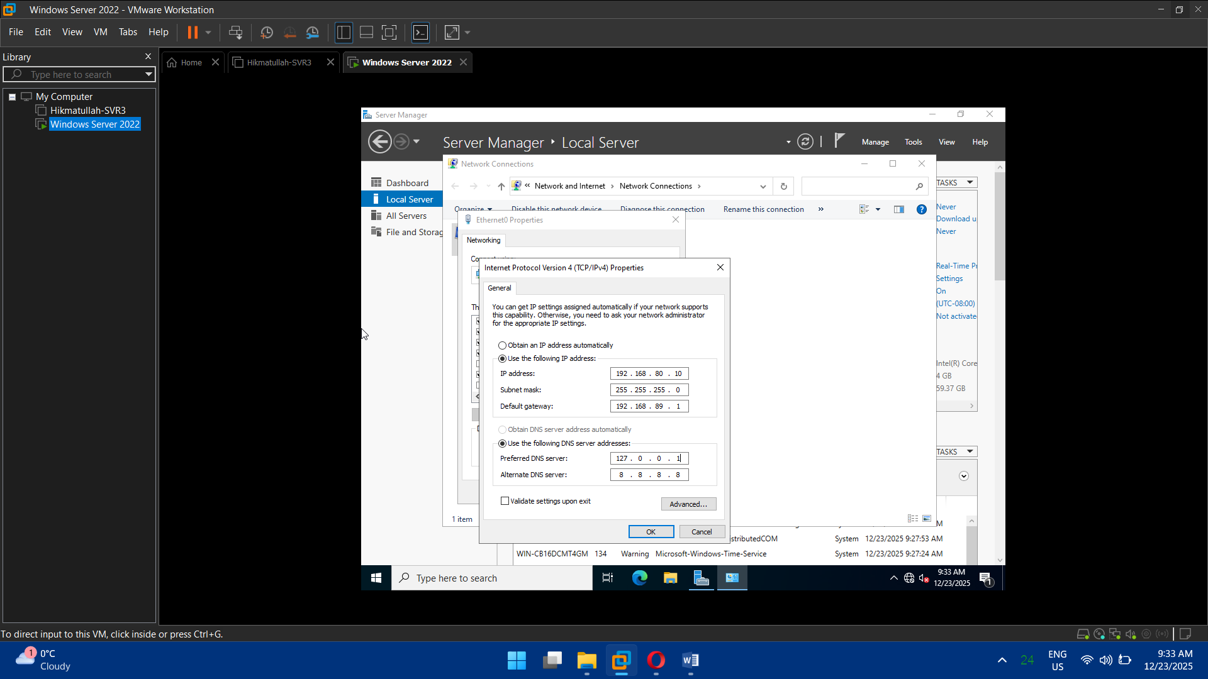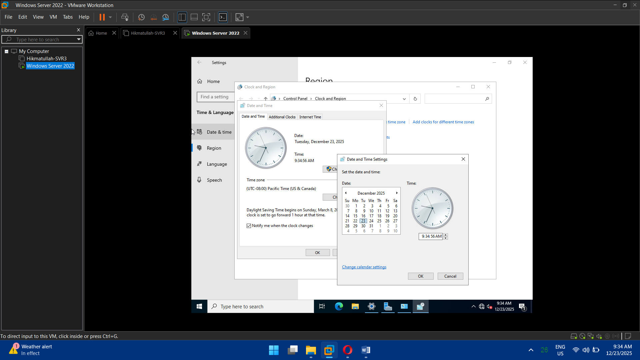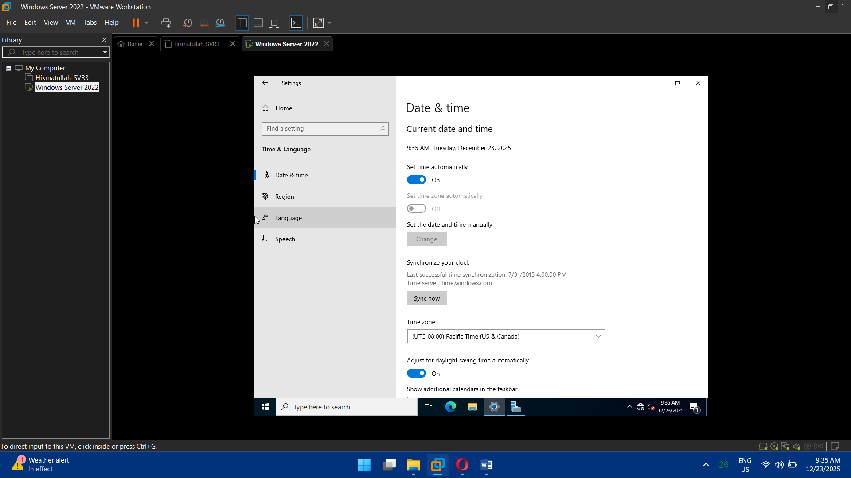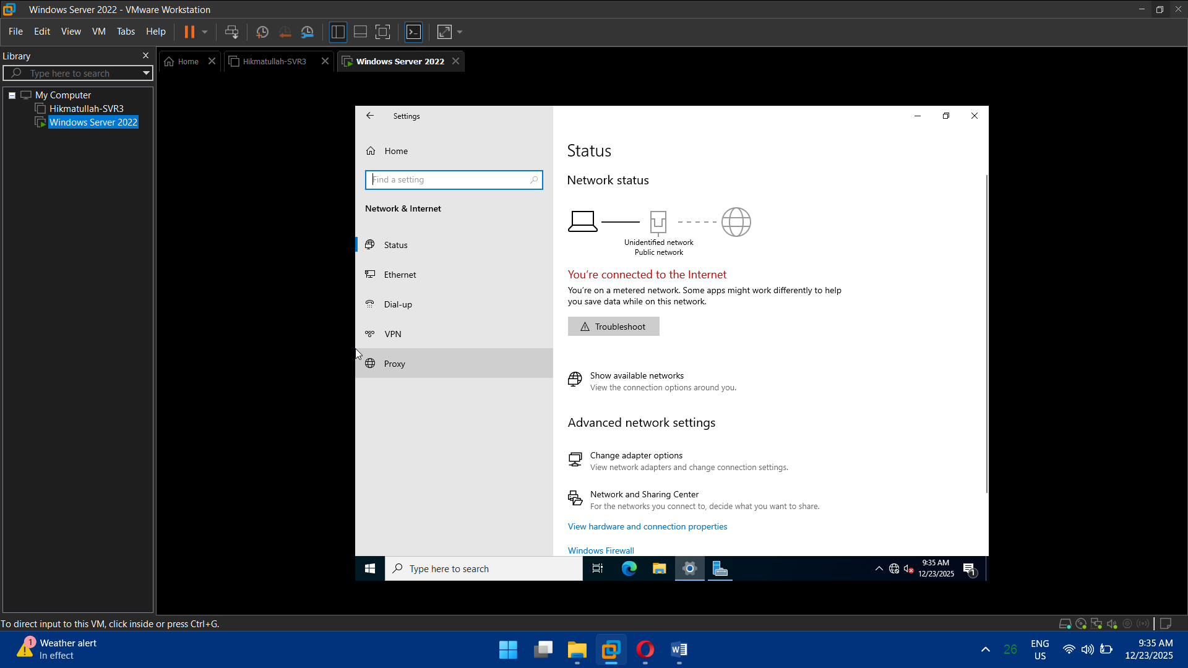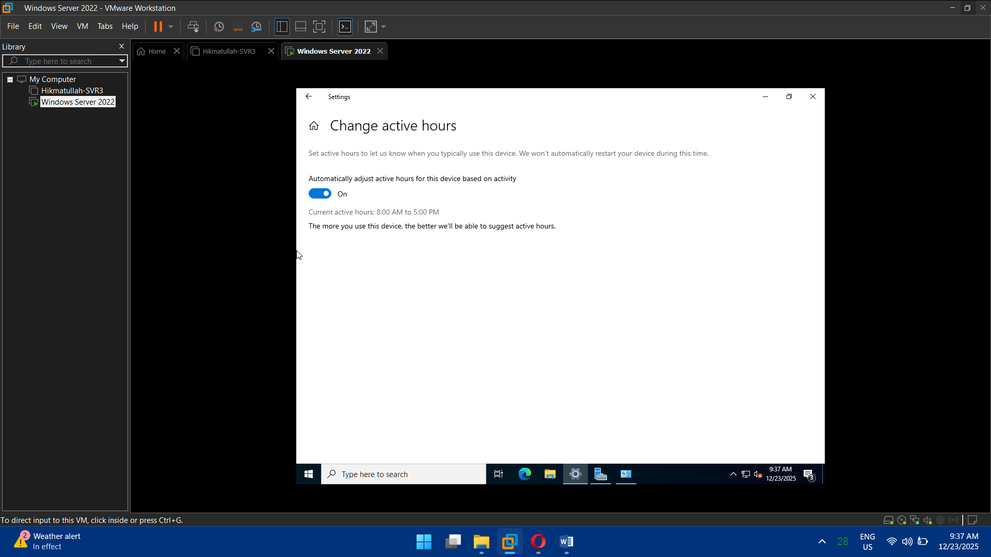

## Task 2: Active Directory Domain Services (AD DS)

* Install **AD DS role**
* Promote server to **Domain Controller**
* Create a new forest and domain:
  + Example: cloudkhan.local
* Verify:
  + NTDS service
  + SYSVOL replication

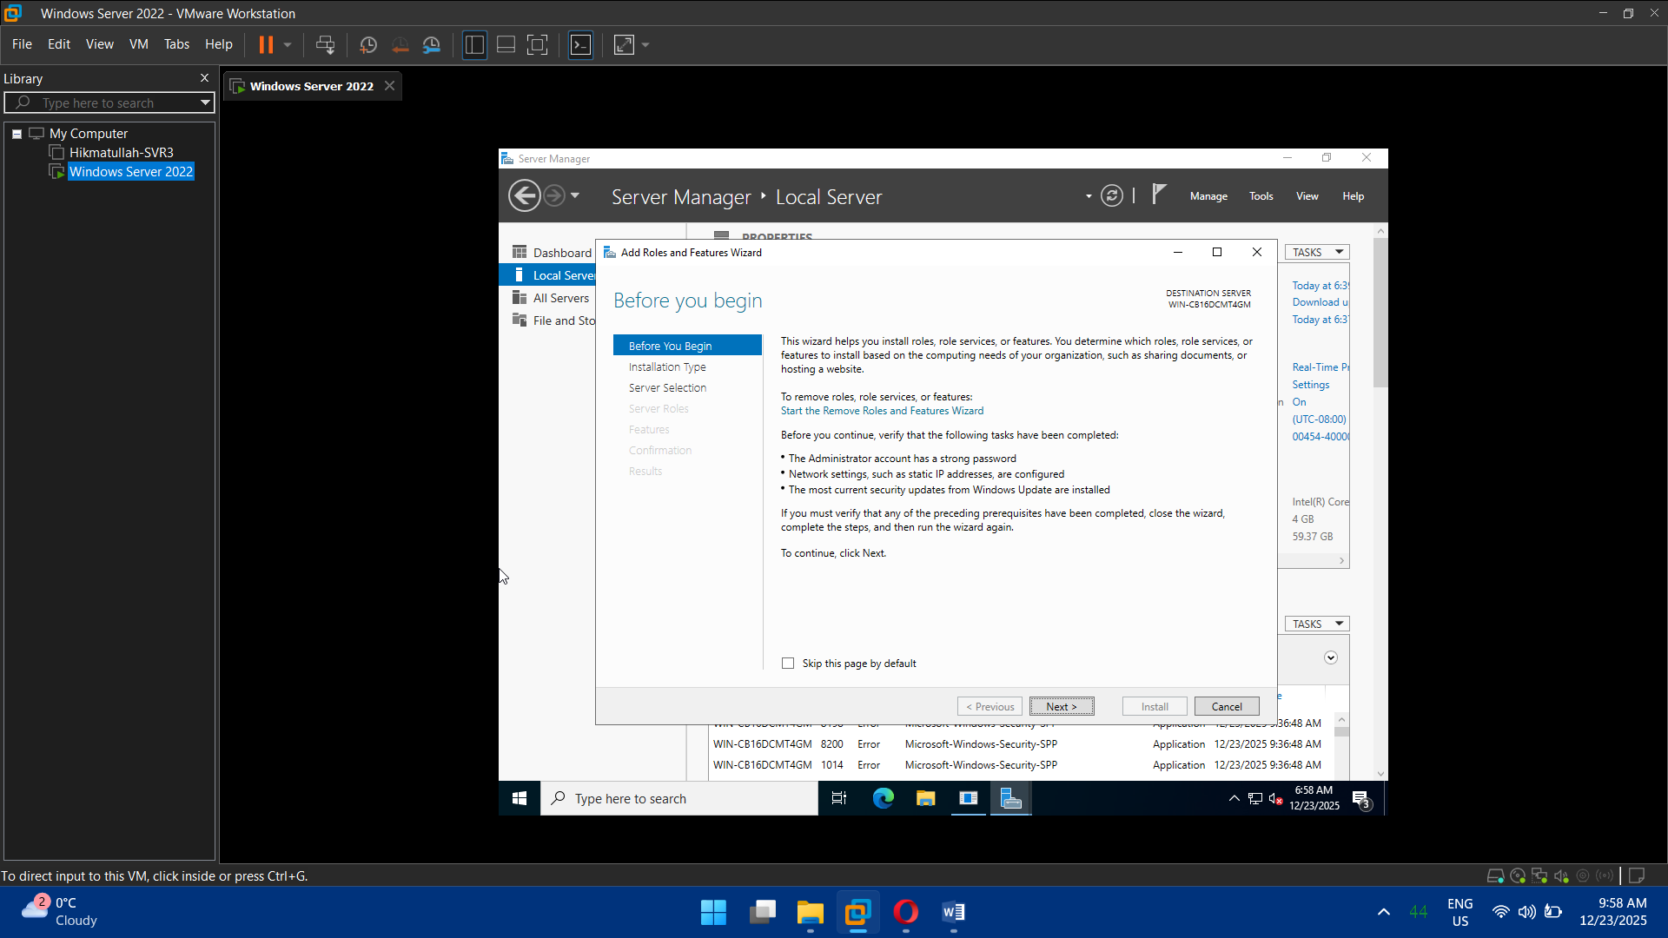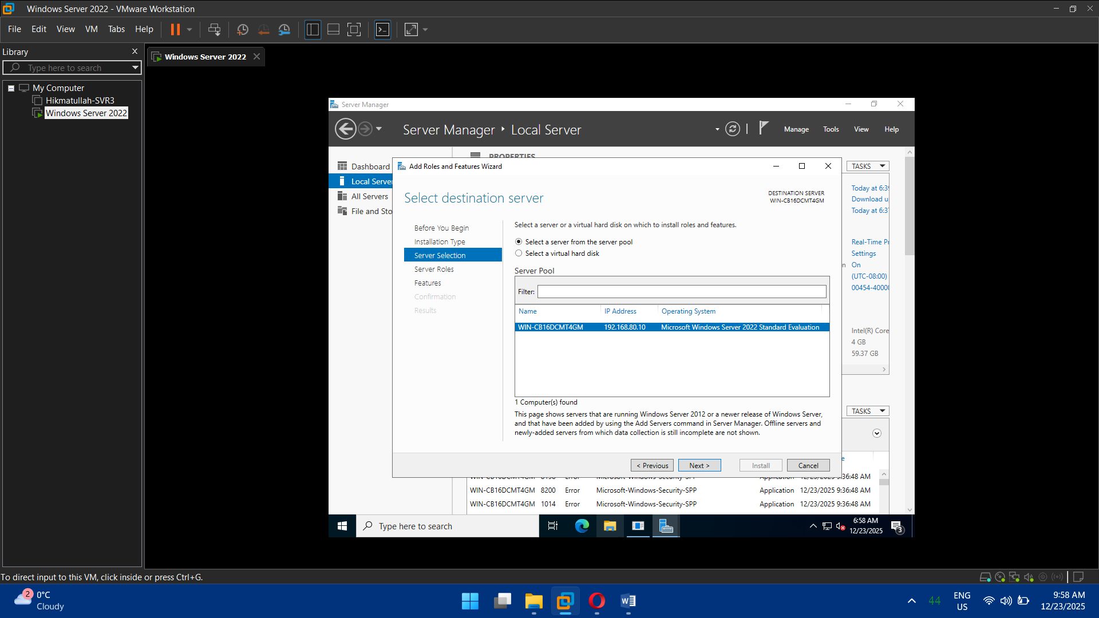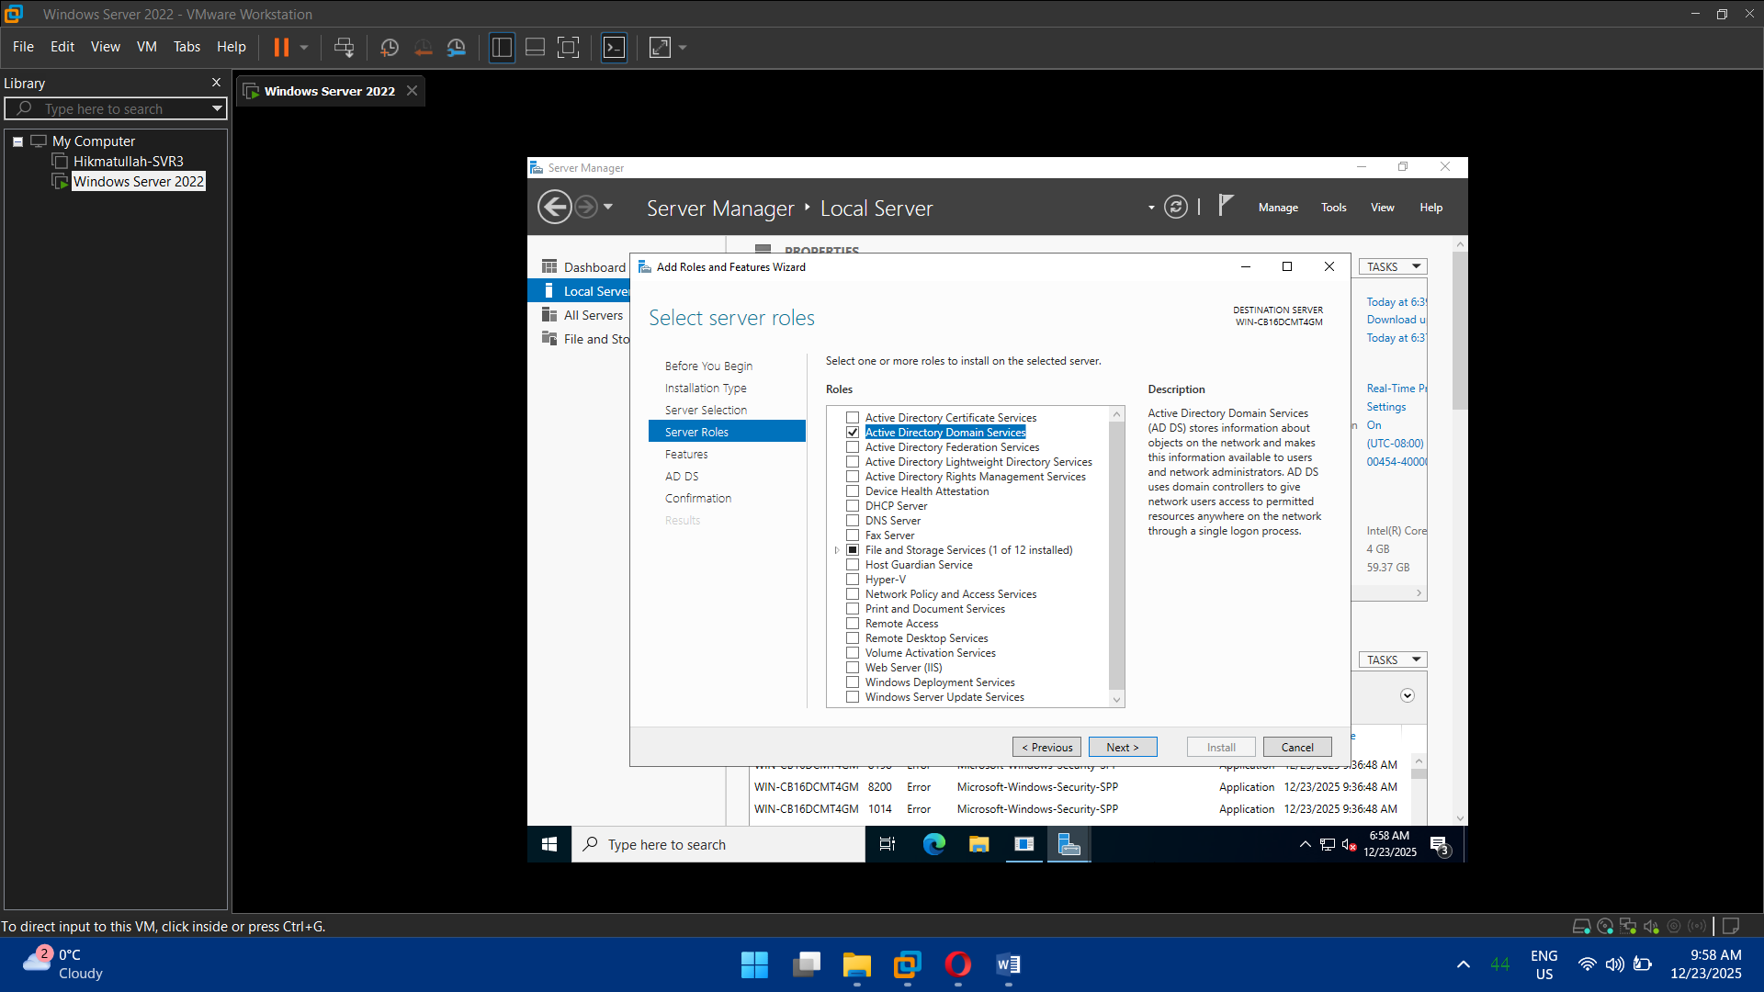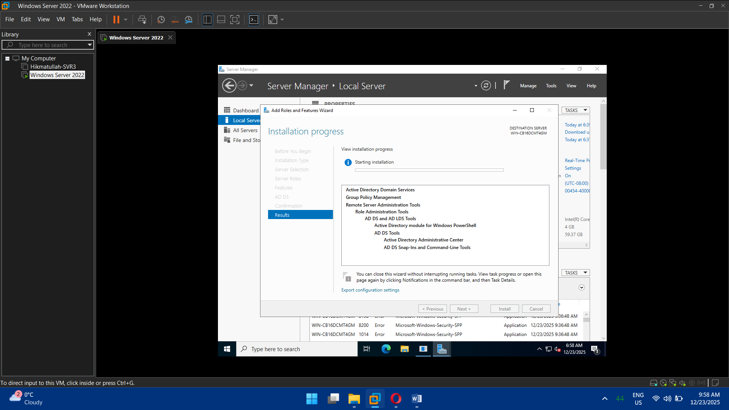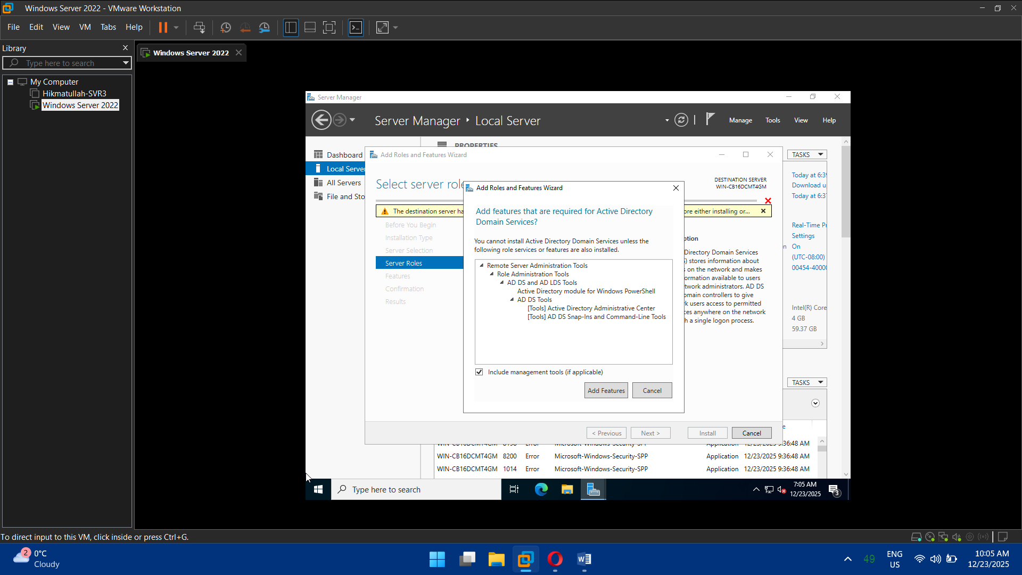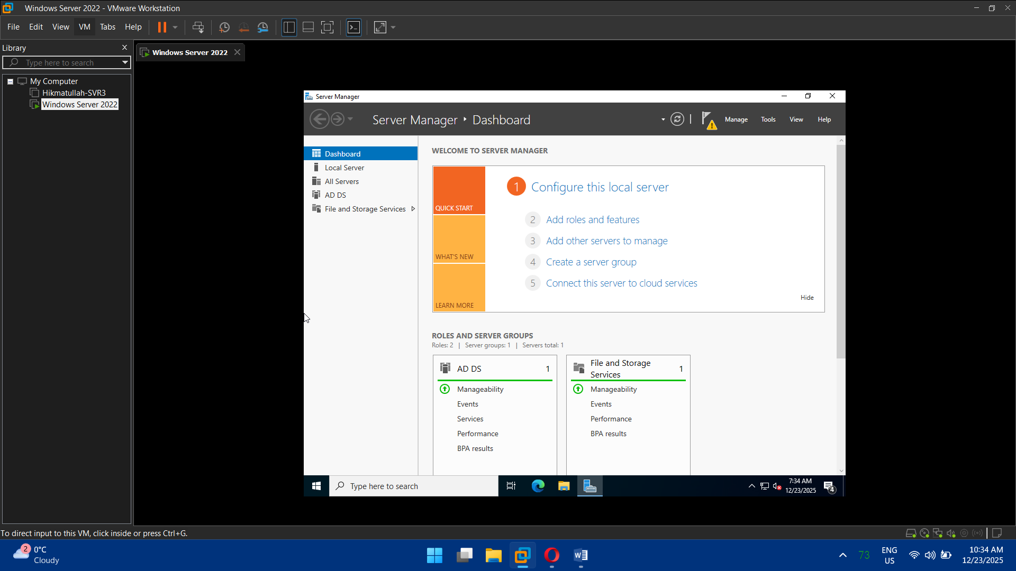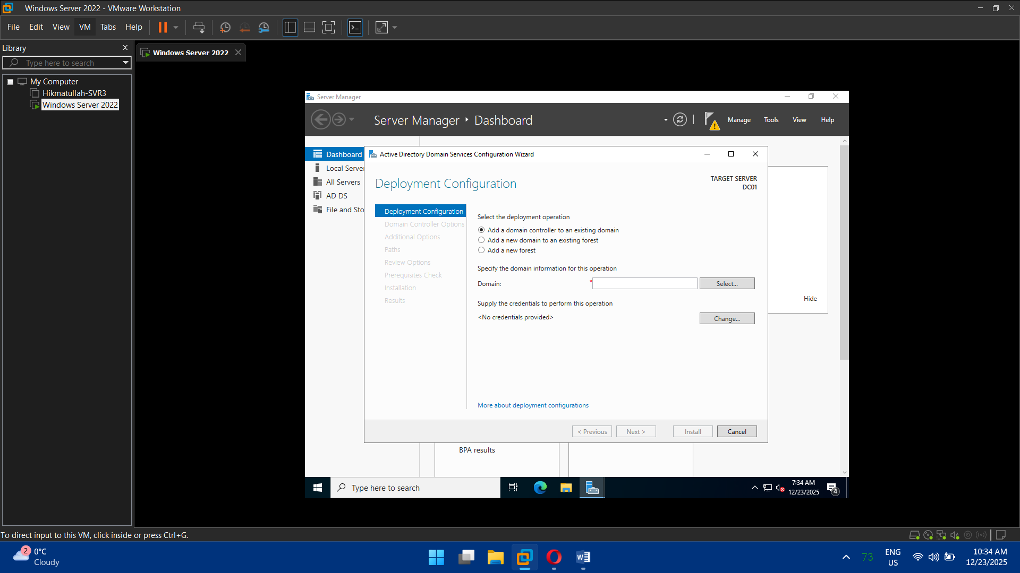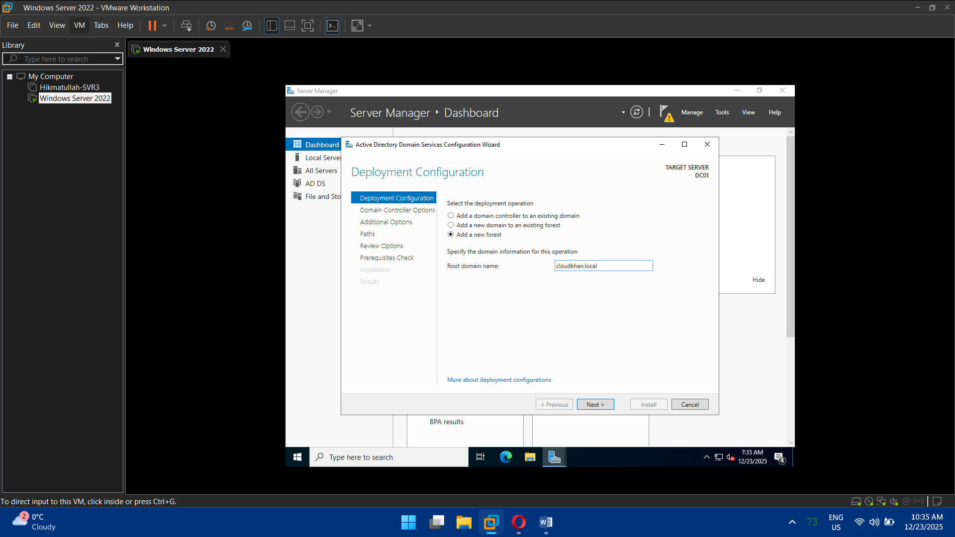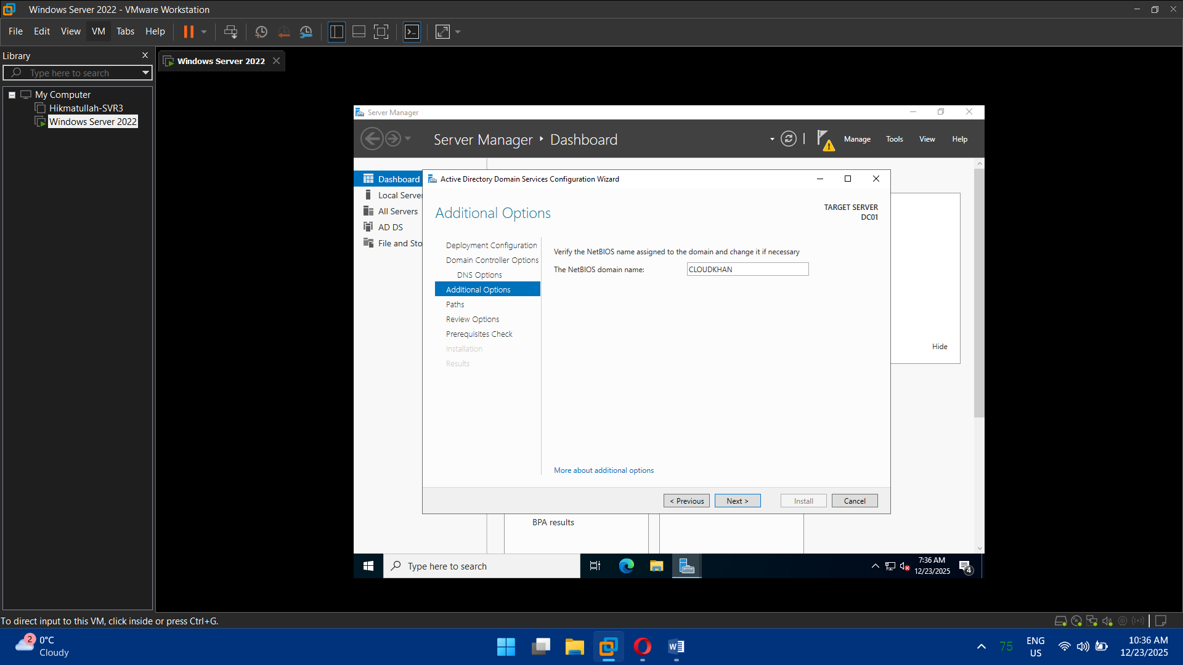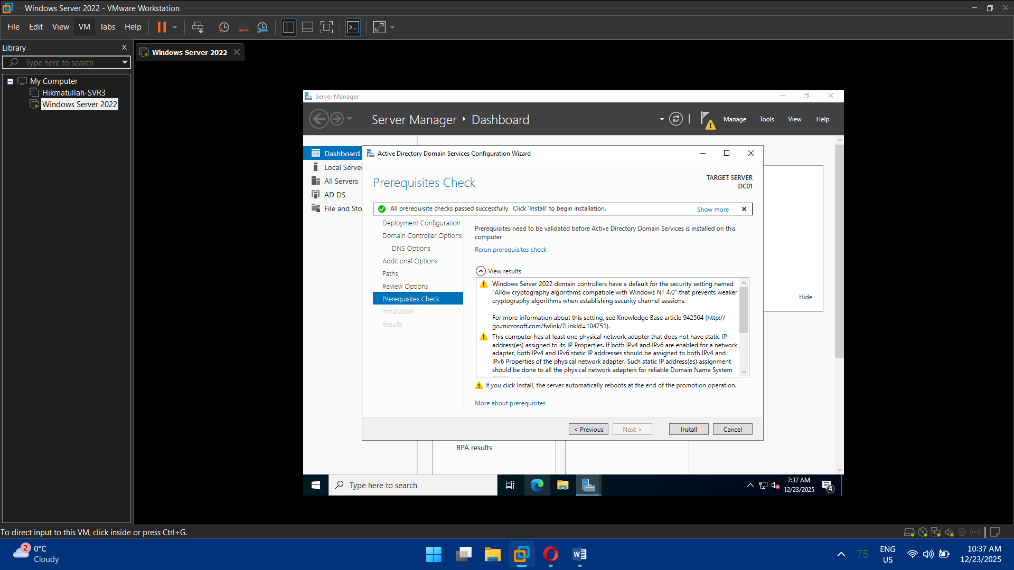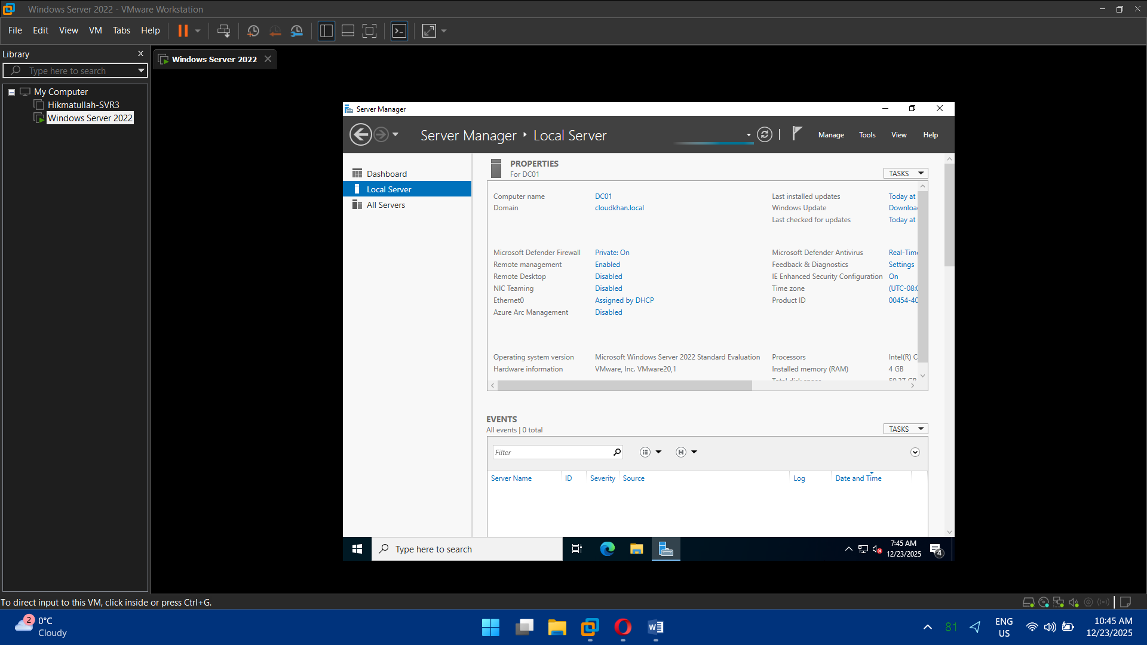

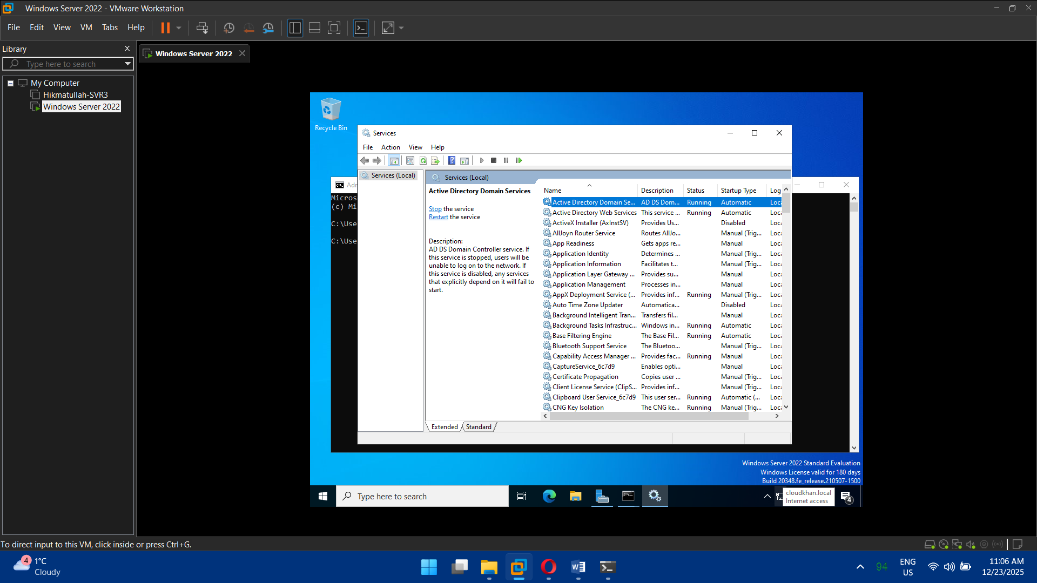

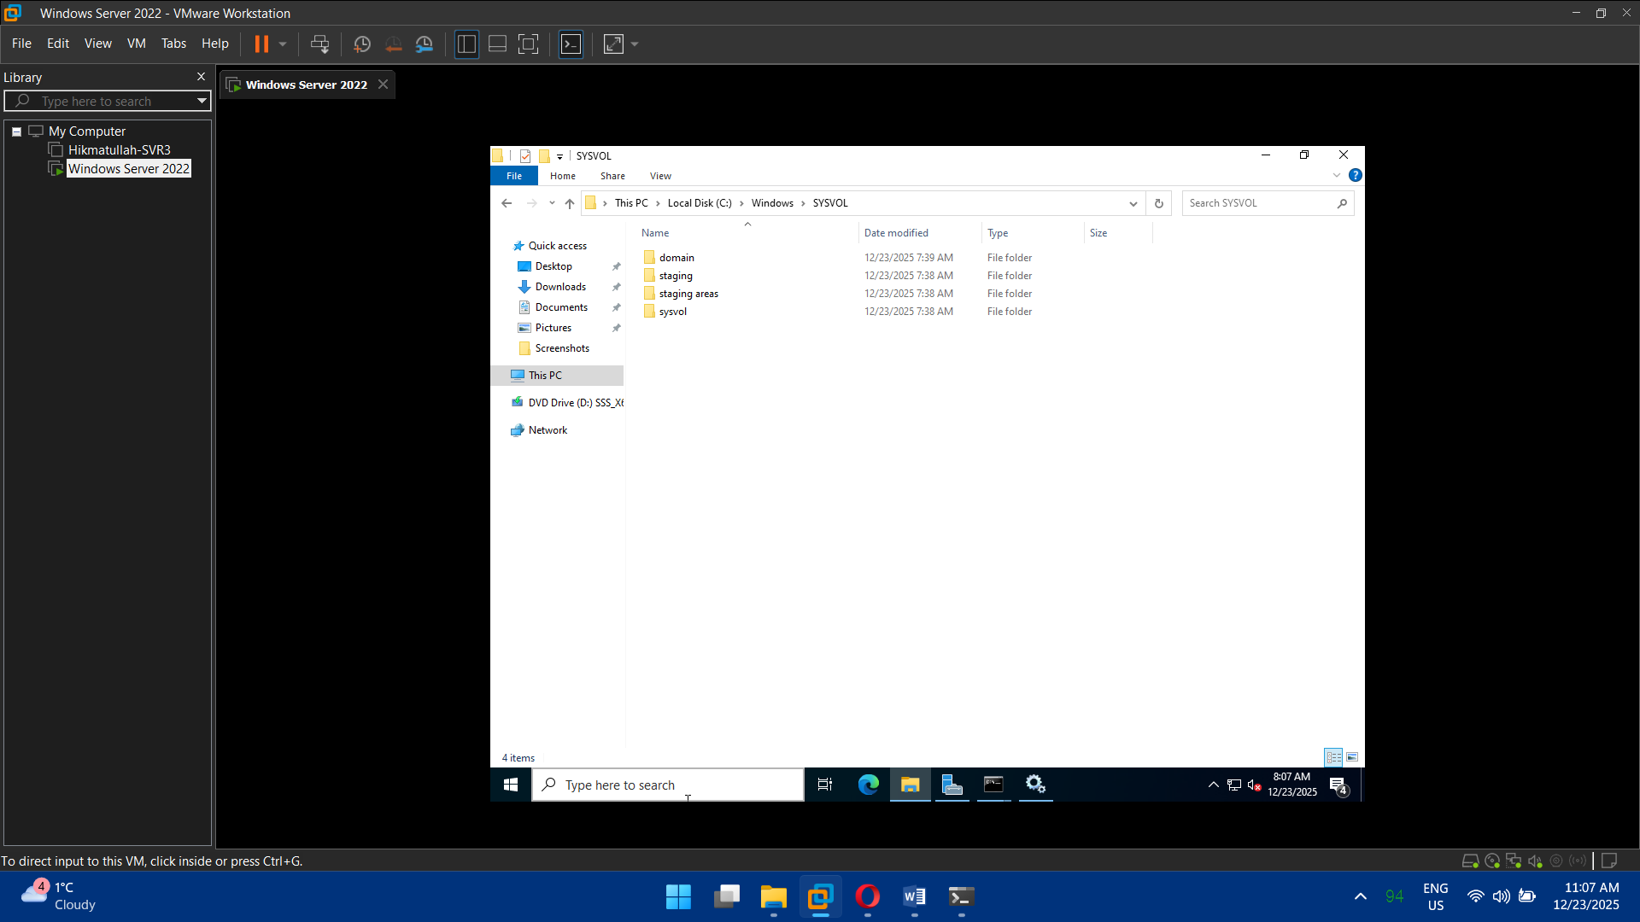

## Task 3: DNS Configuration

* Install **DNS Server role**
* Configure:
  + Forward lookup zones
  + Reverse lookup zones
* Set DNS forwarding to public resolvers
* Verify domain name resolution

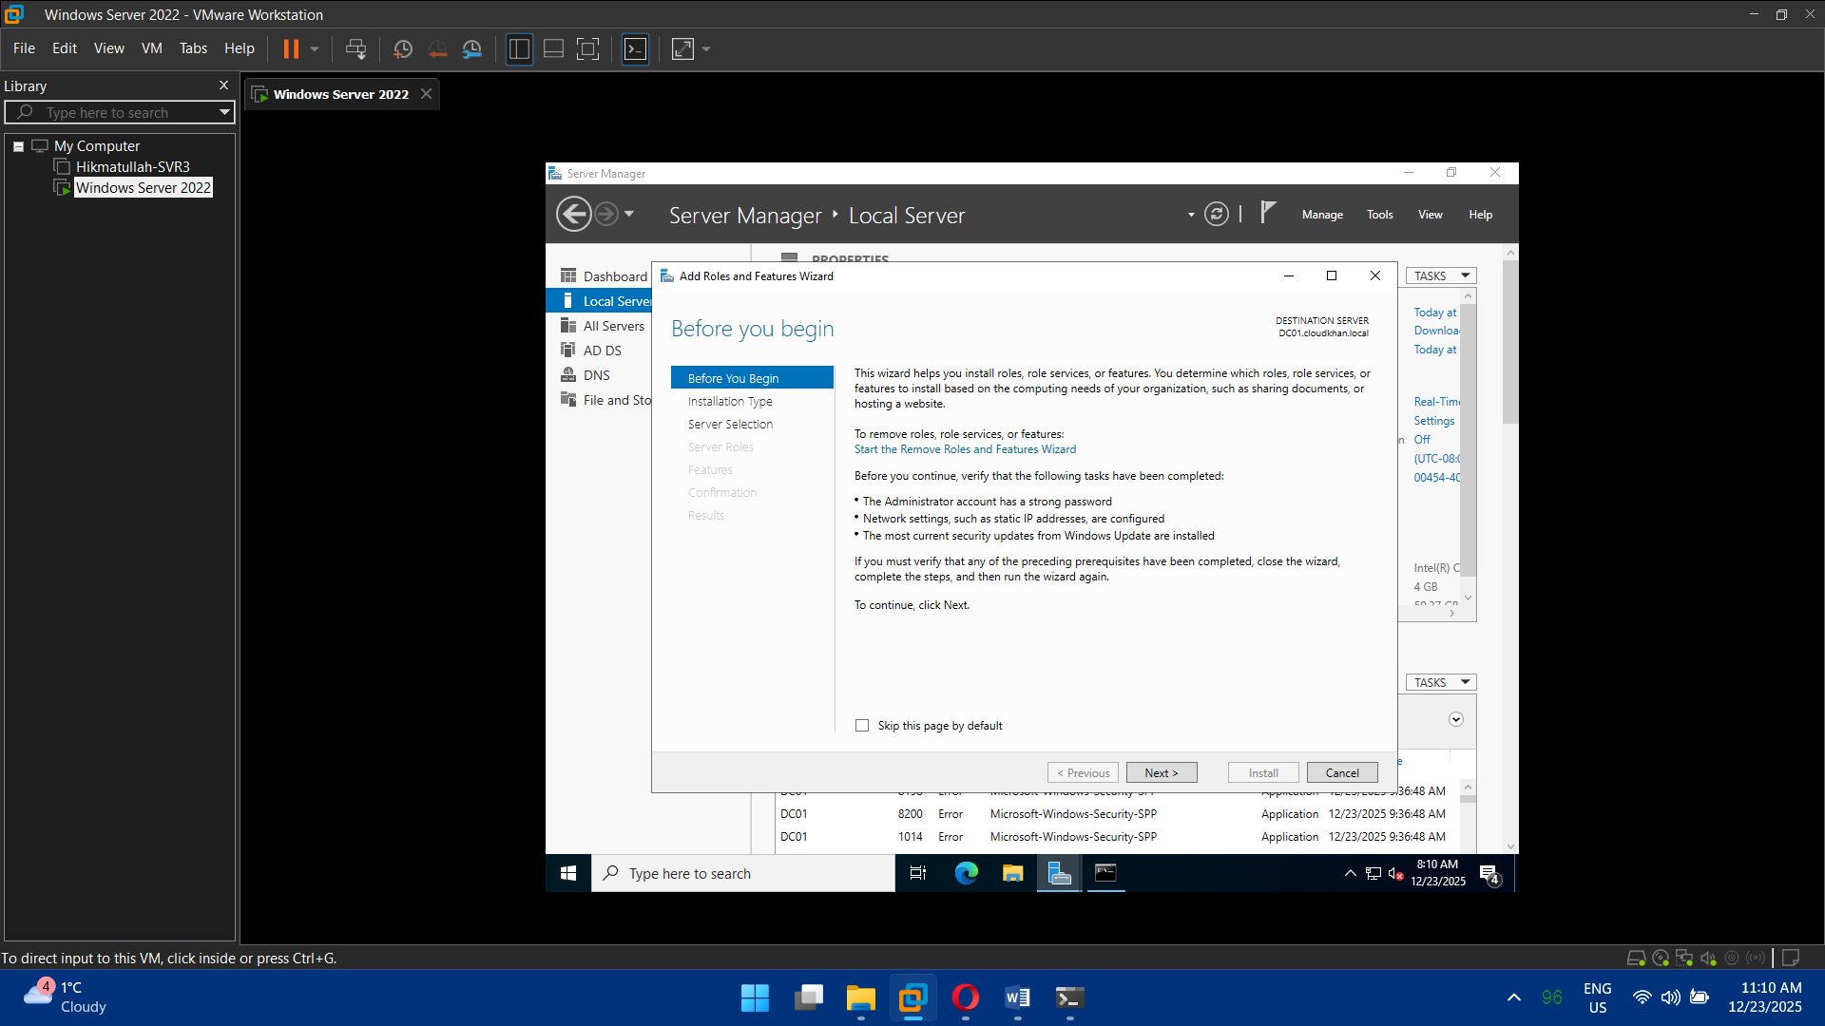

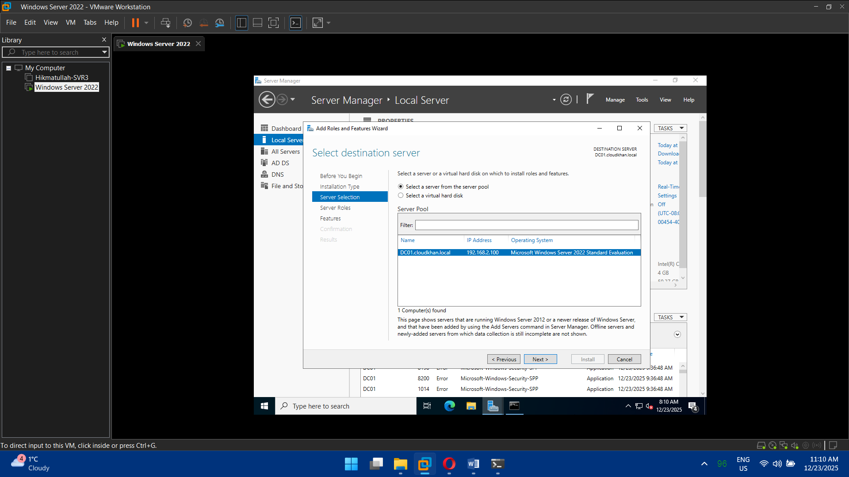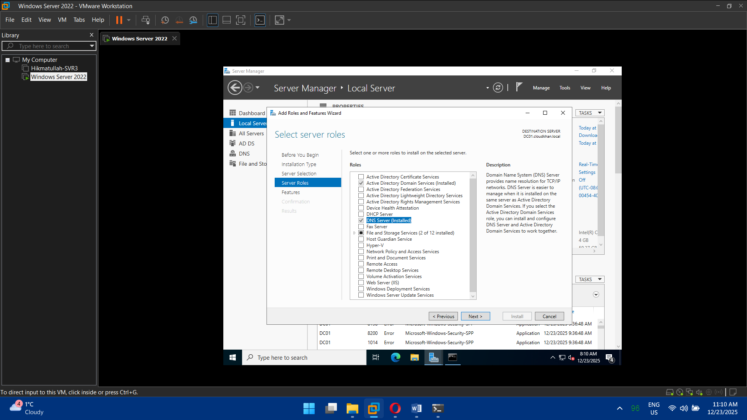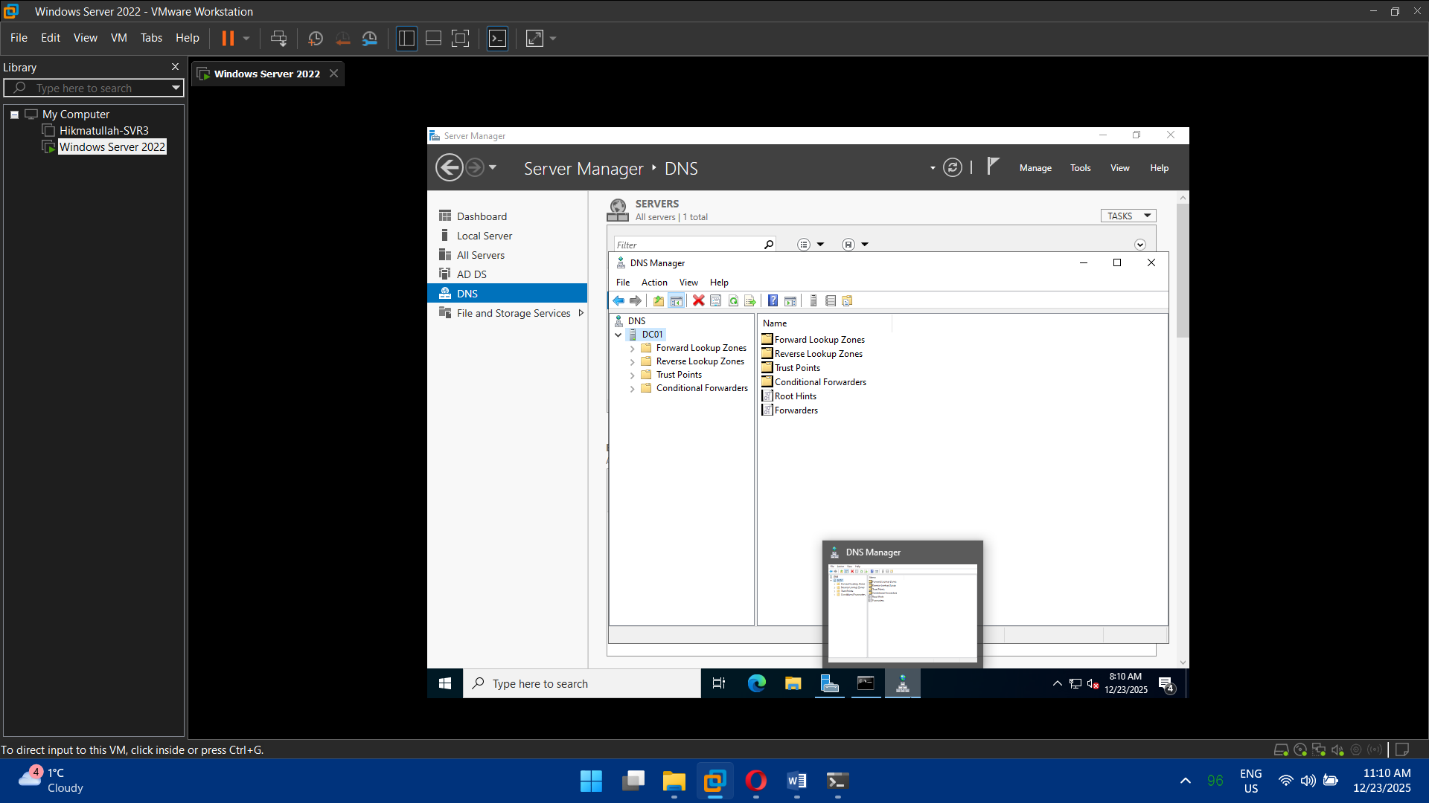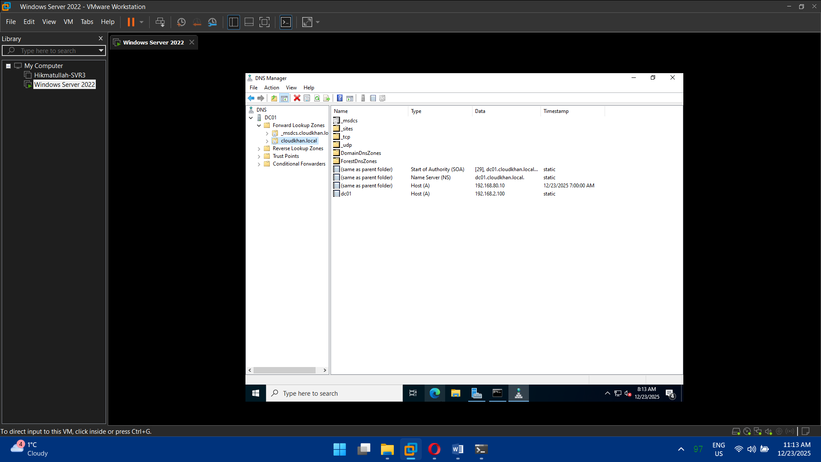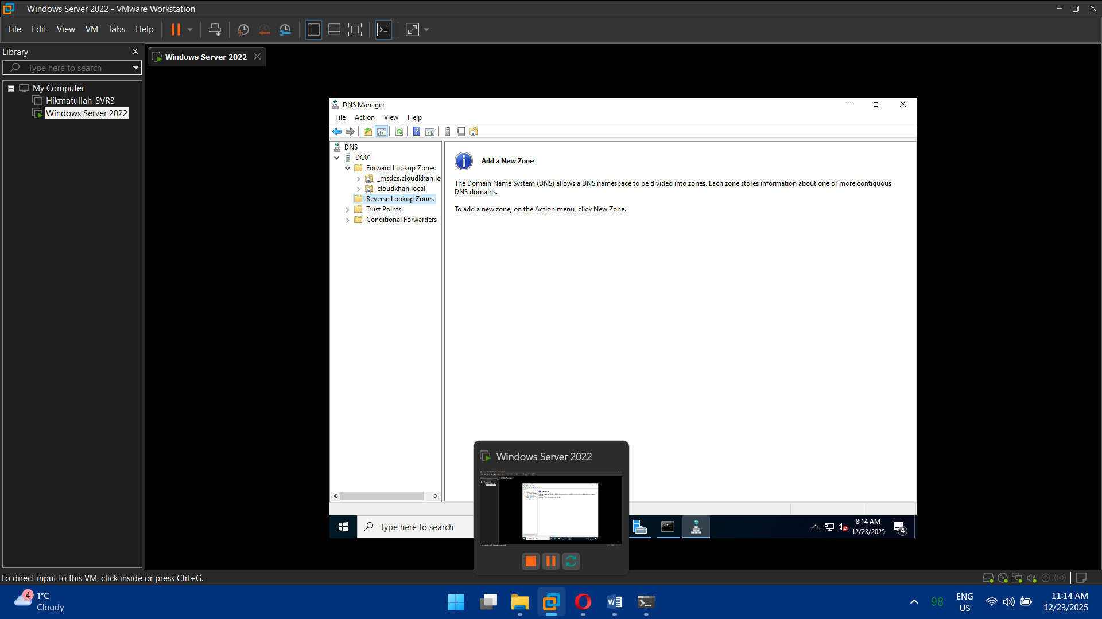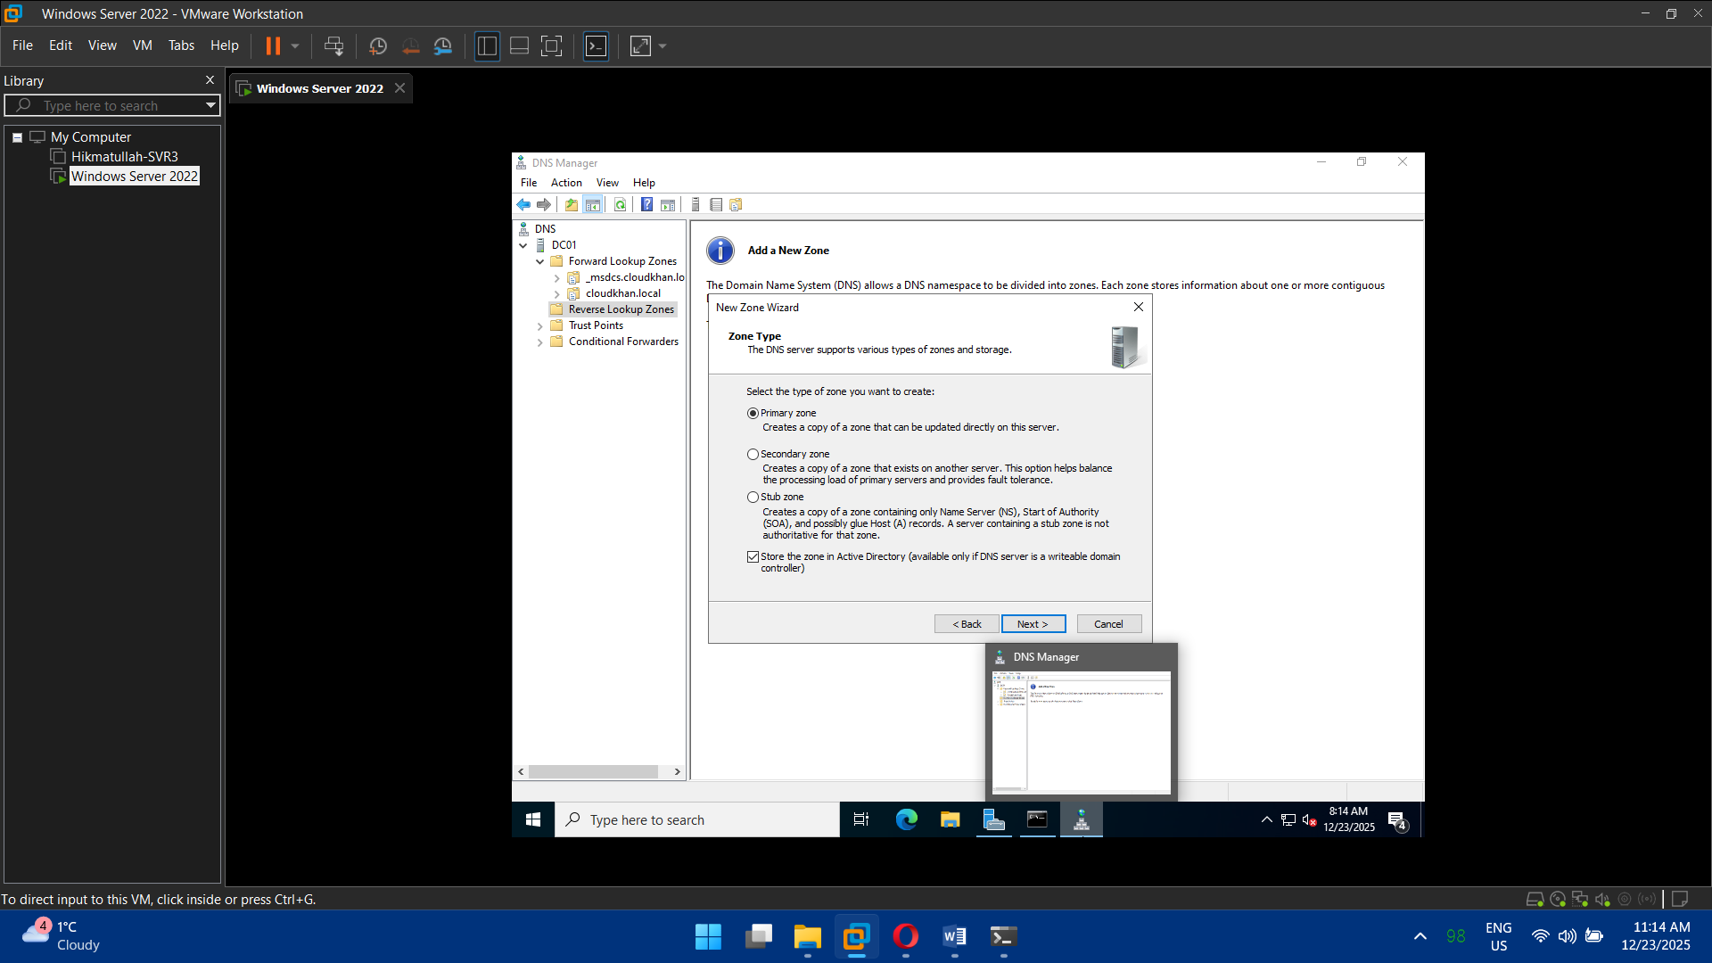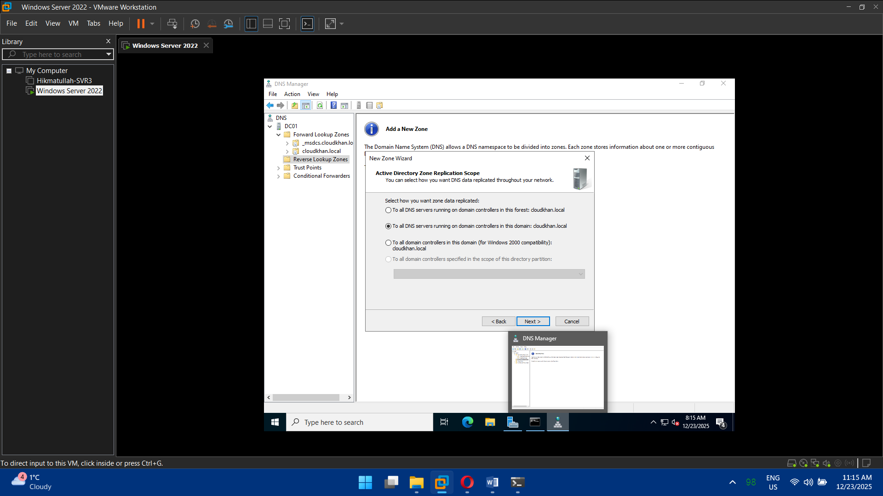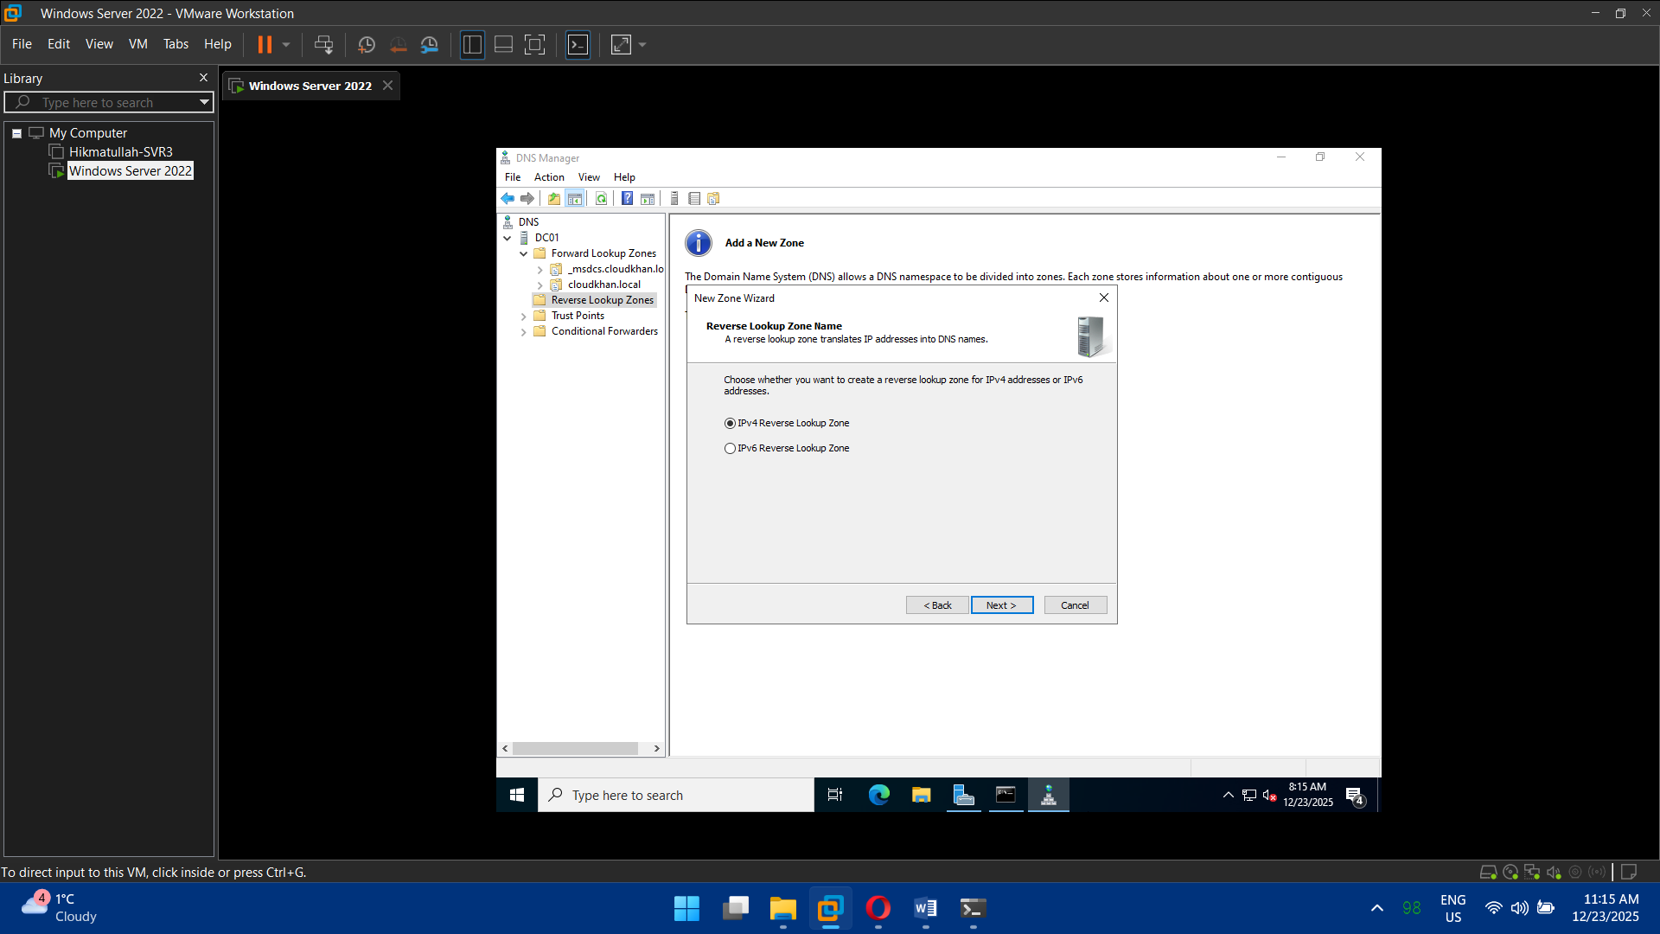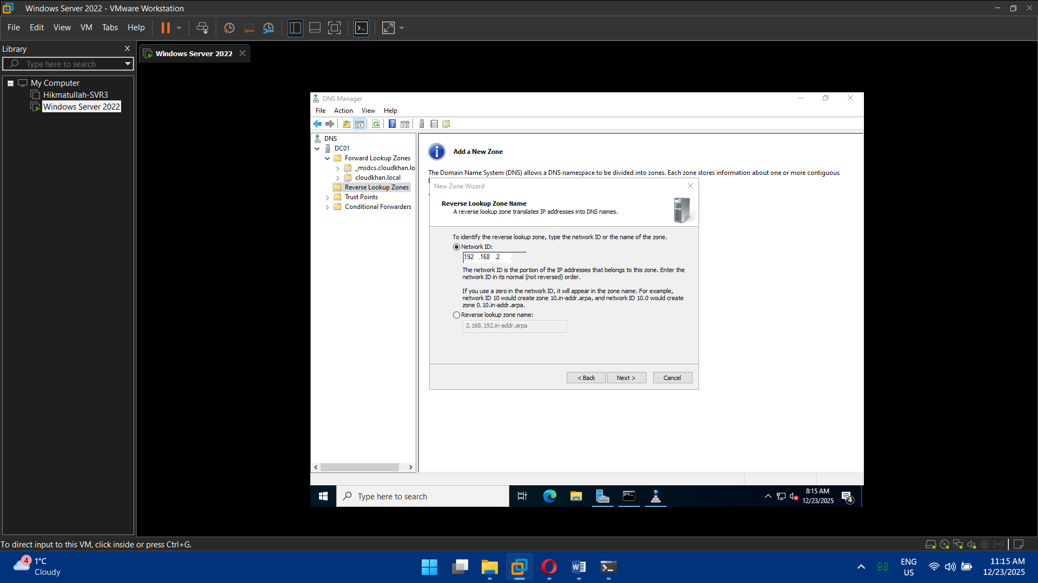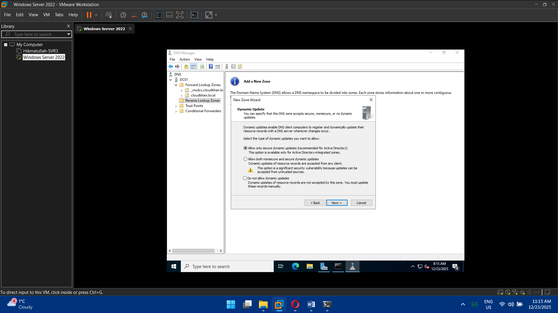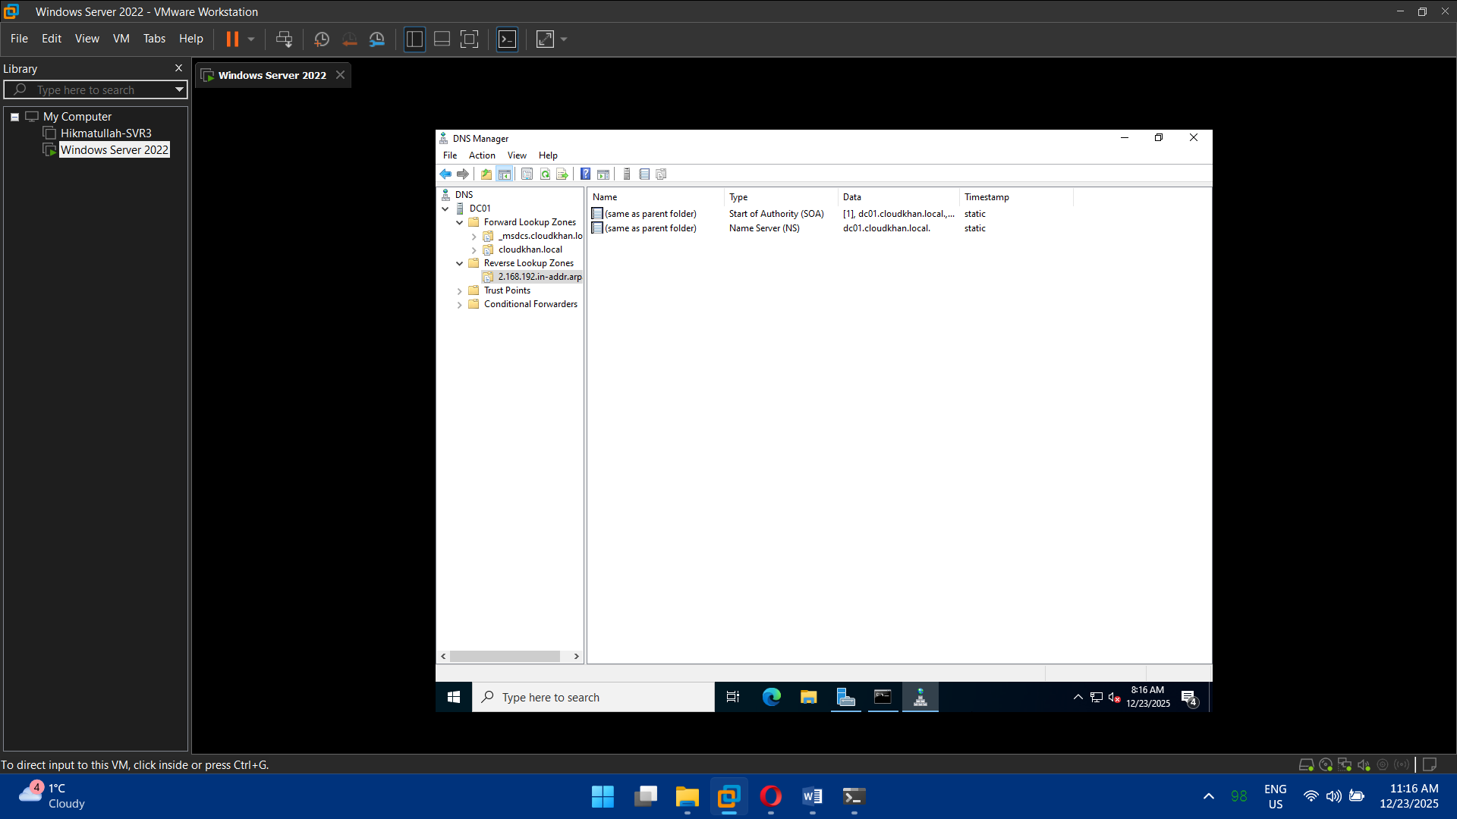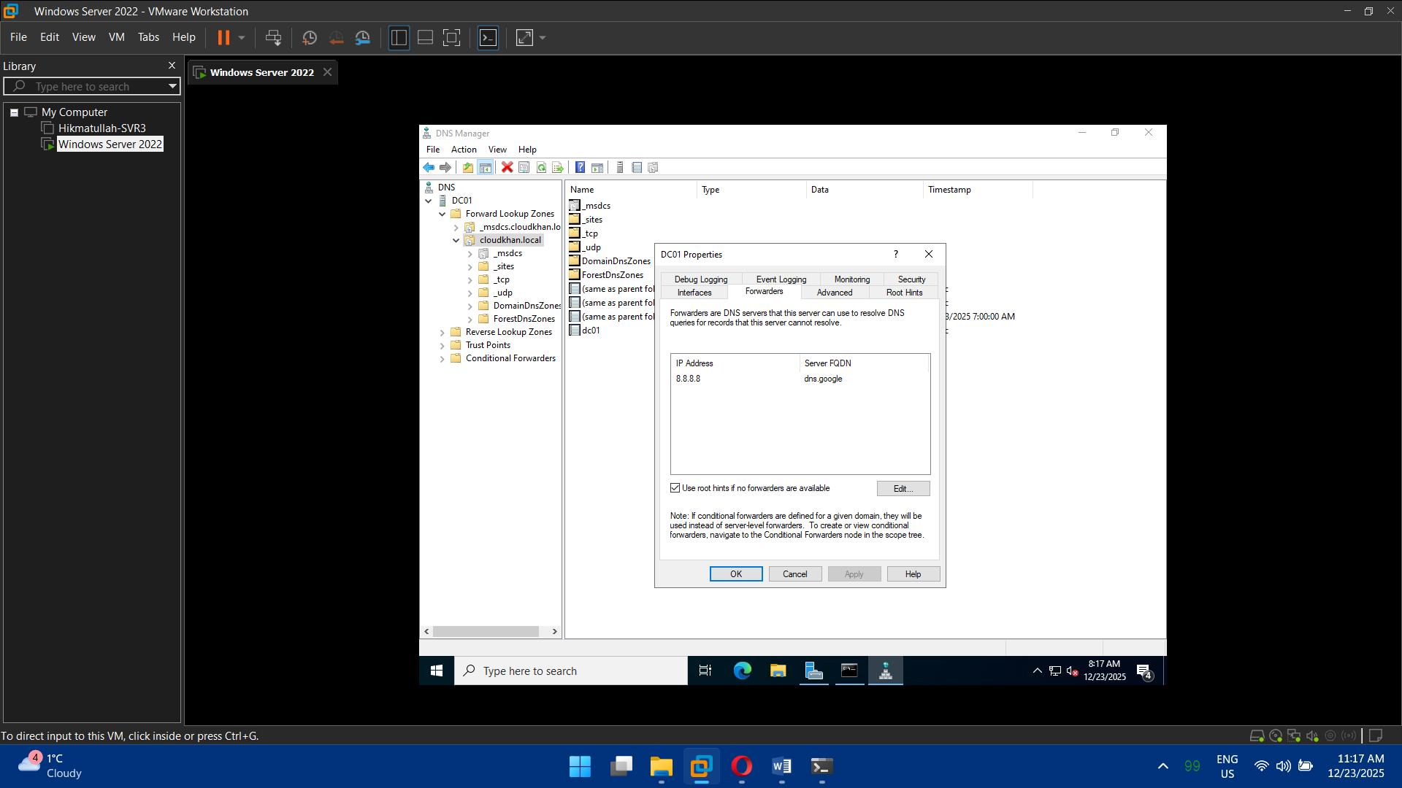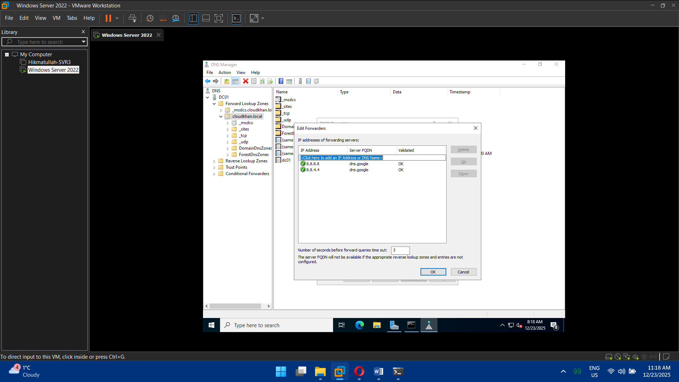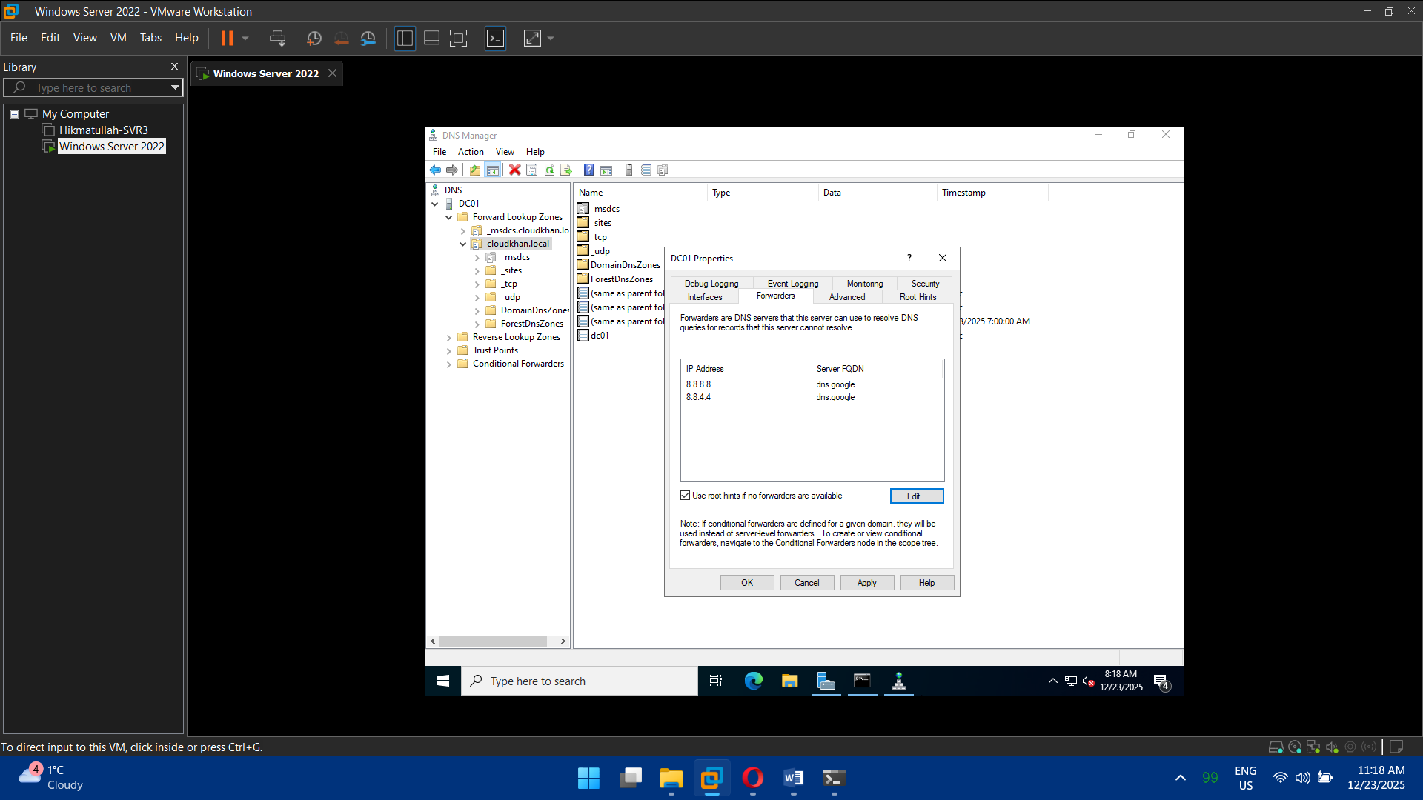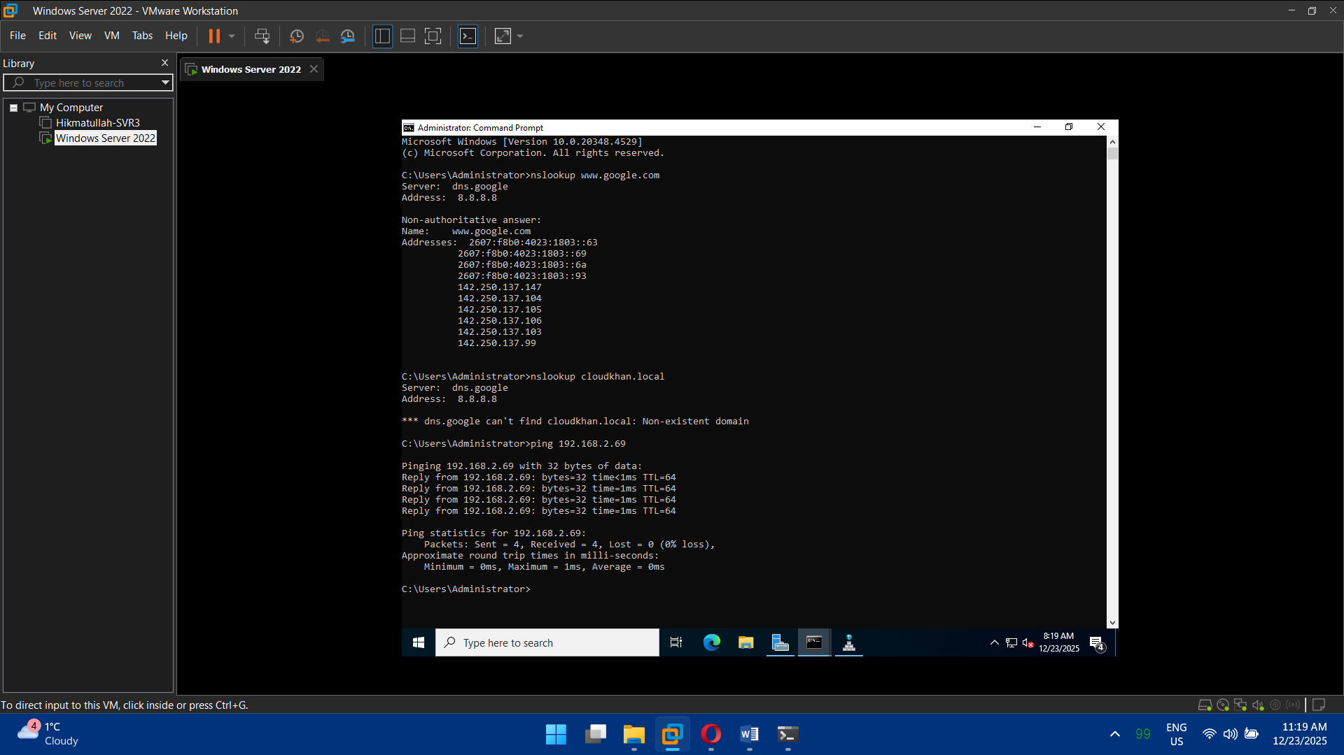

## Task 4: Organizational Units (OUs) & User Management

* Create OUs:
  + Users
  + Computers
  + Servers
  + IT Admins
* Create users:
  + Normal users
  + IT administrators
* Assign group memberships

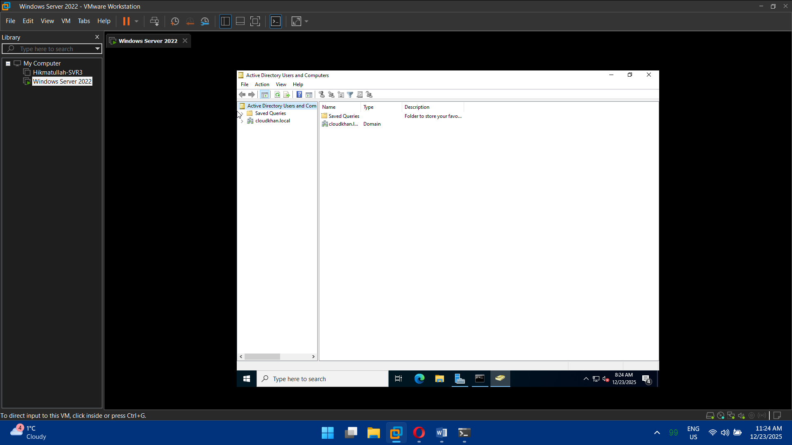

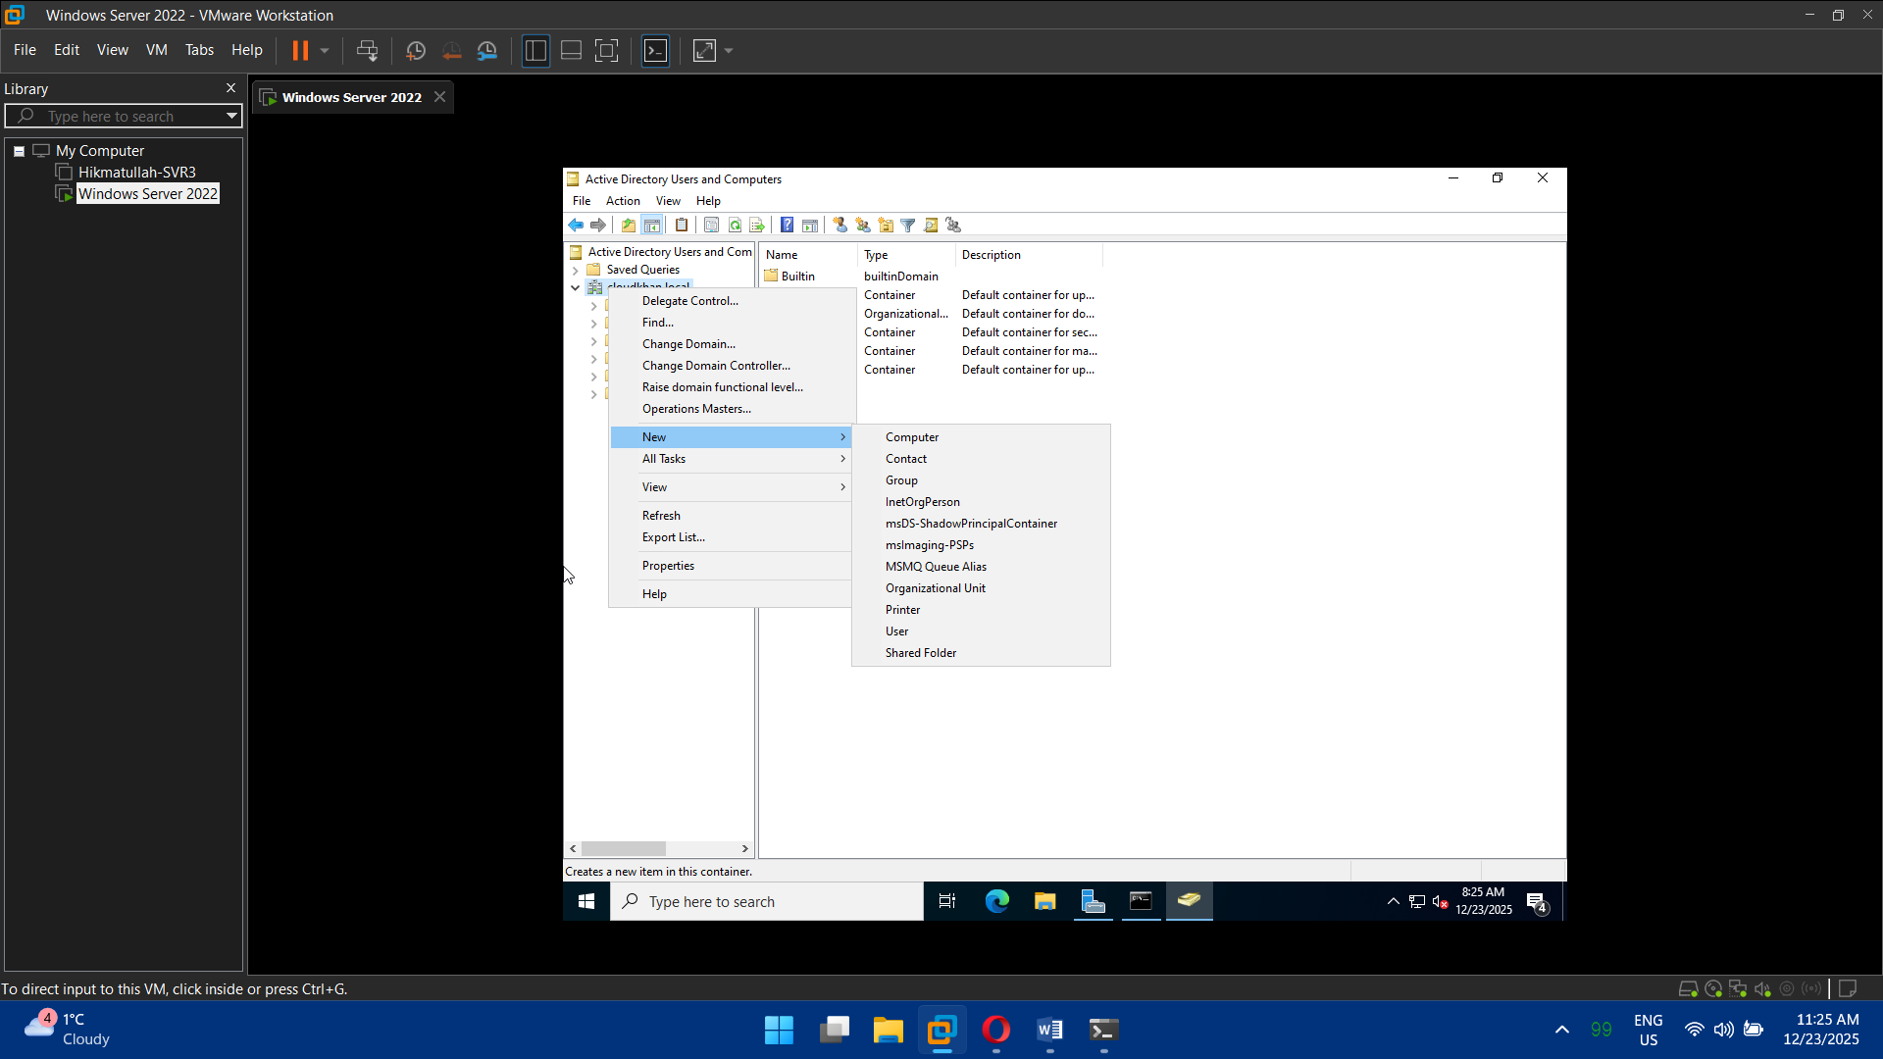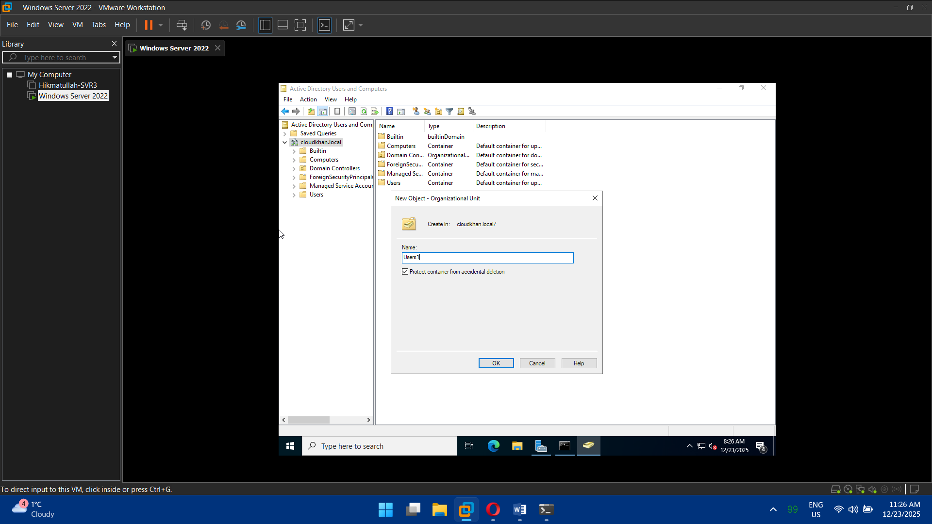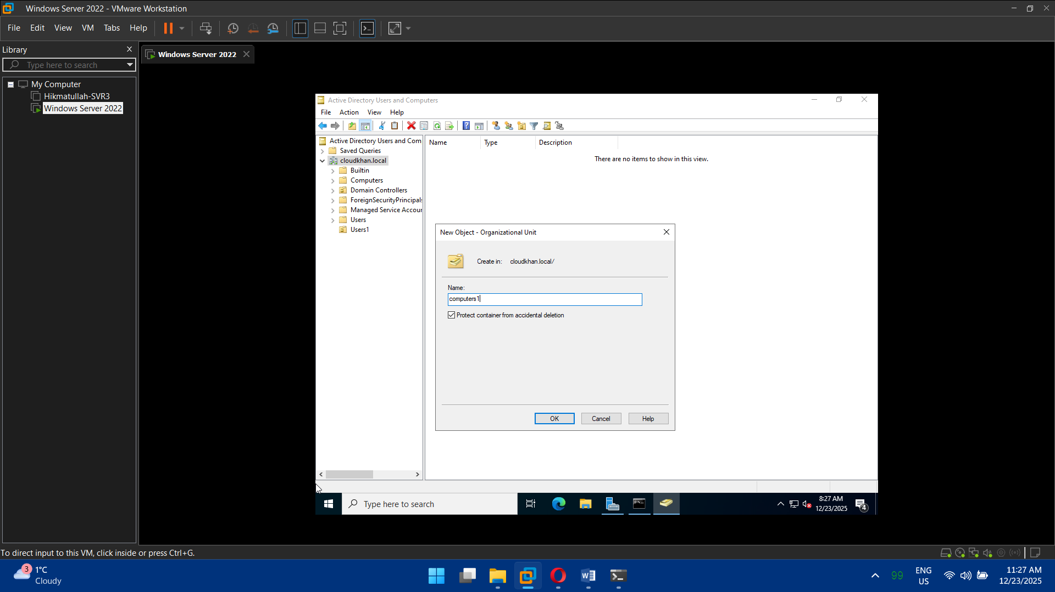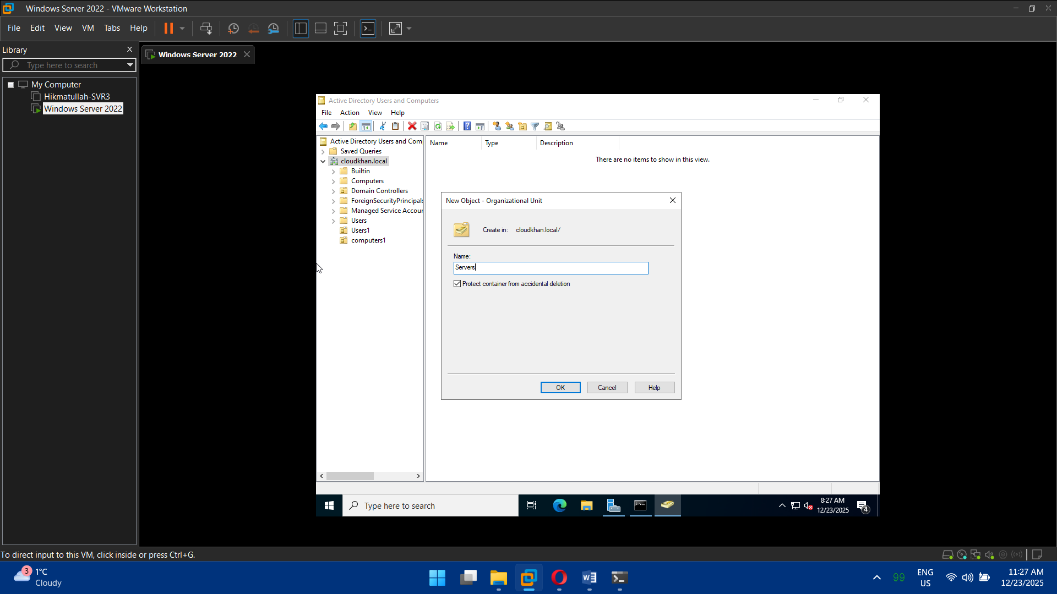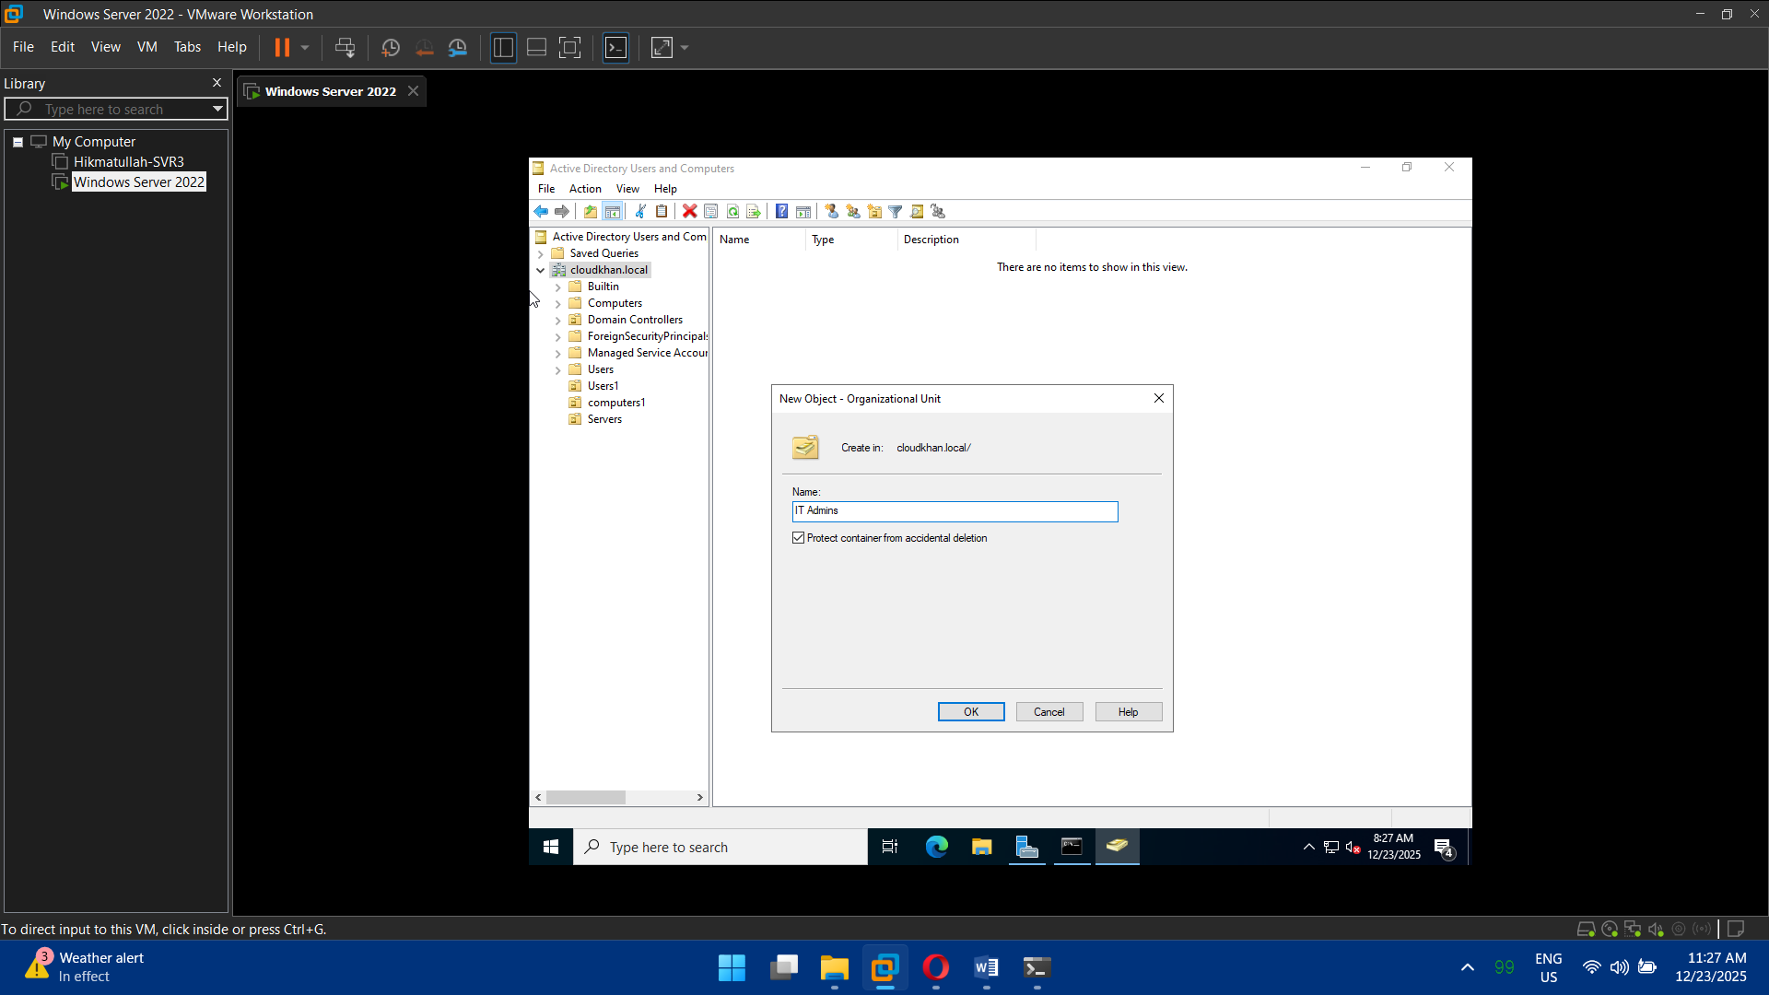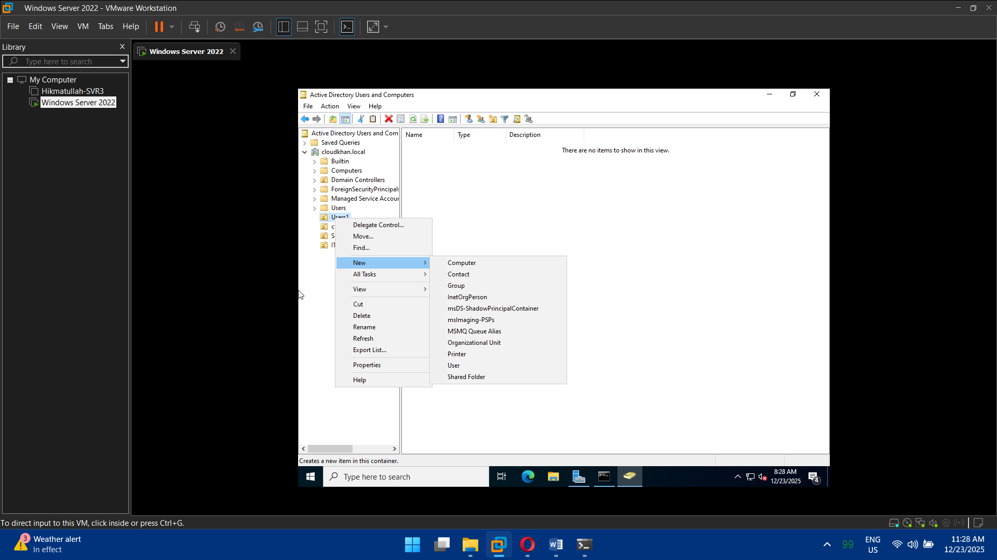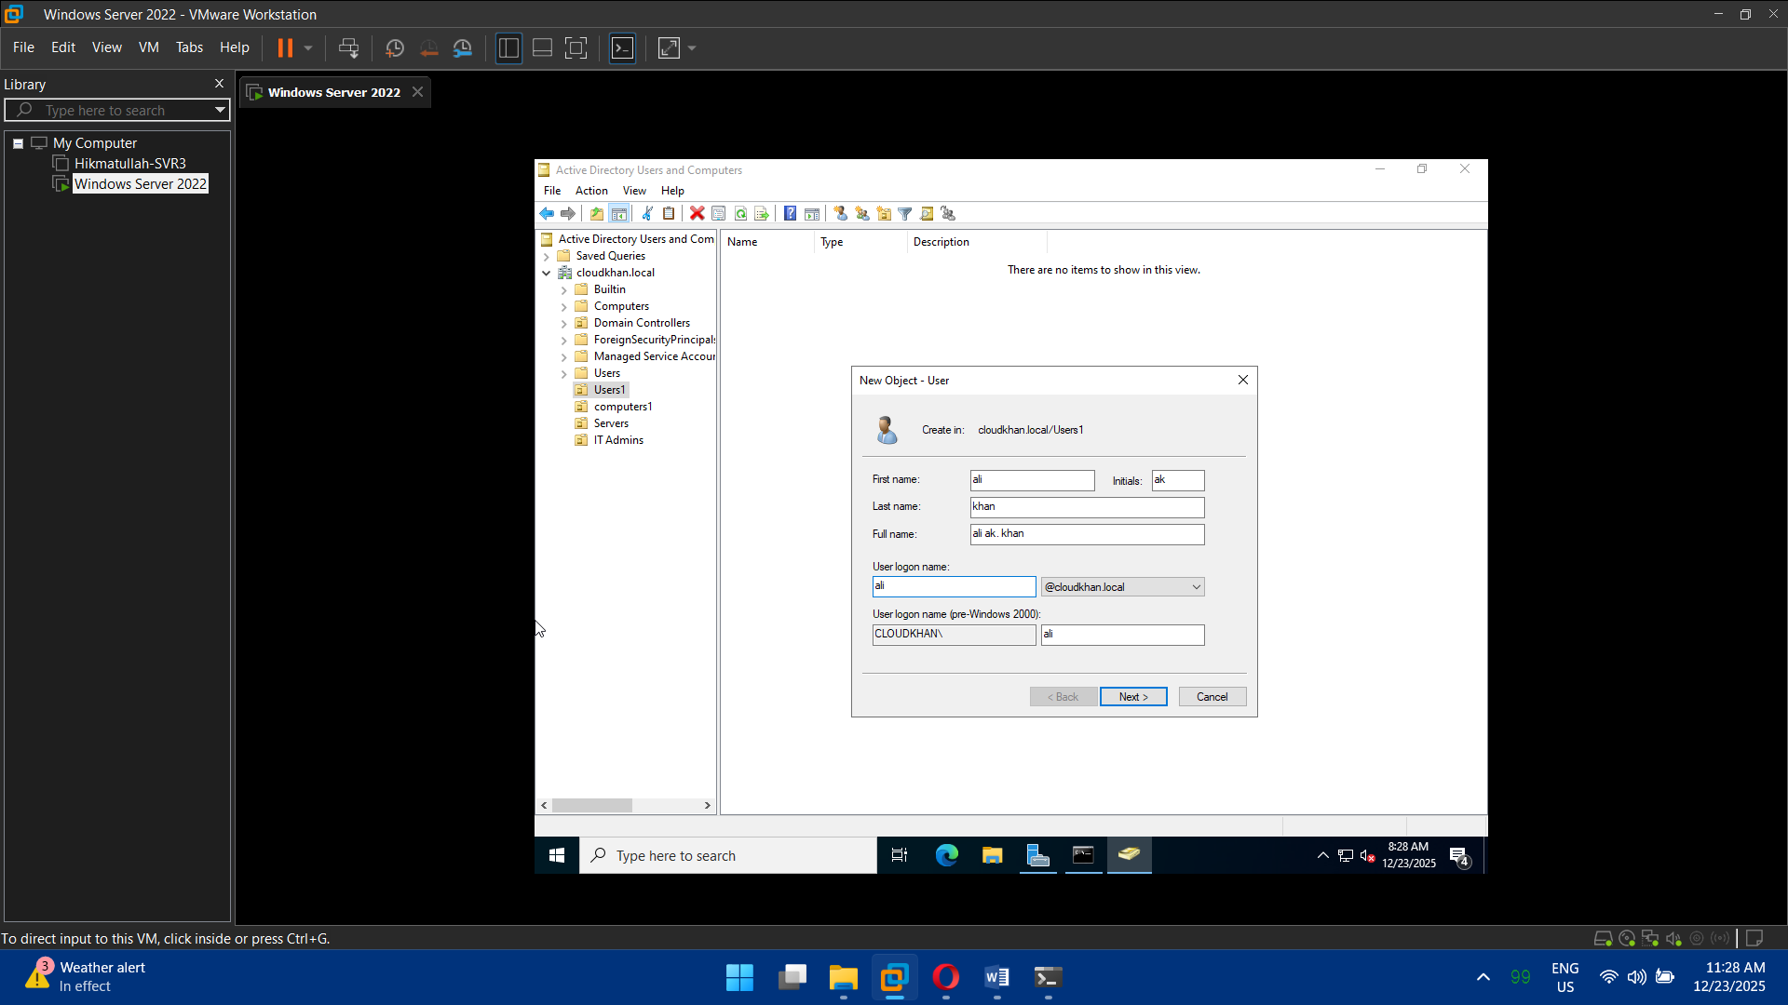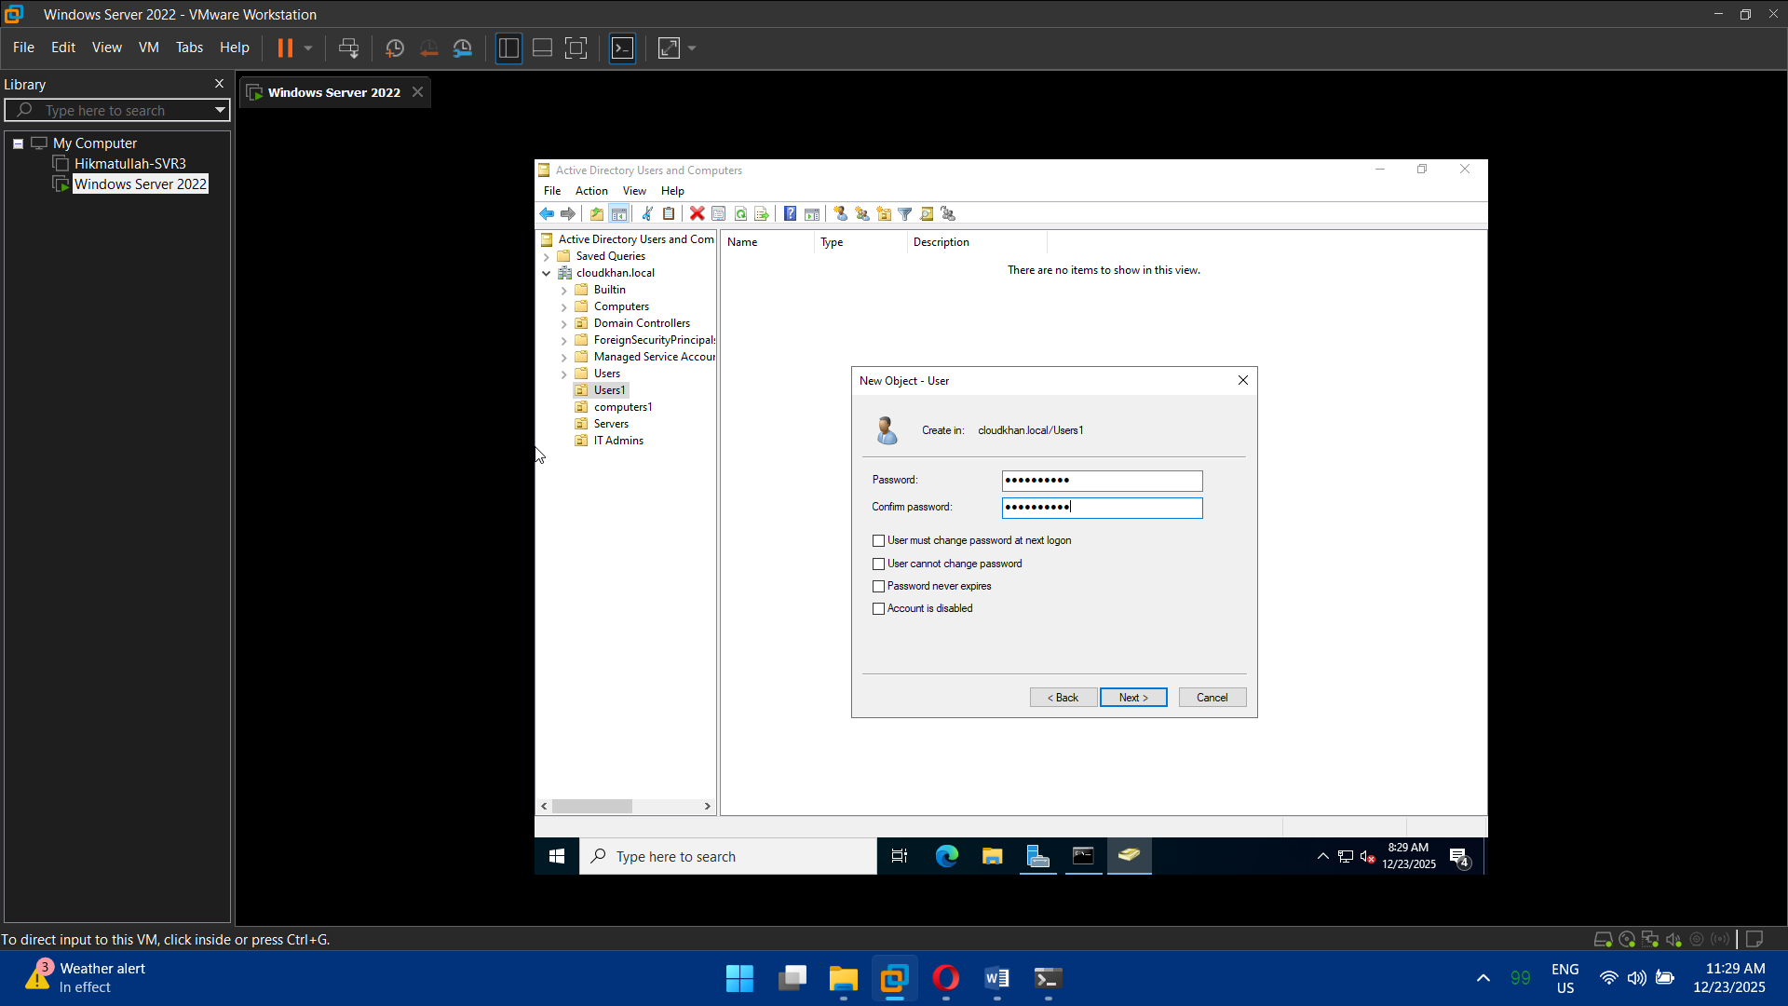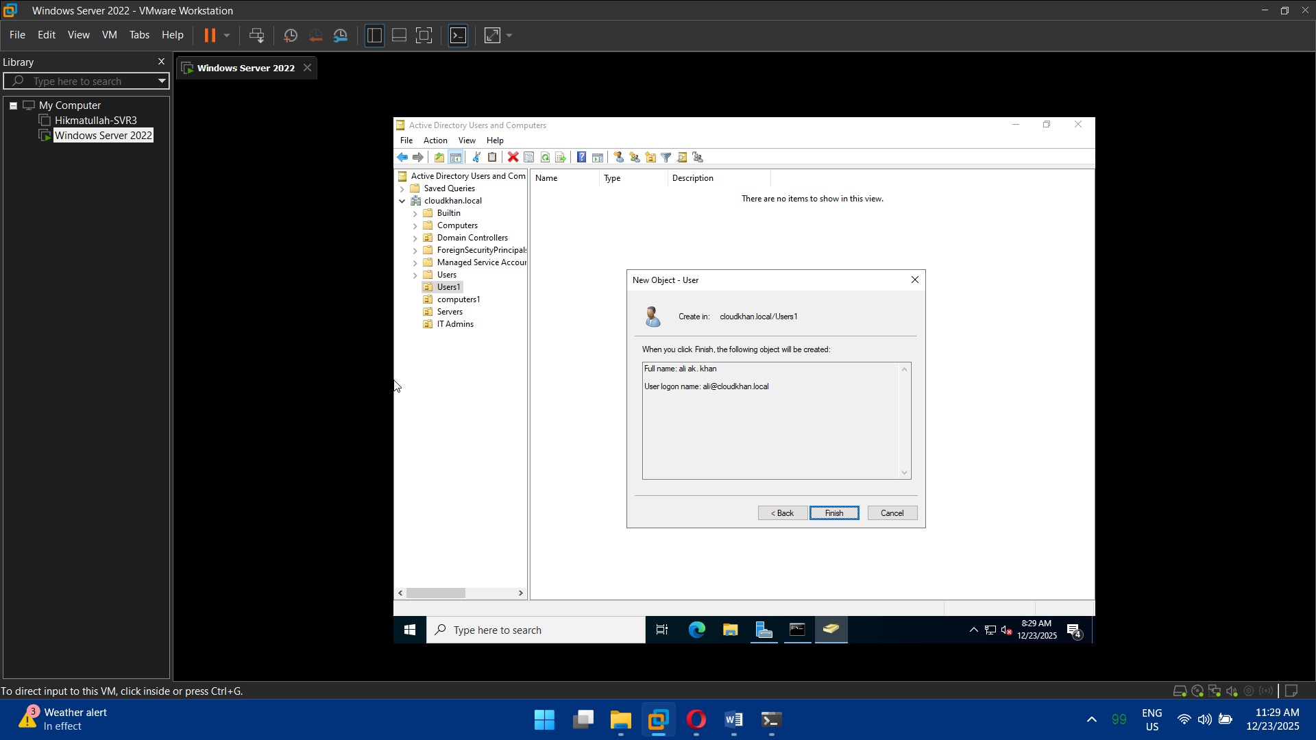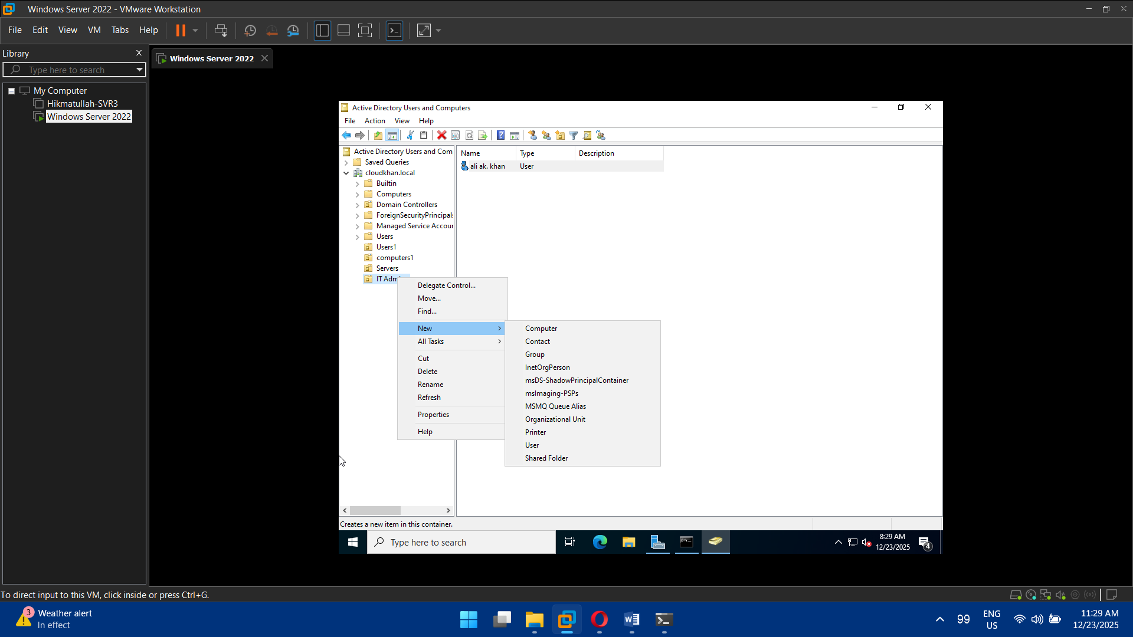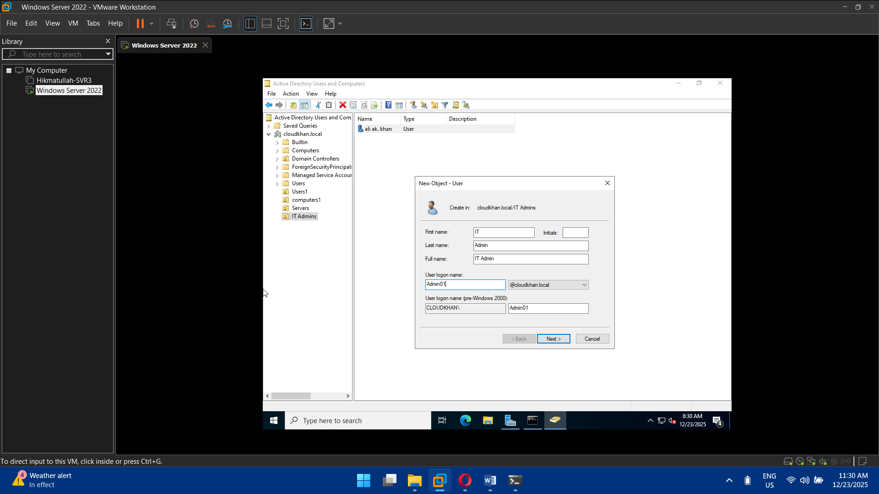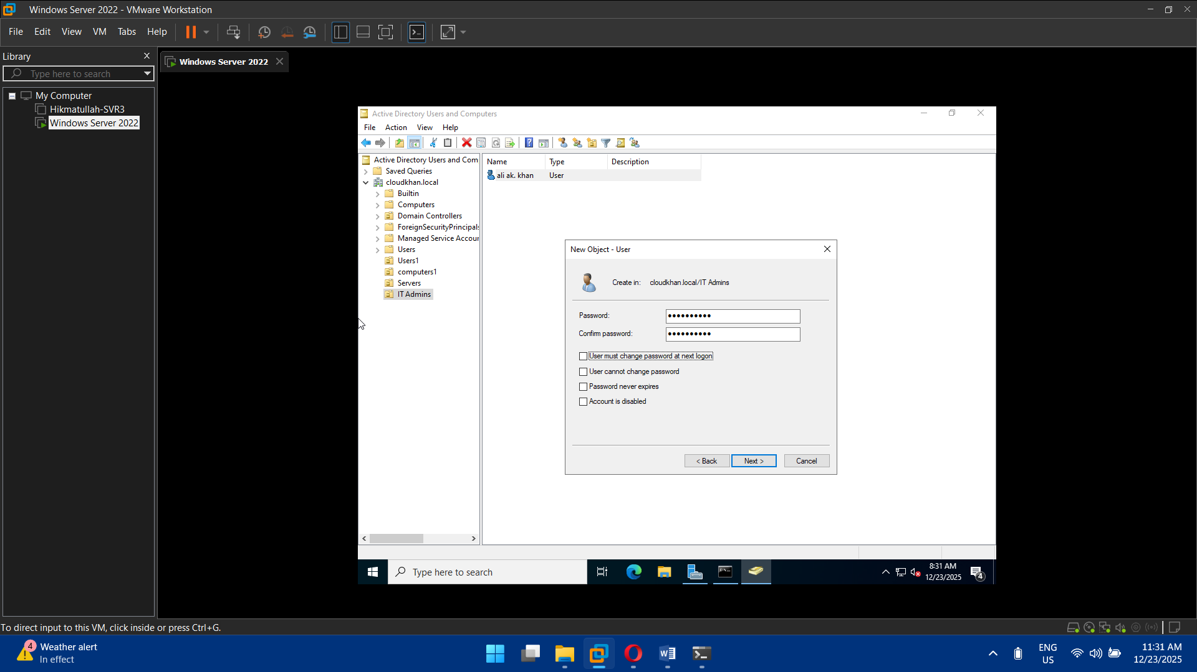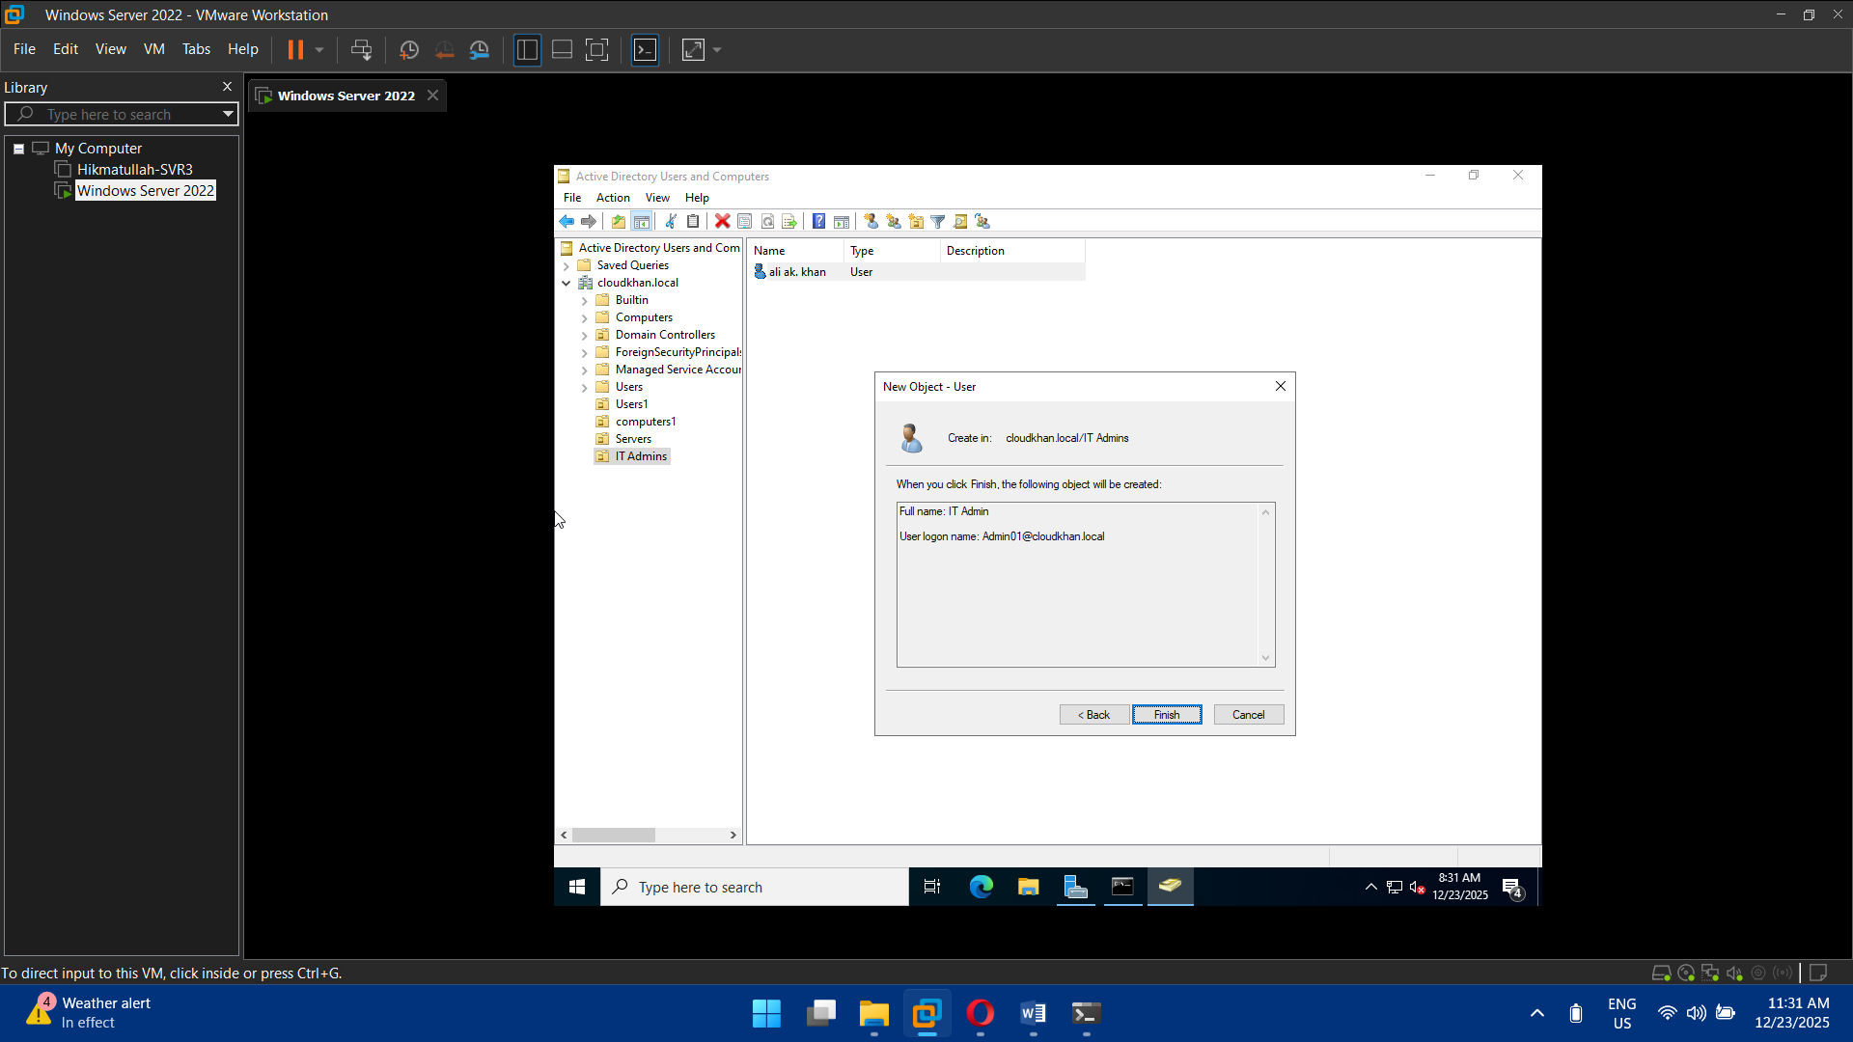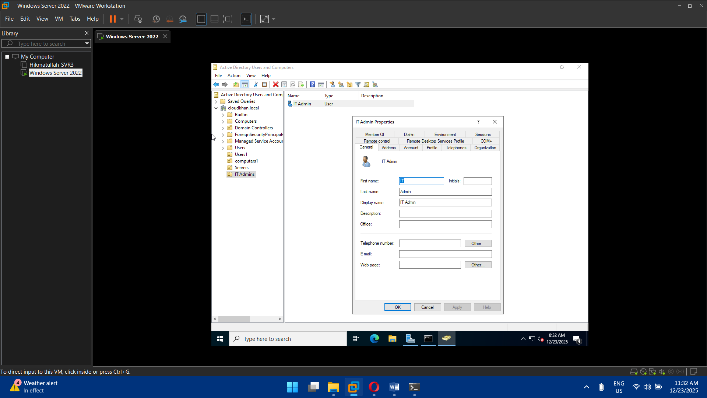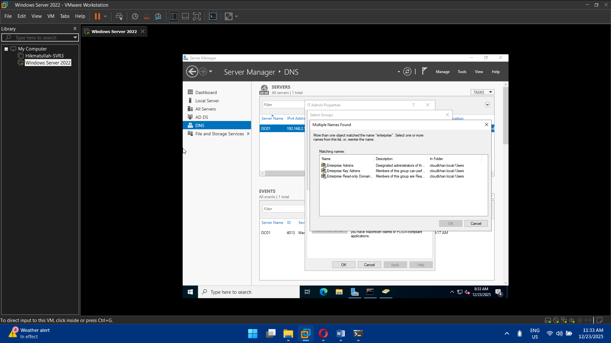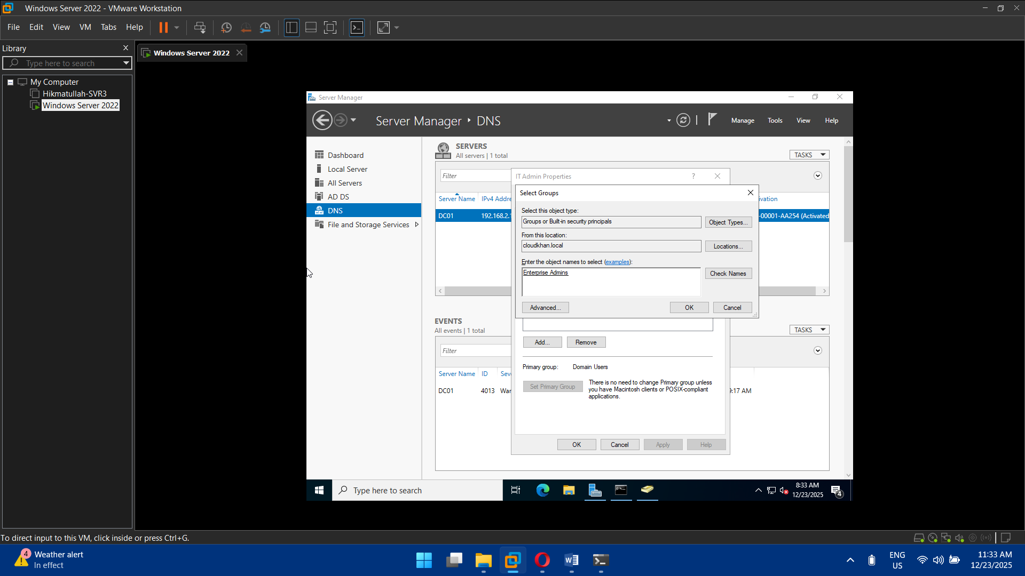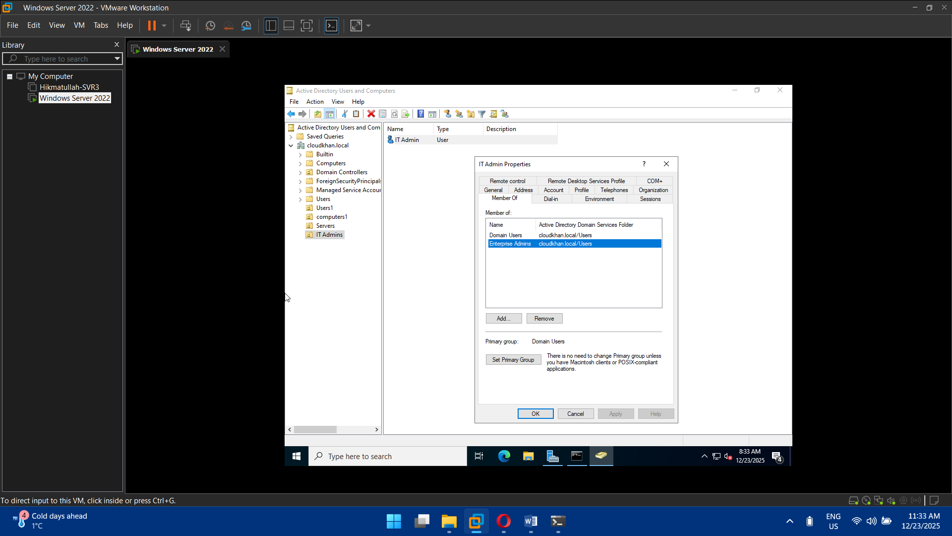

## Task 5: Group Policy Objects (GPOs)

* Create GPOs for:
  + Password policy
  + Account lockout policy
  + Desktop restrictions
  + Windows Update settings
* Link GPOs to appropriate OUs
* Test policy application using gpresult

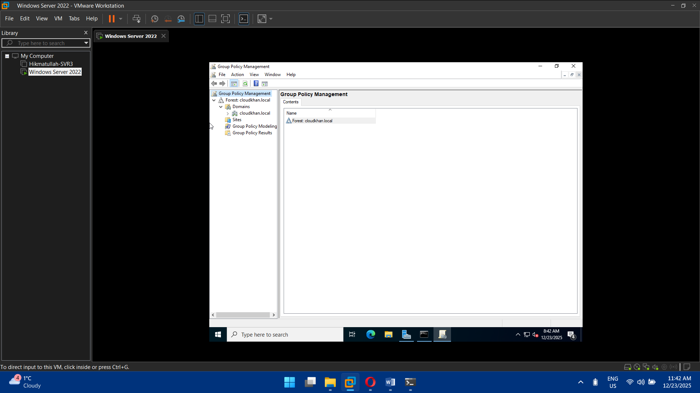

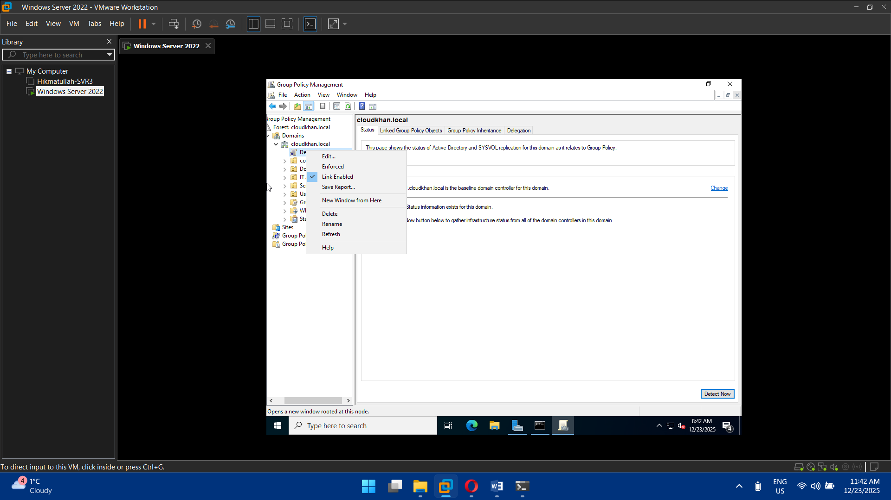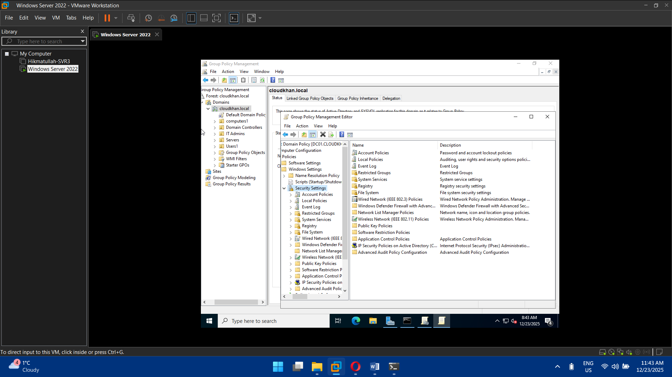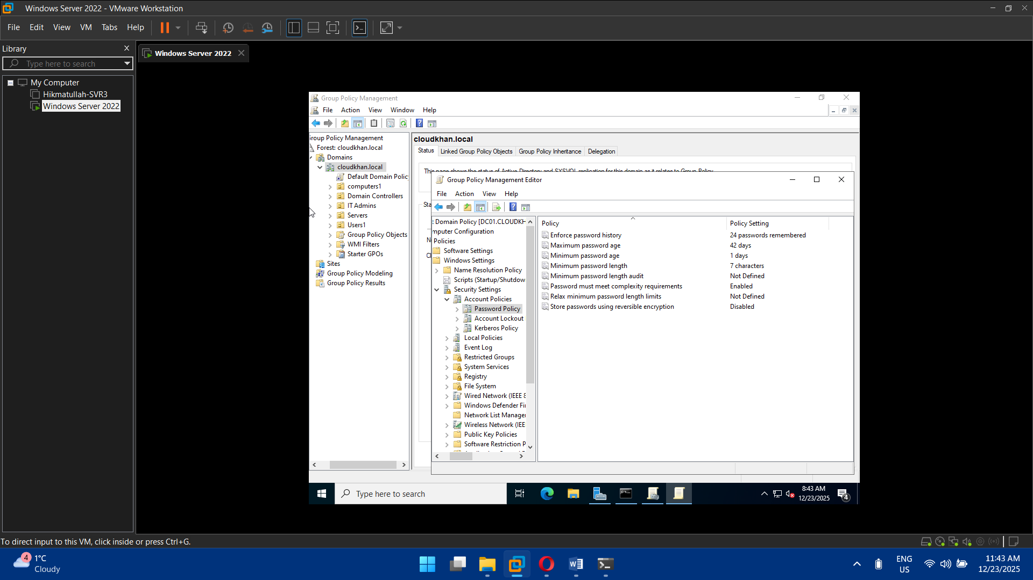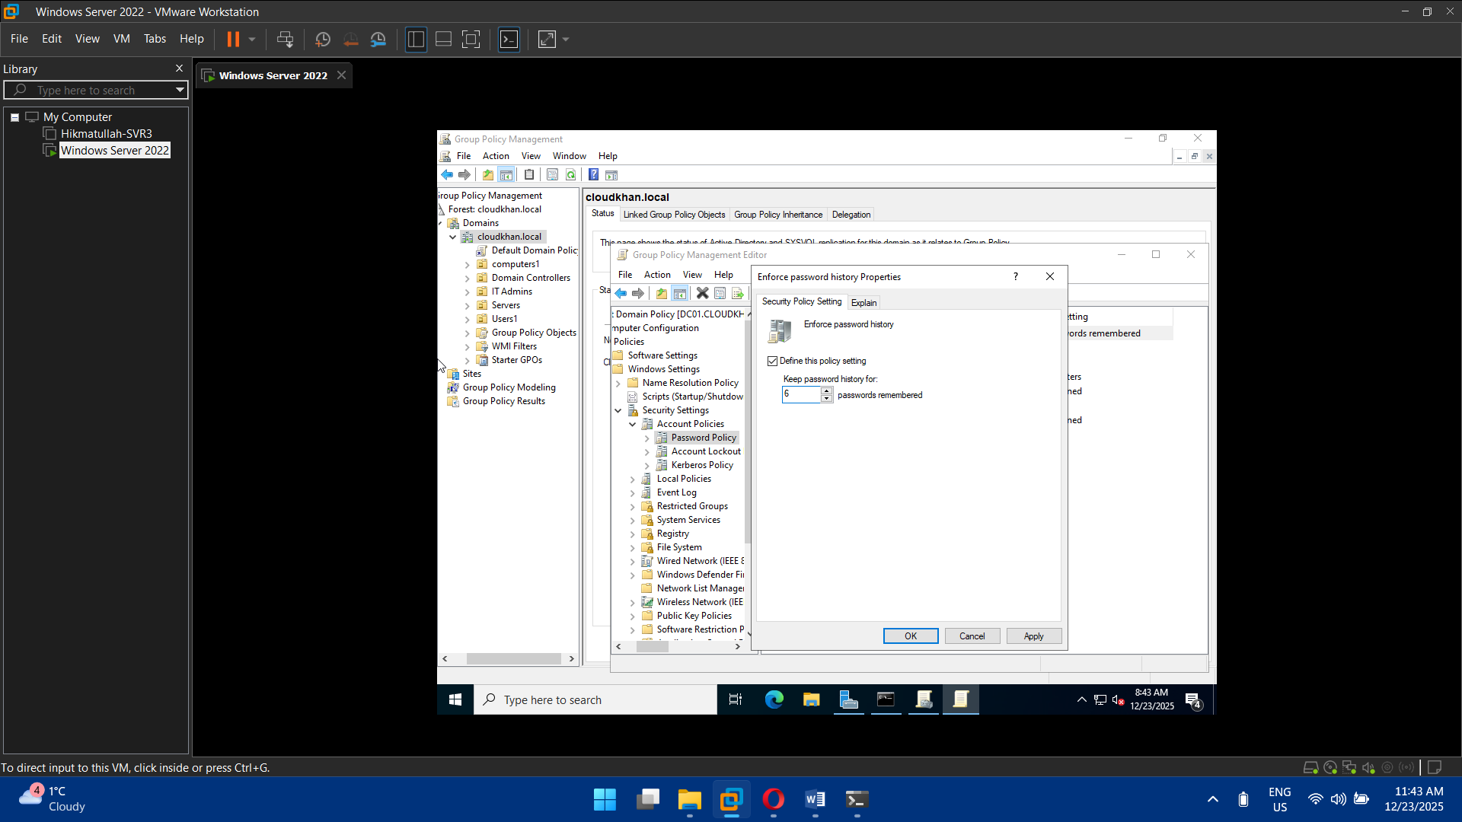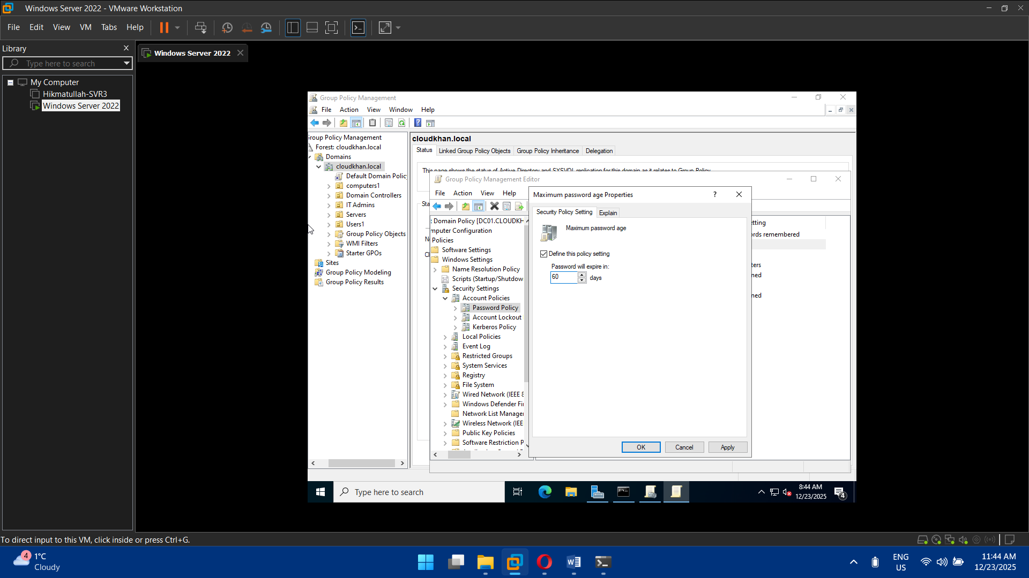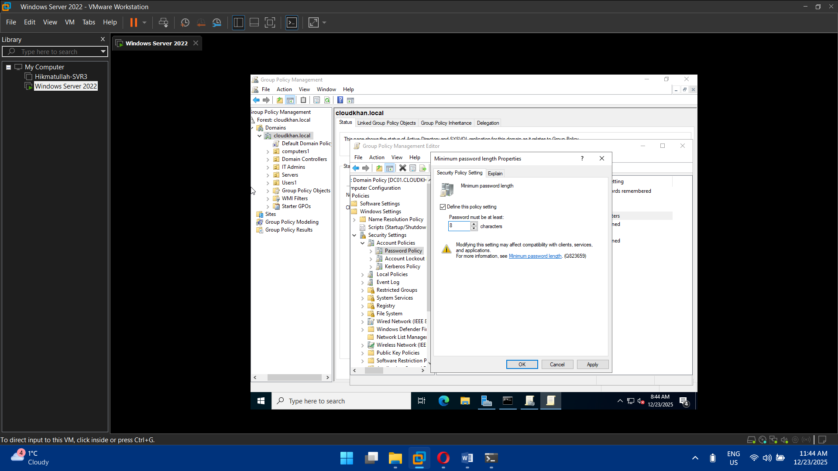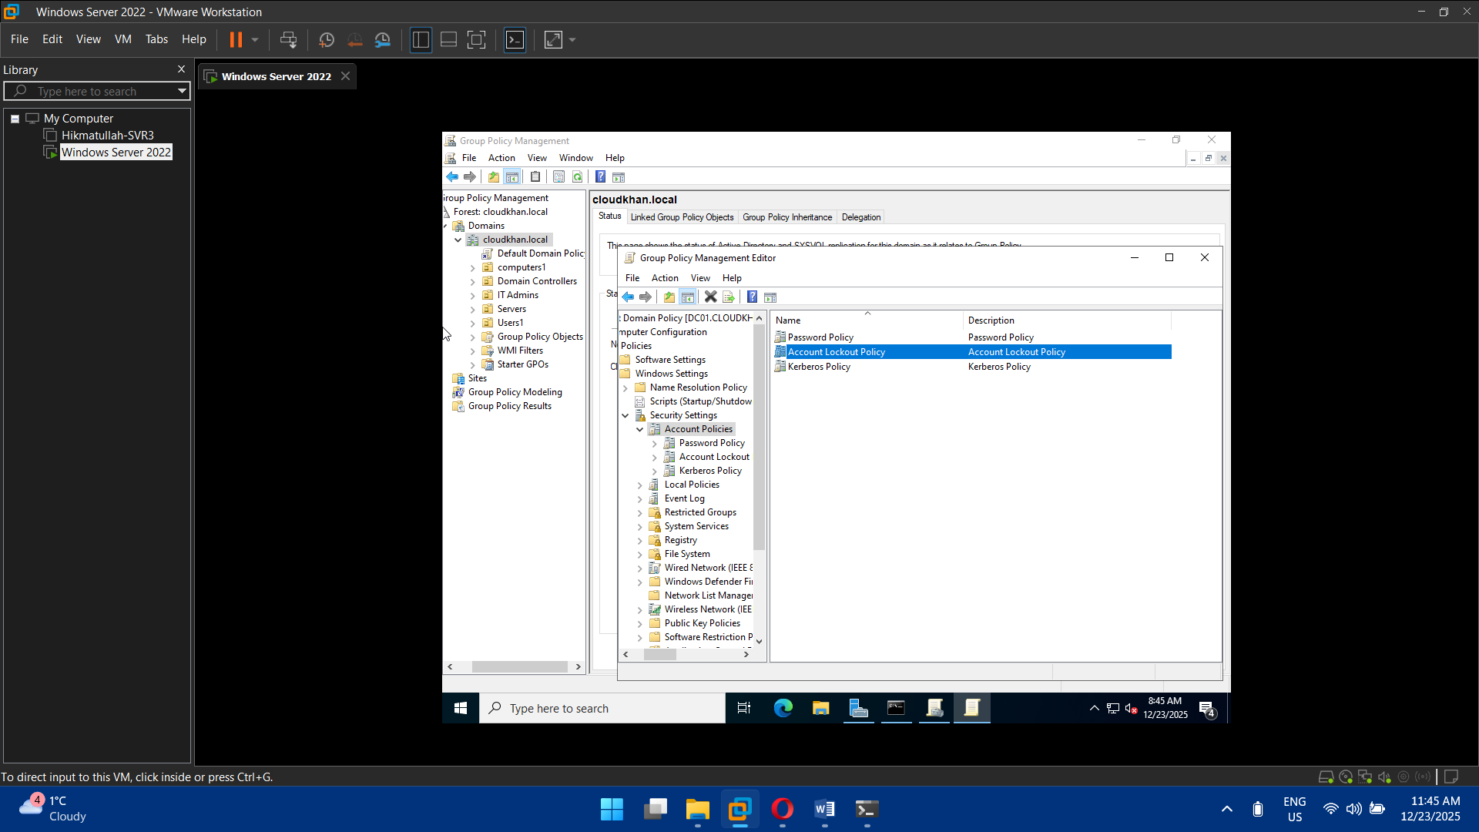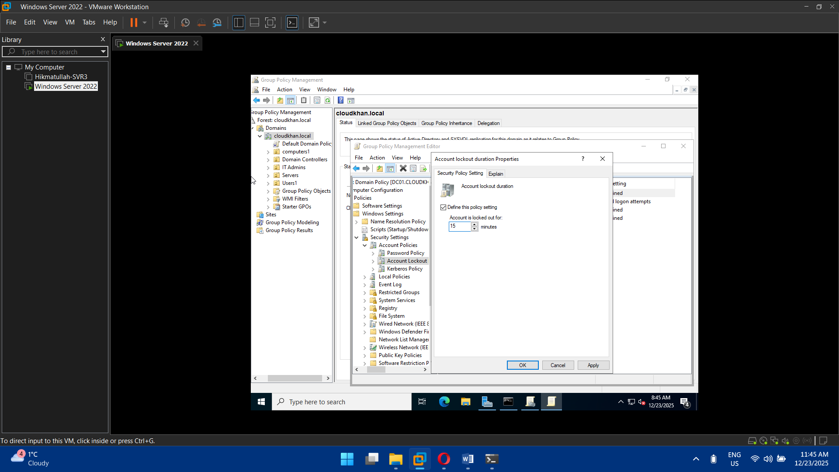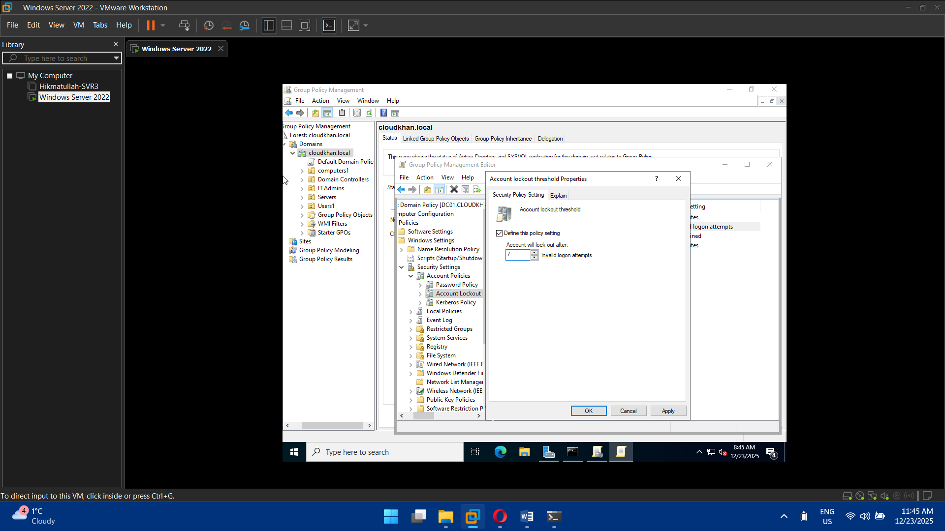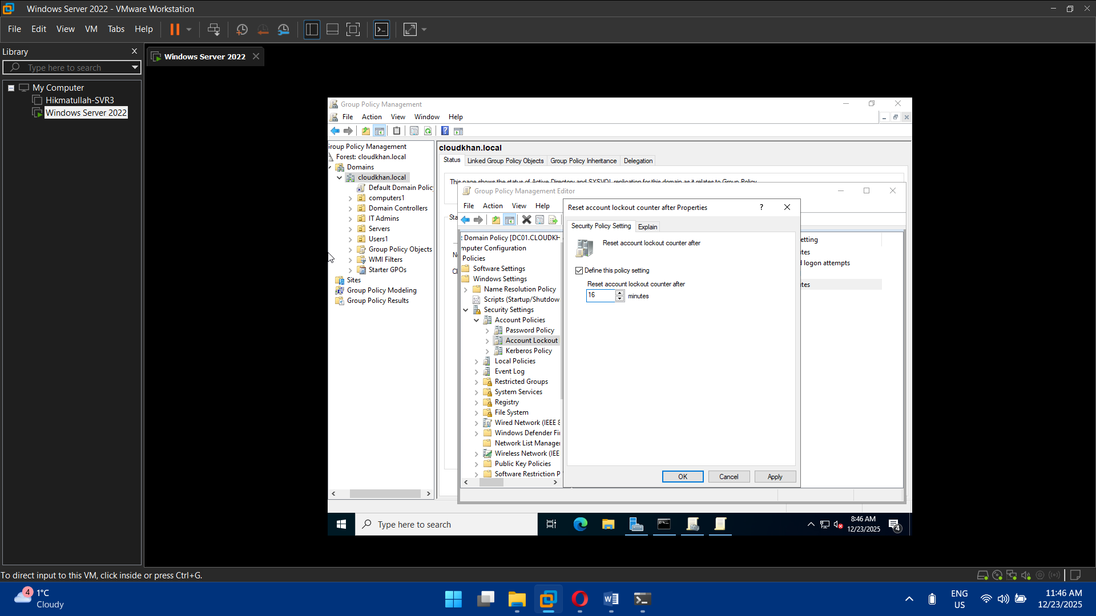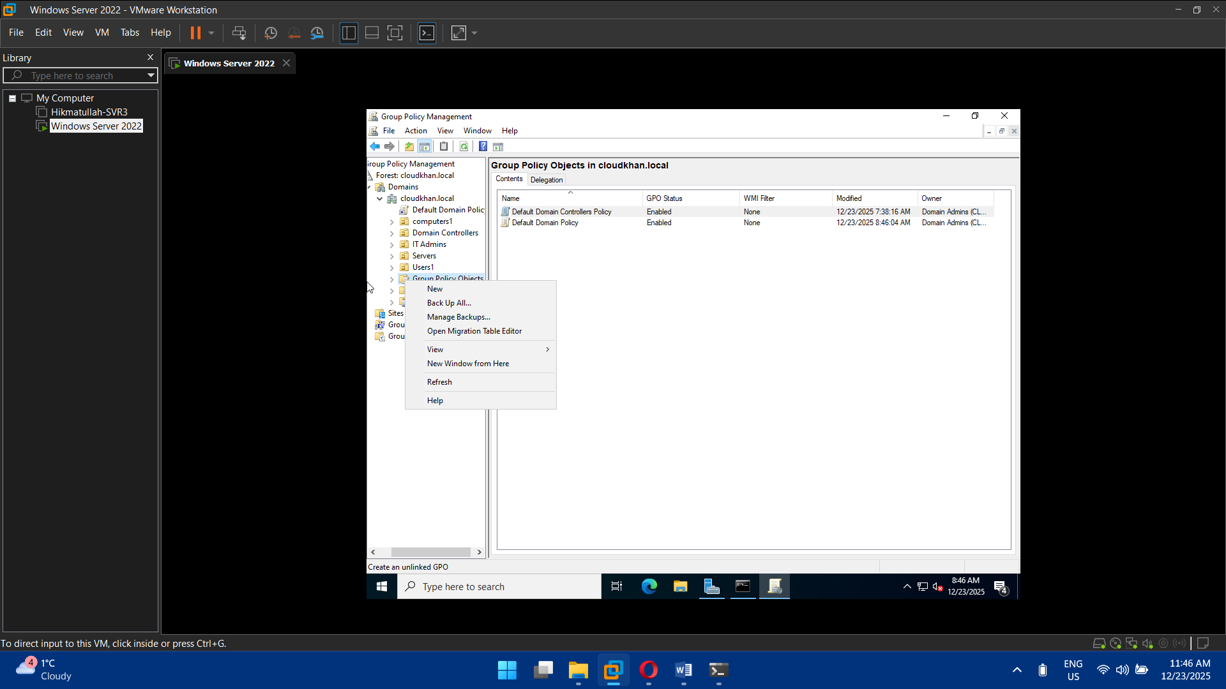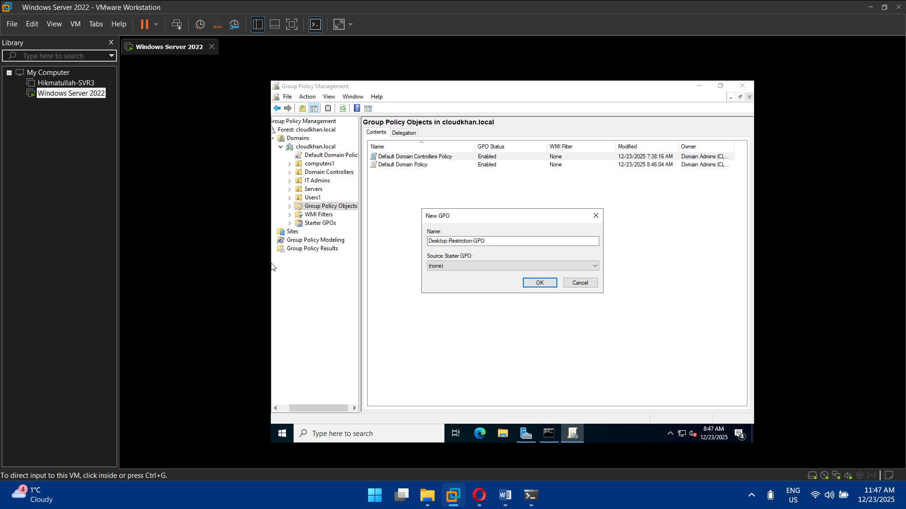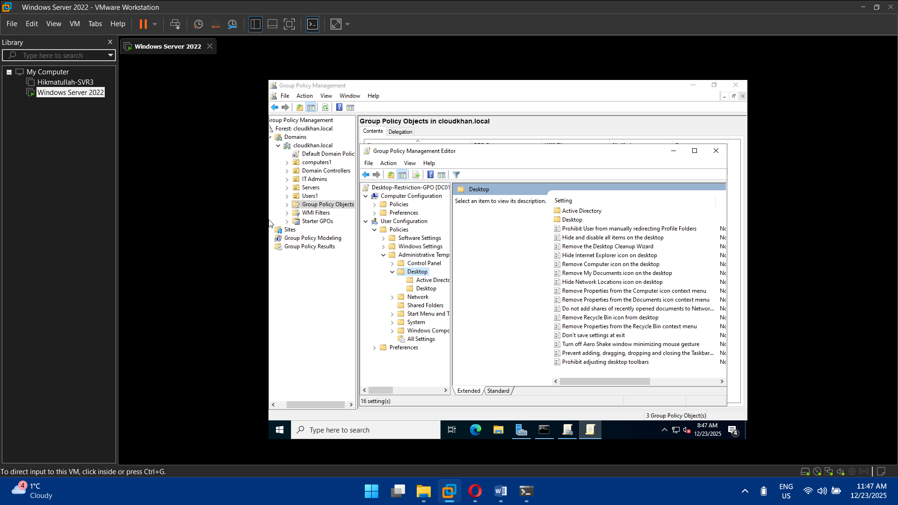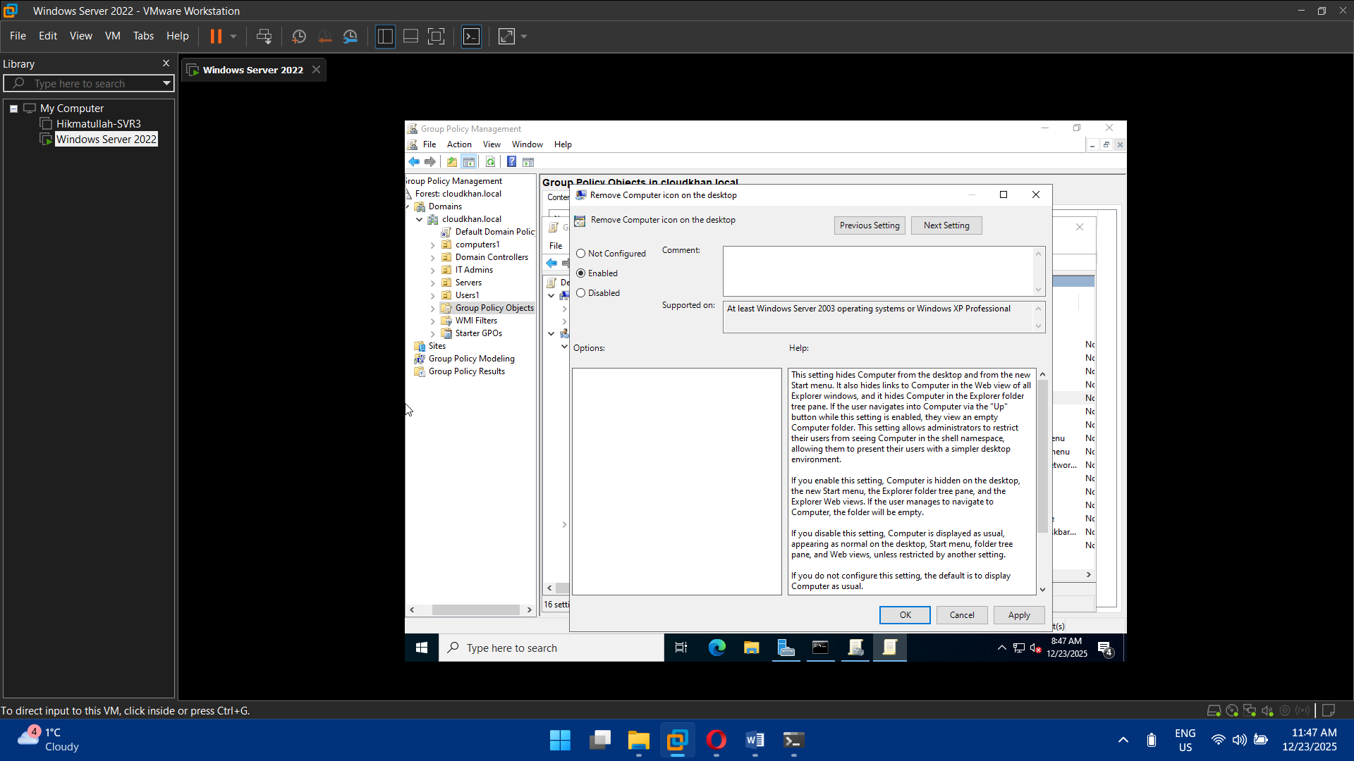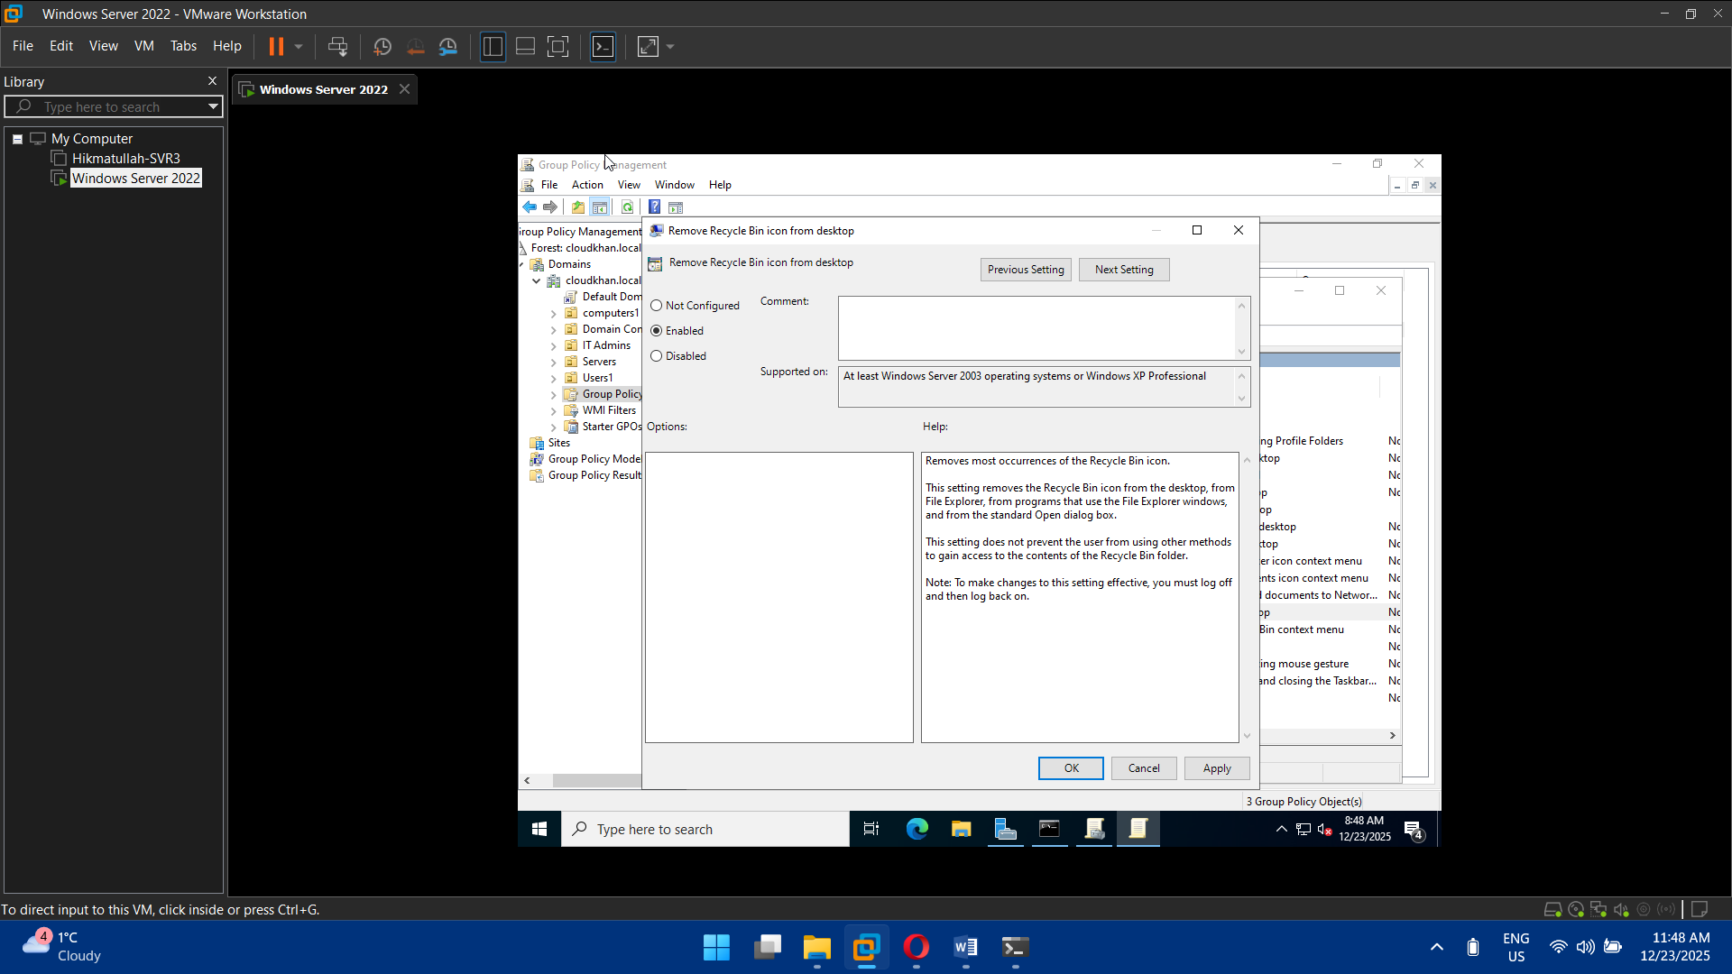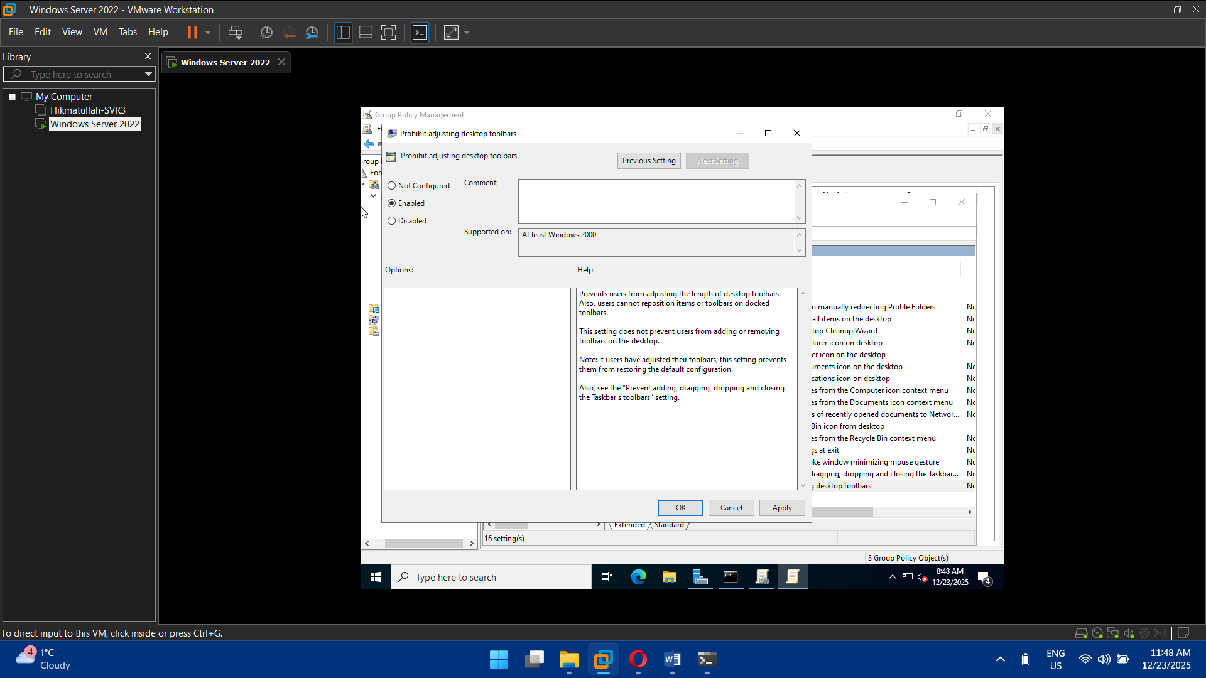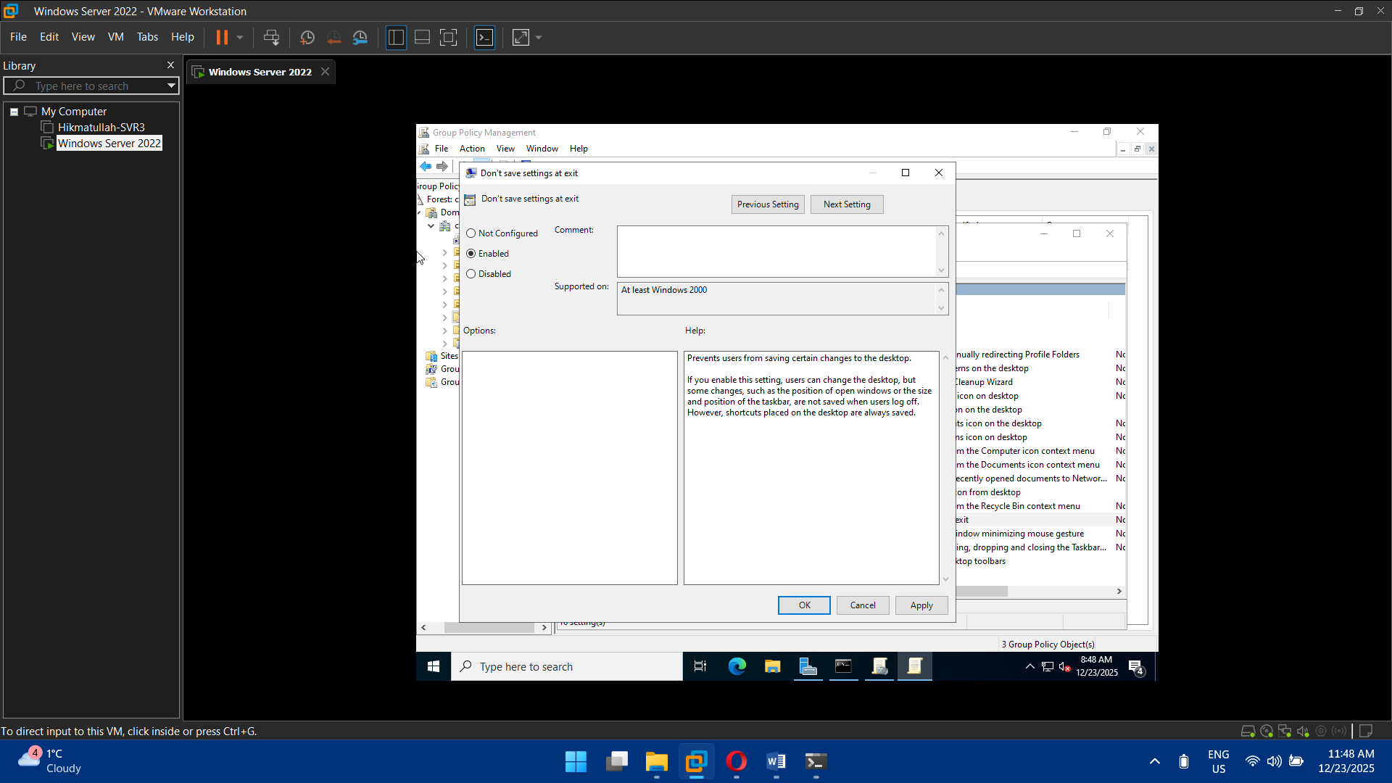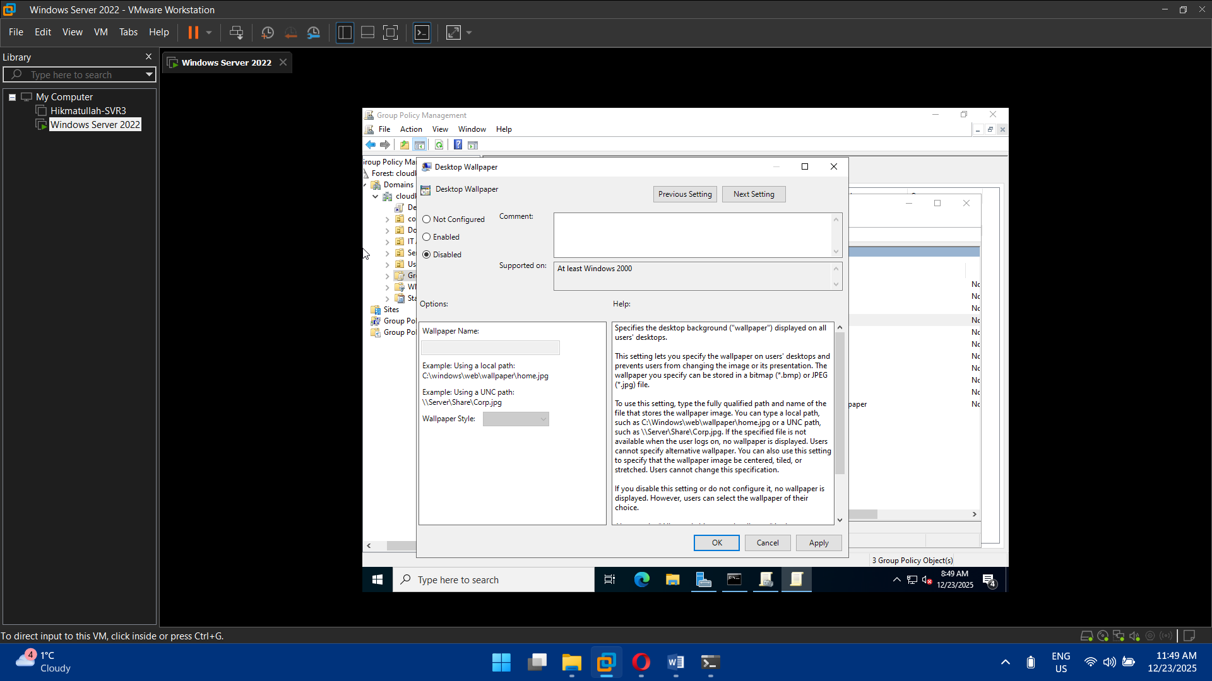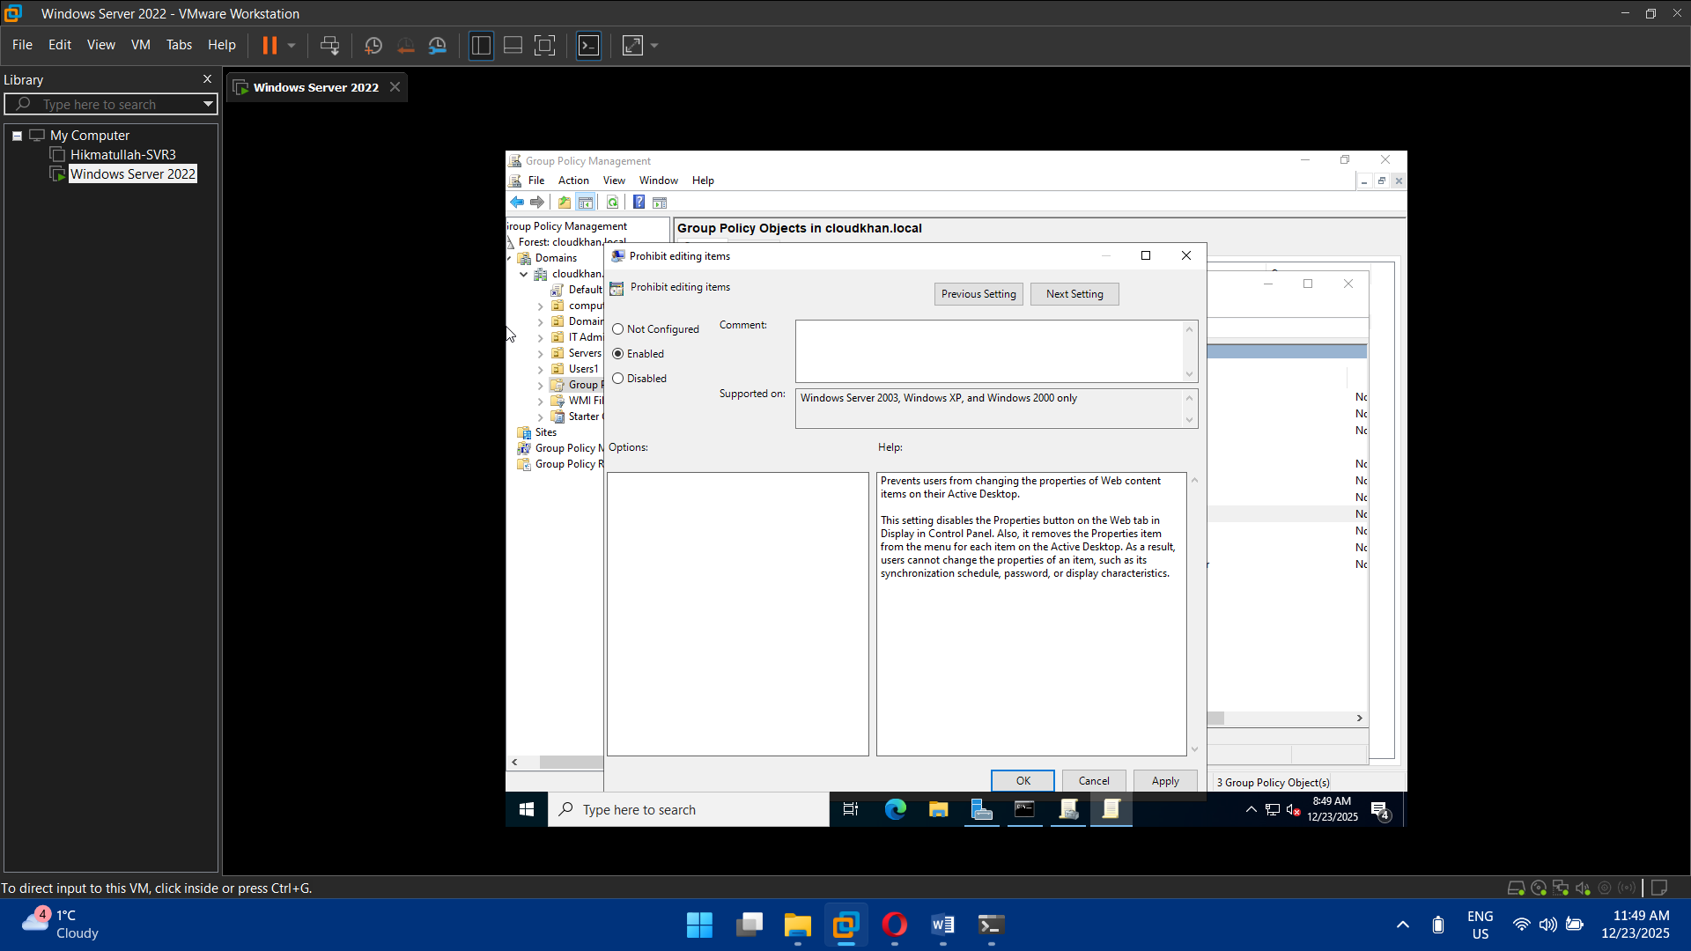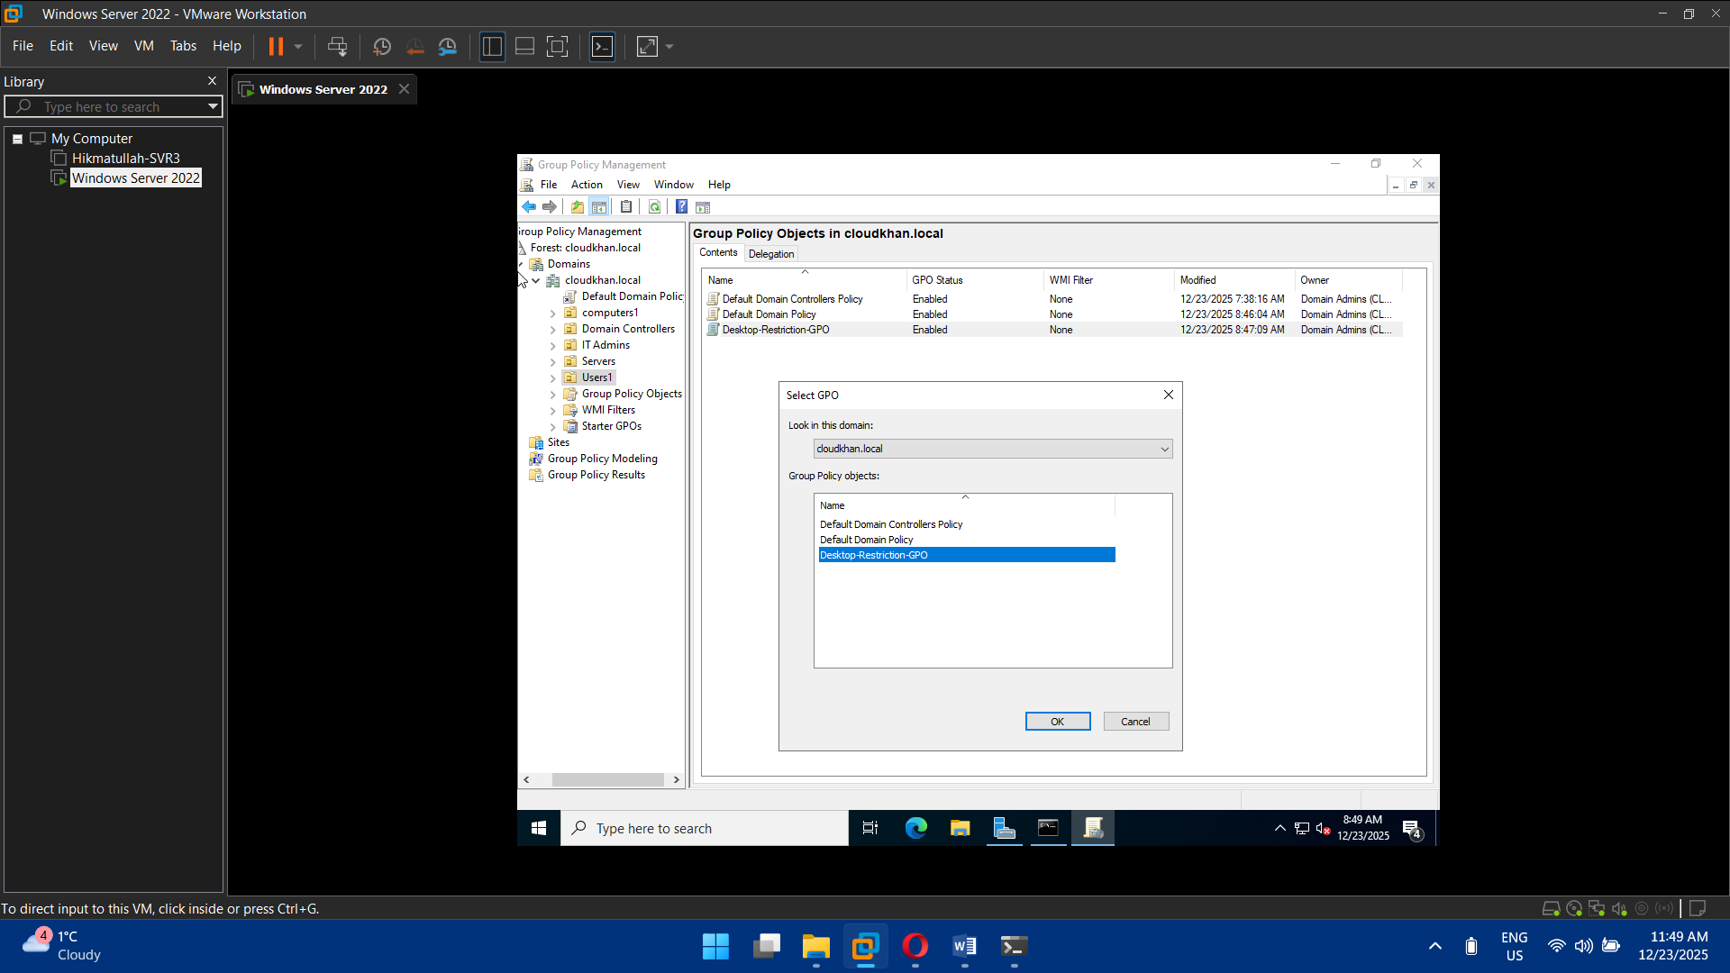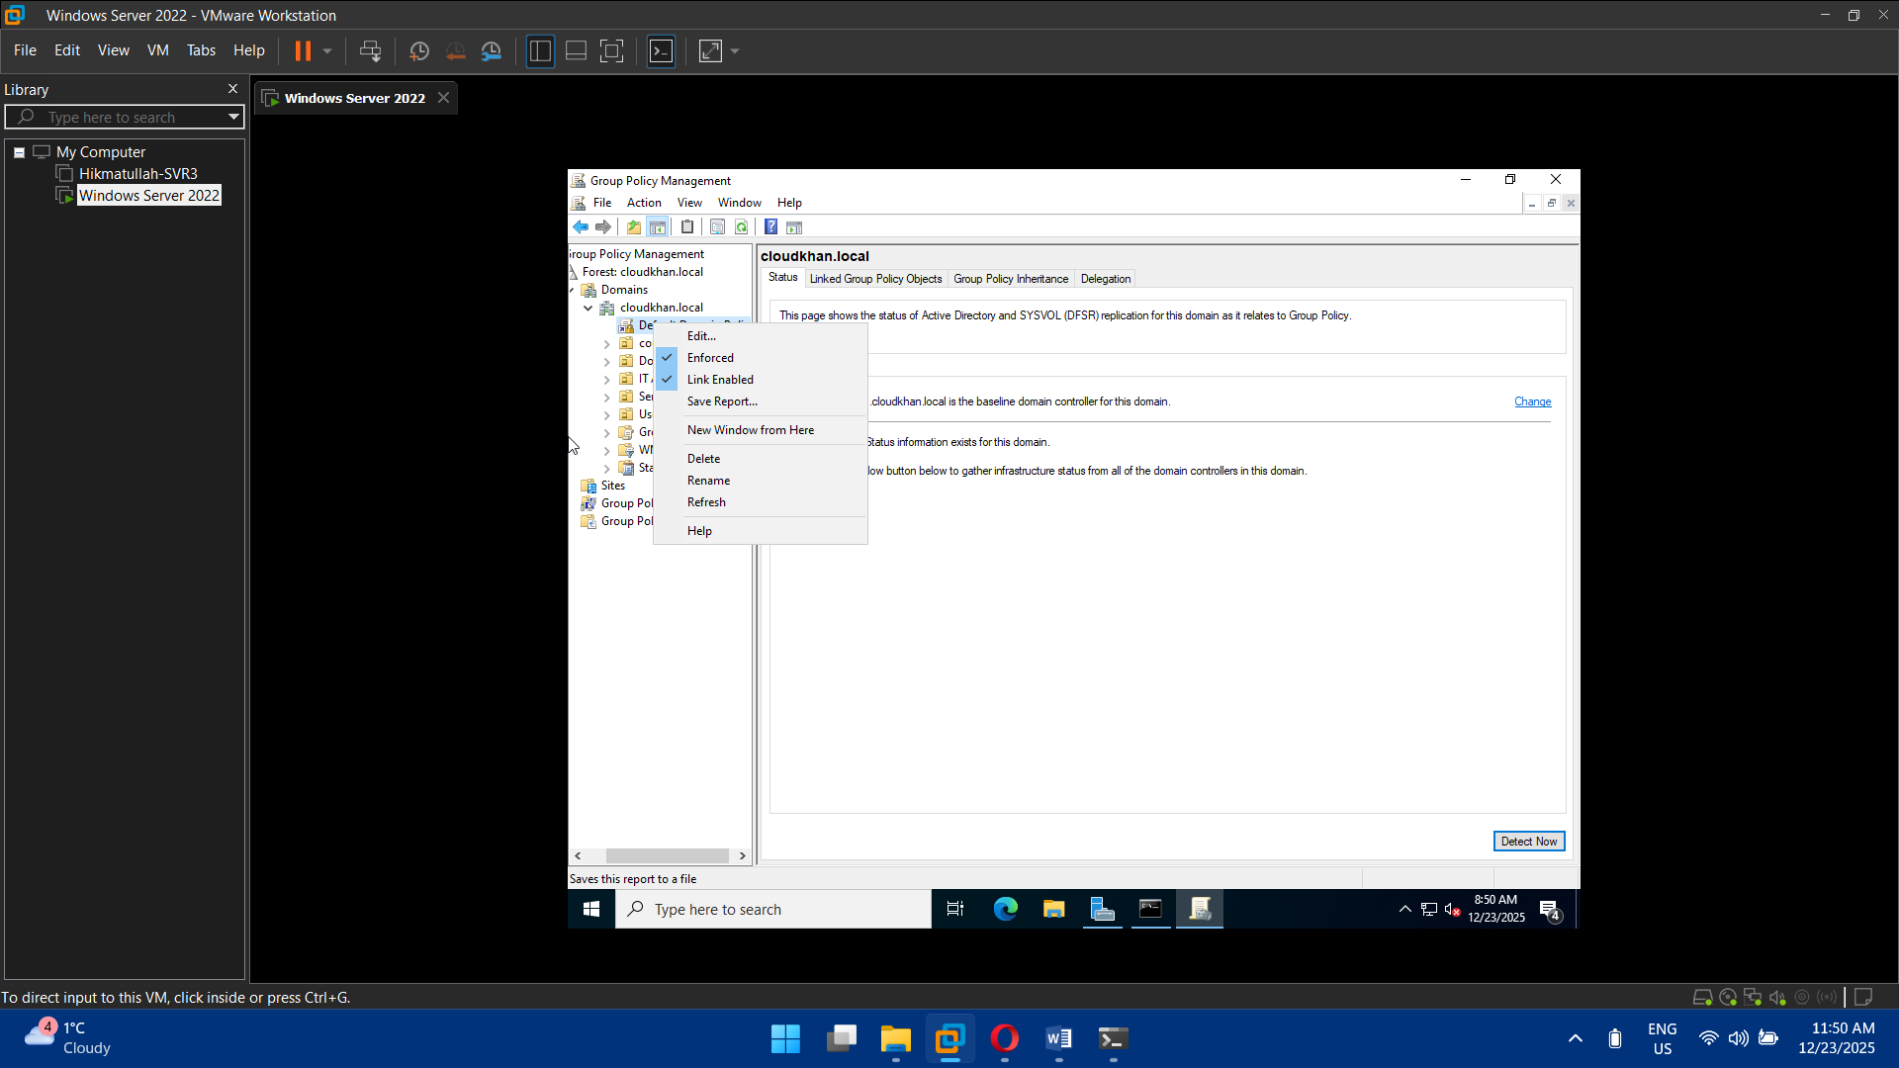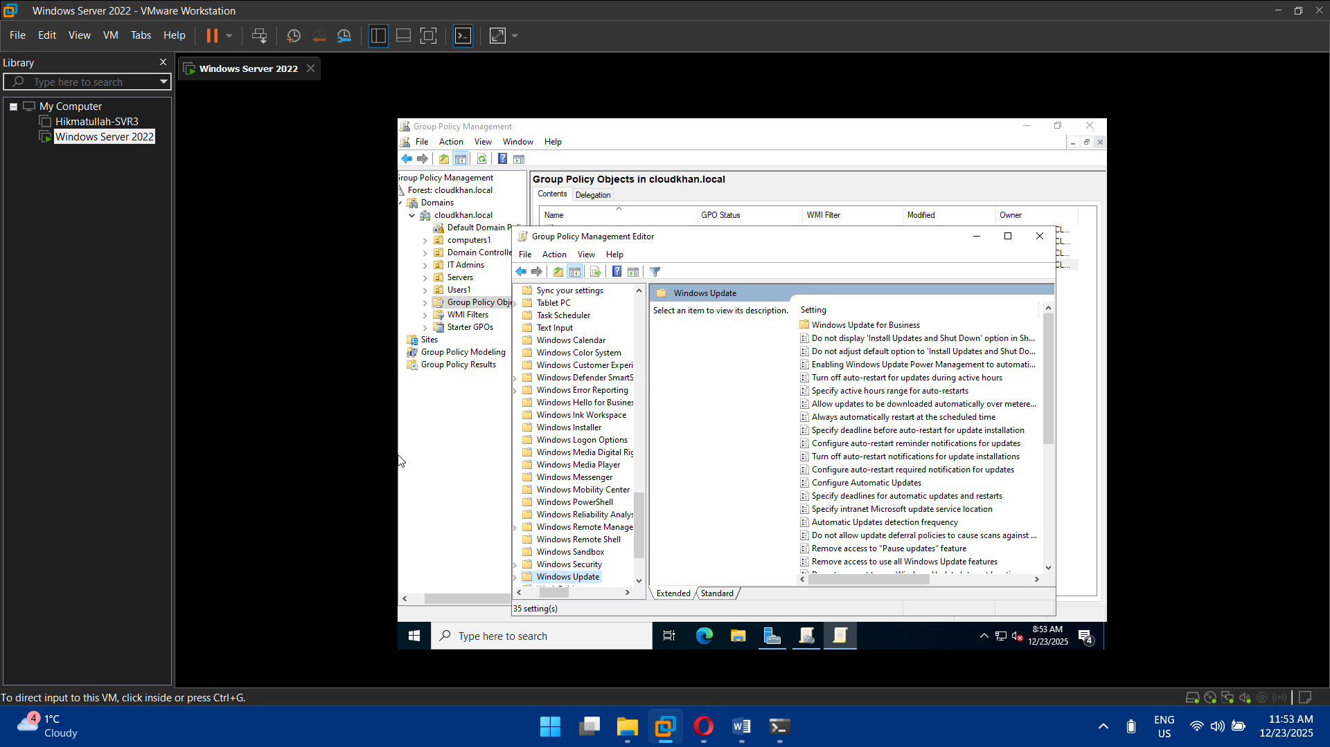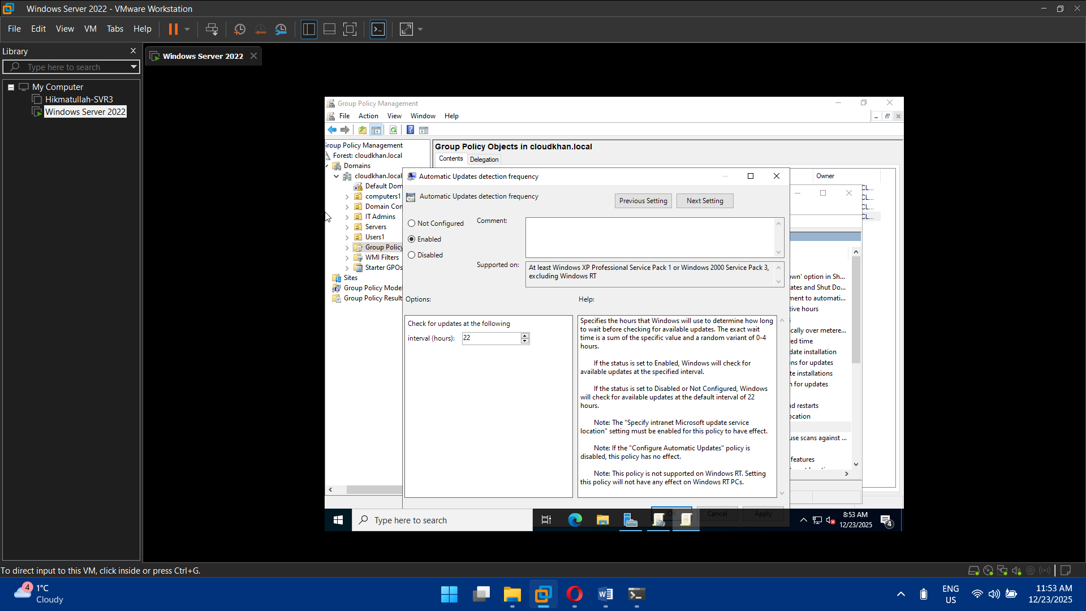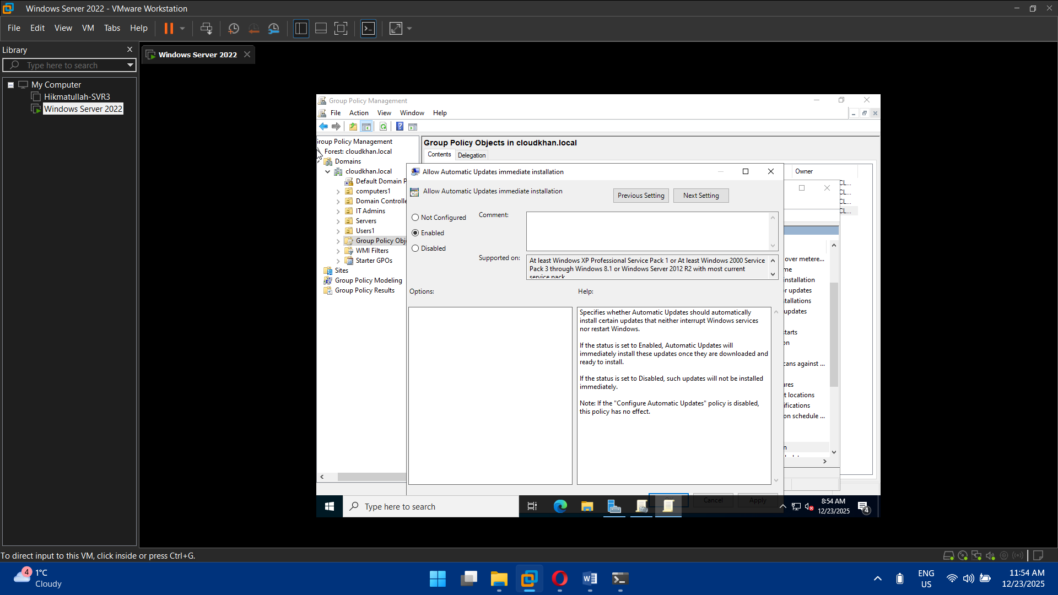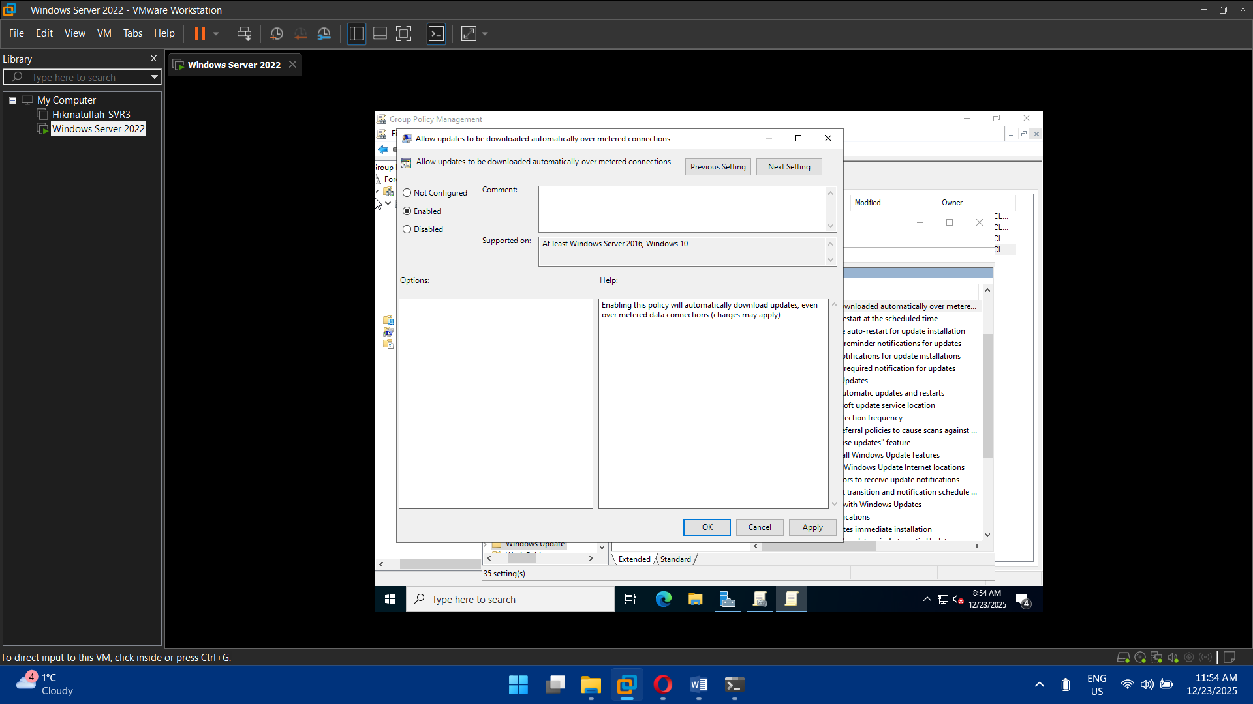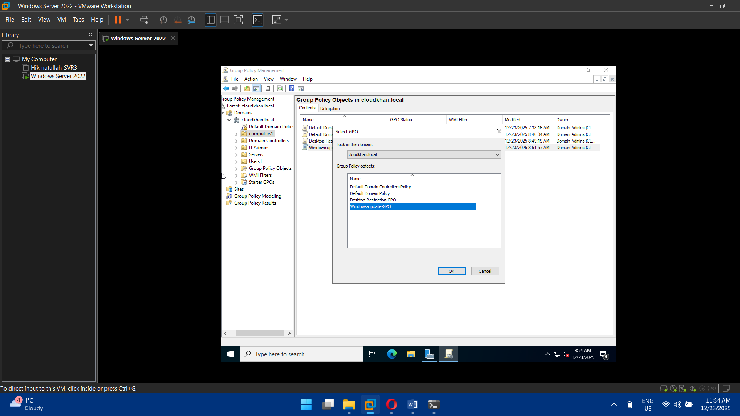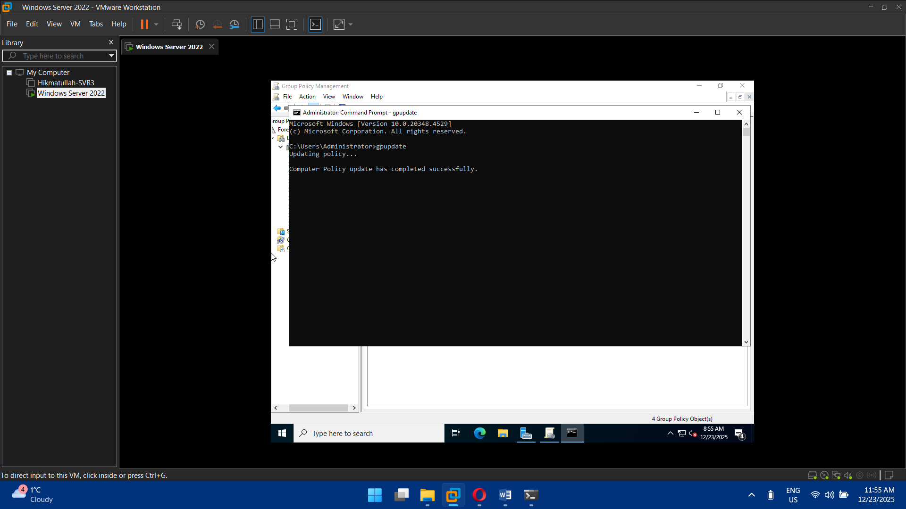

## Task 6: Azure Entra ID (Azure AD) Preparation

* Create Azure tenant
* Verify custom domain (optional)
* Assign Azure AD roles:
  + Global Admin
  + Hybrid Identity Admin

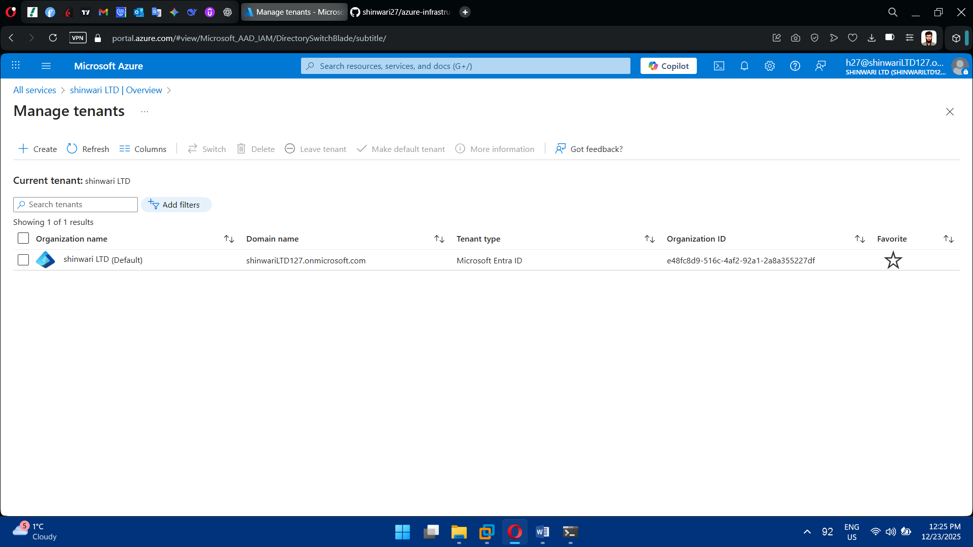

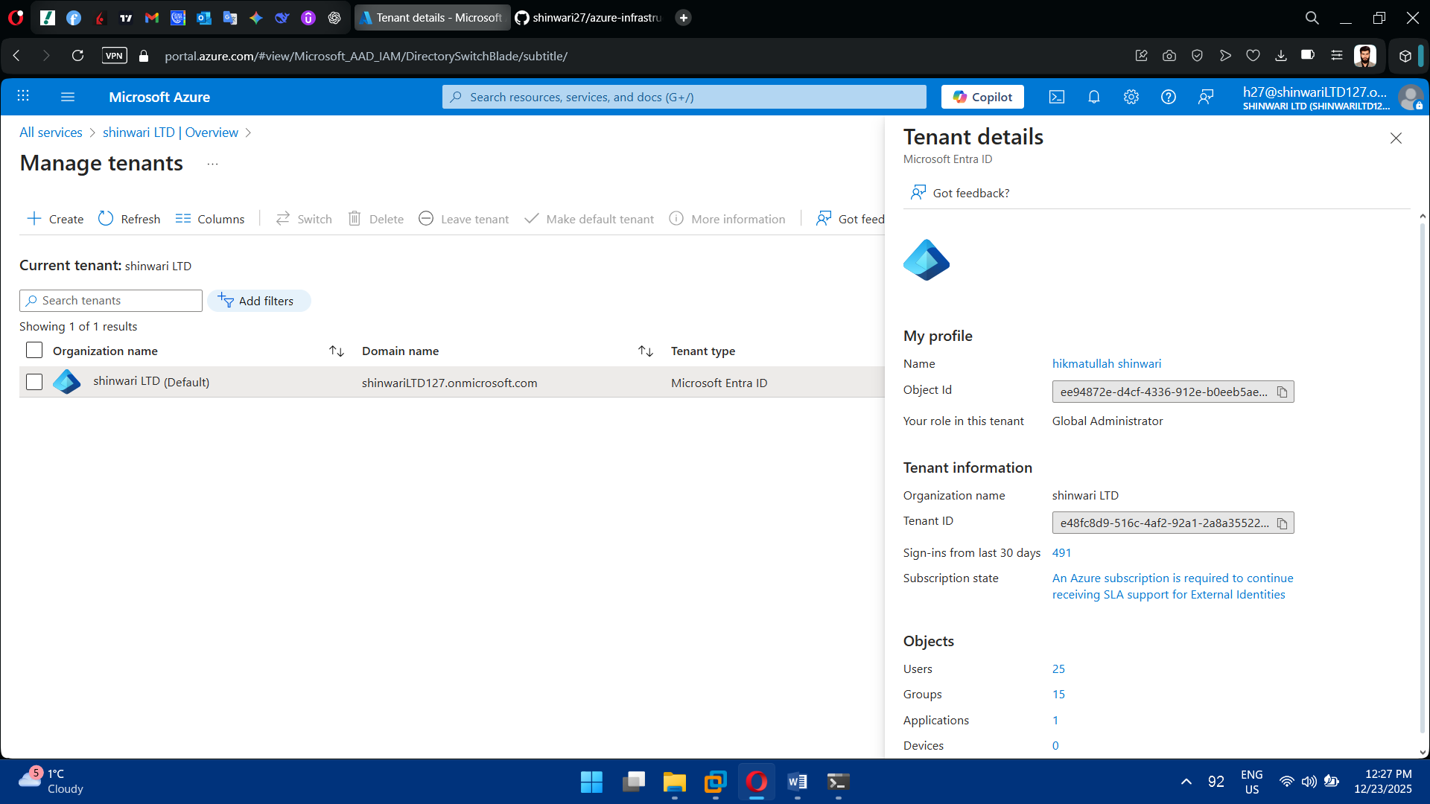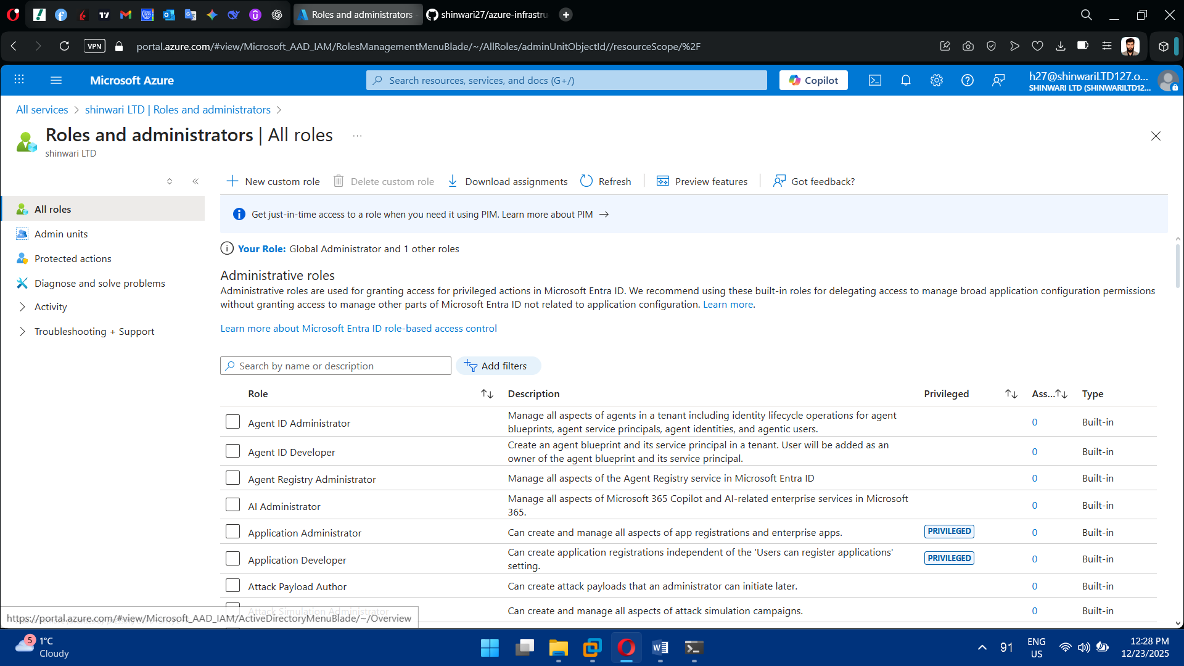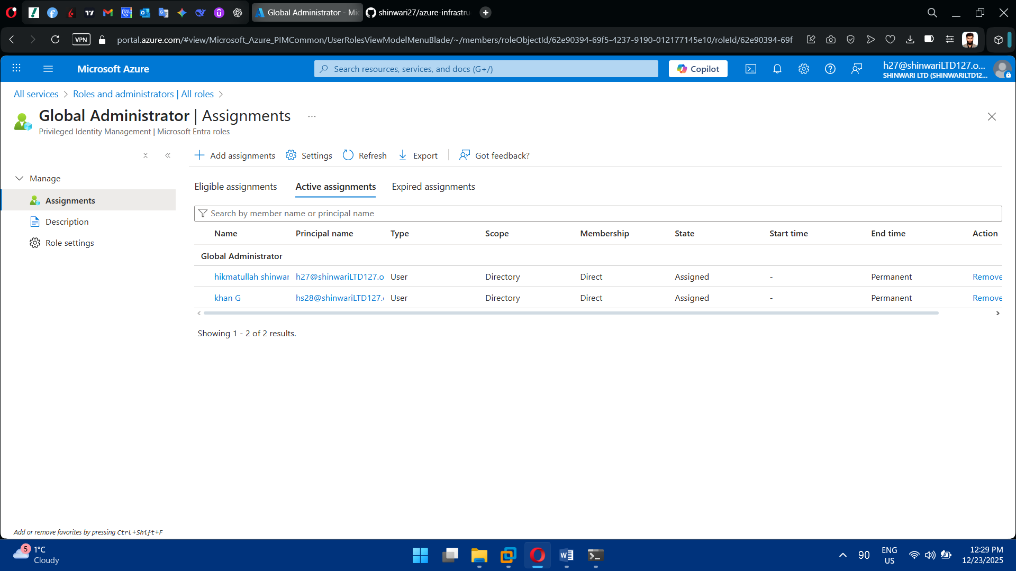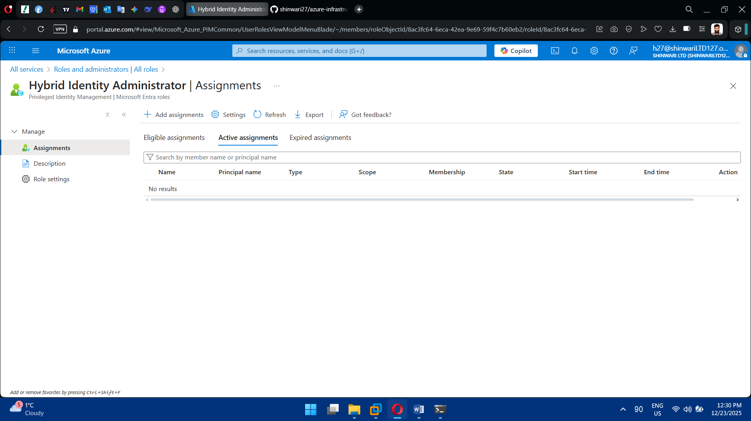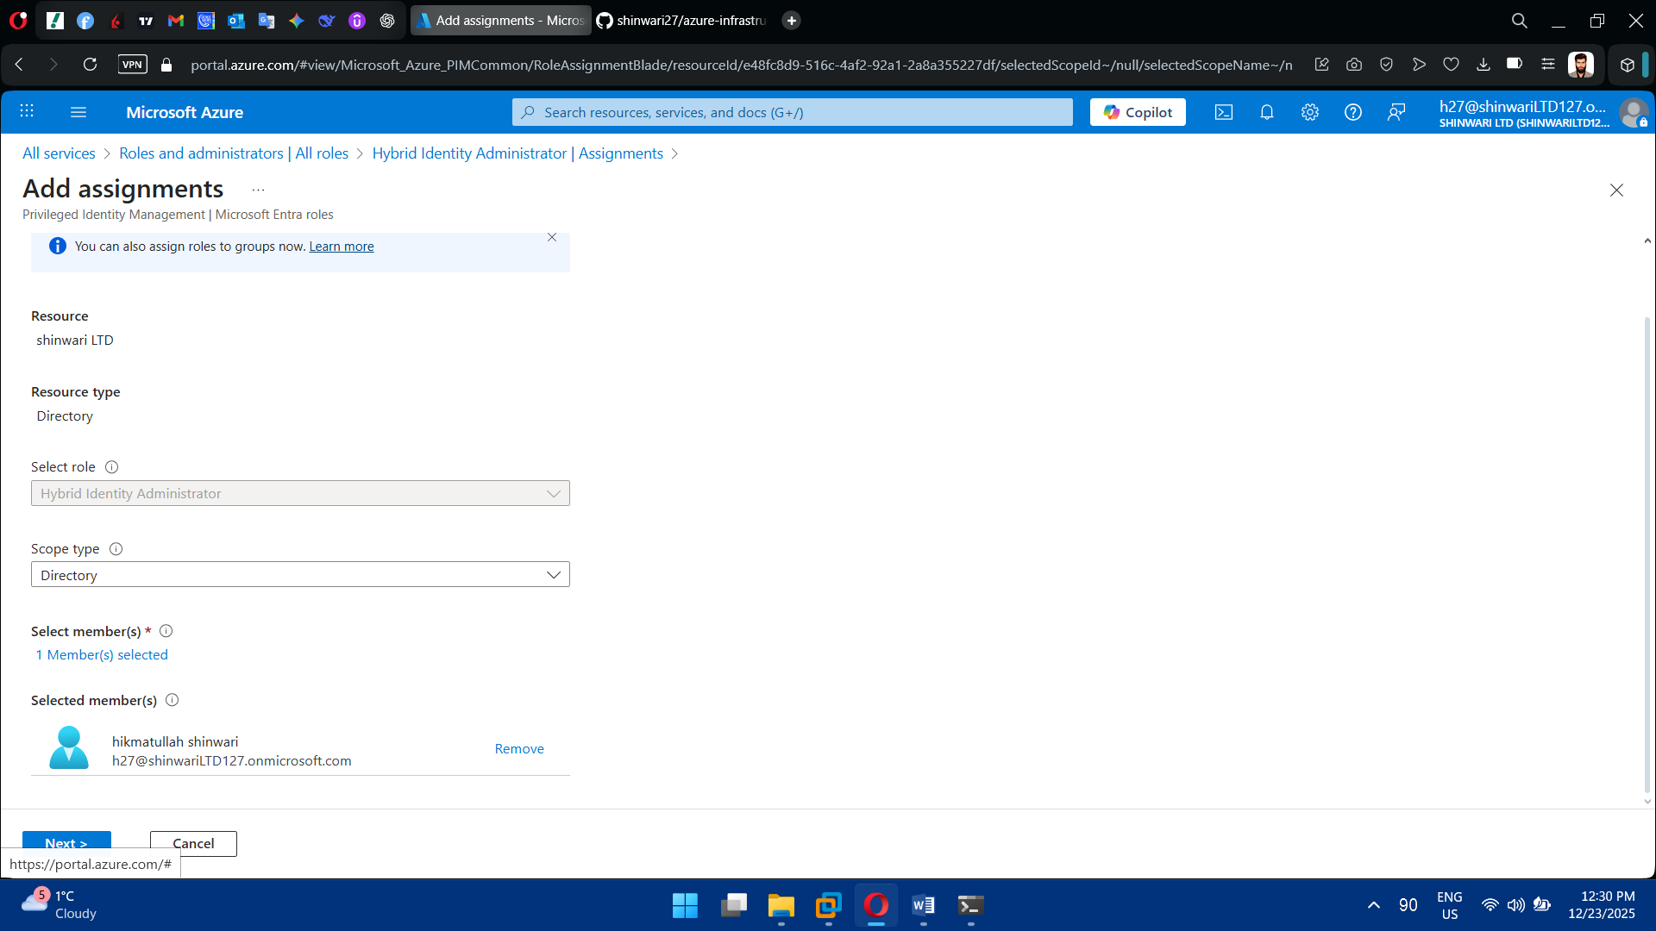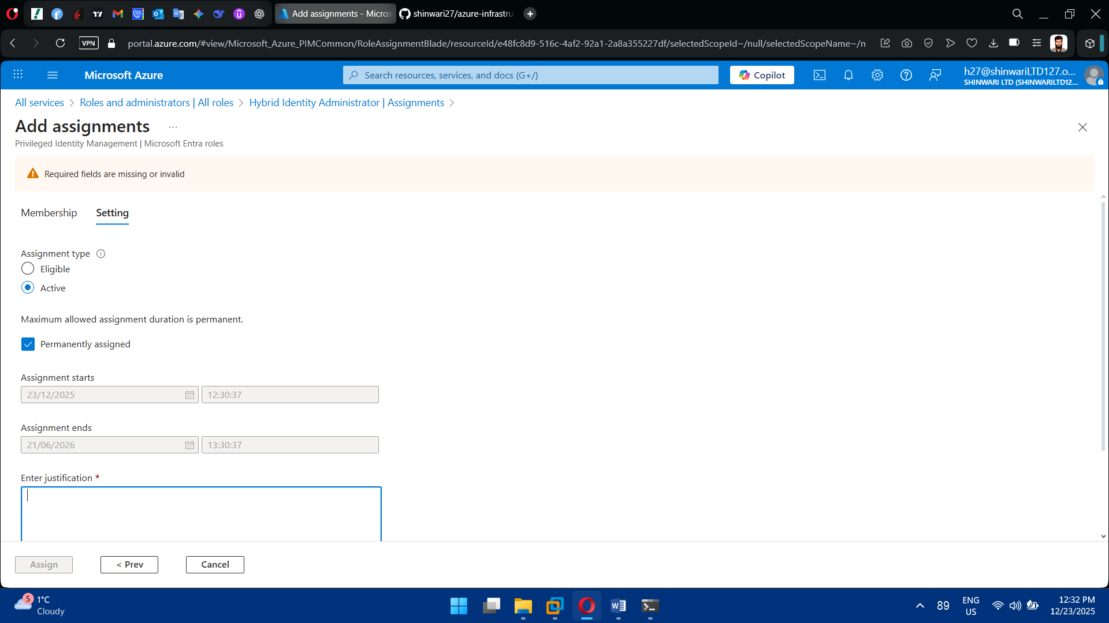

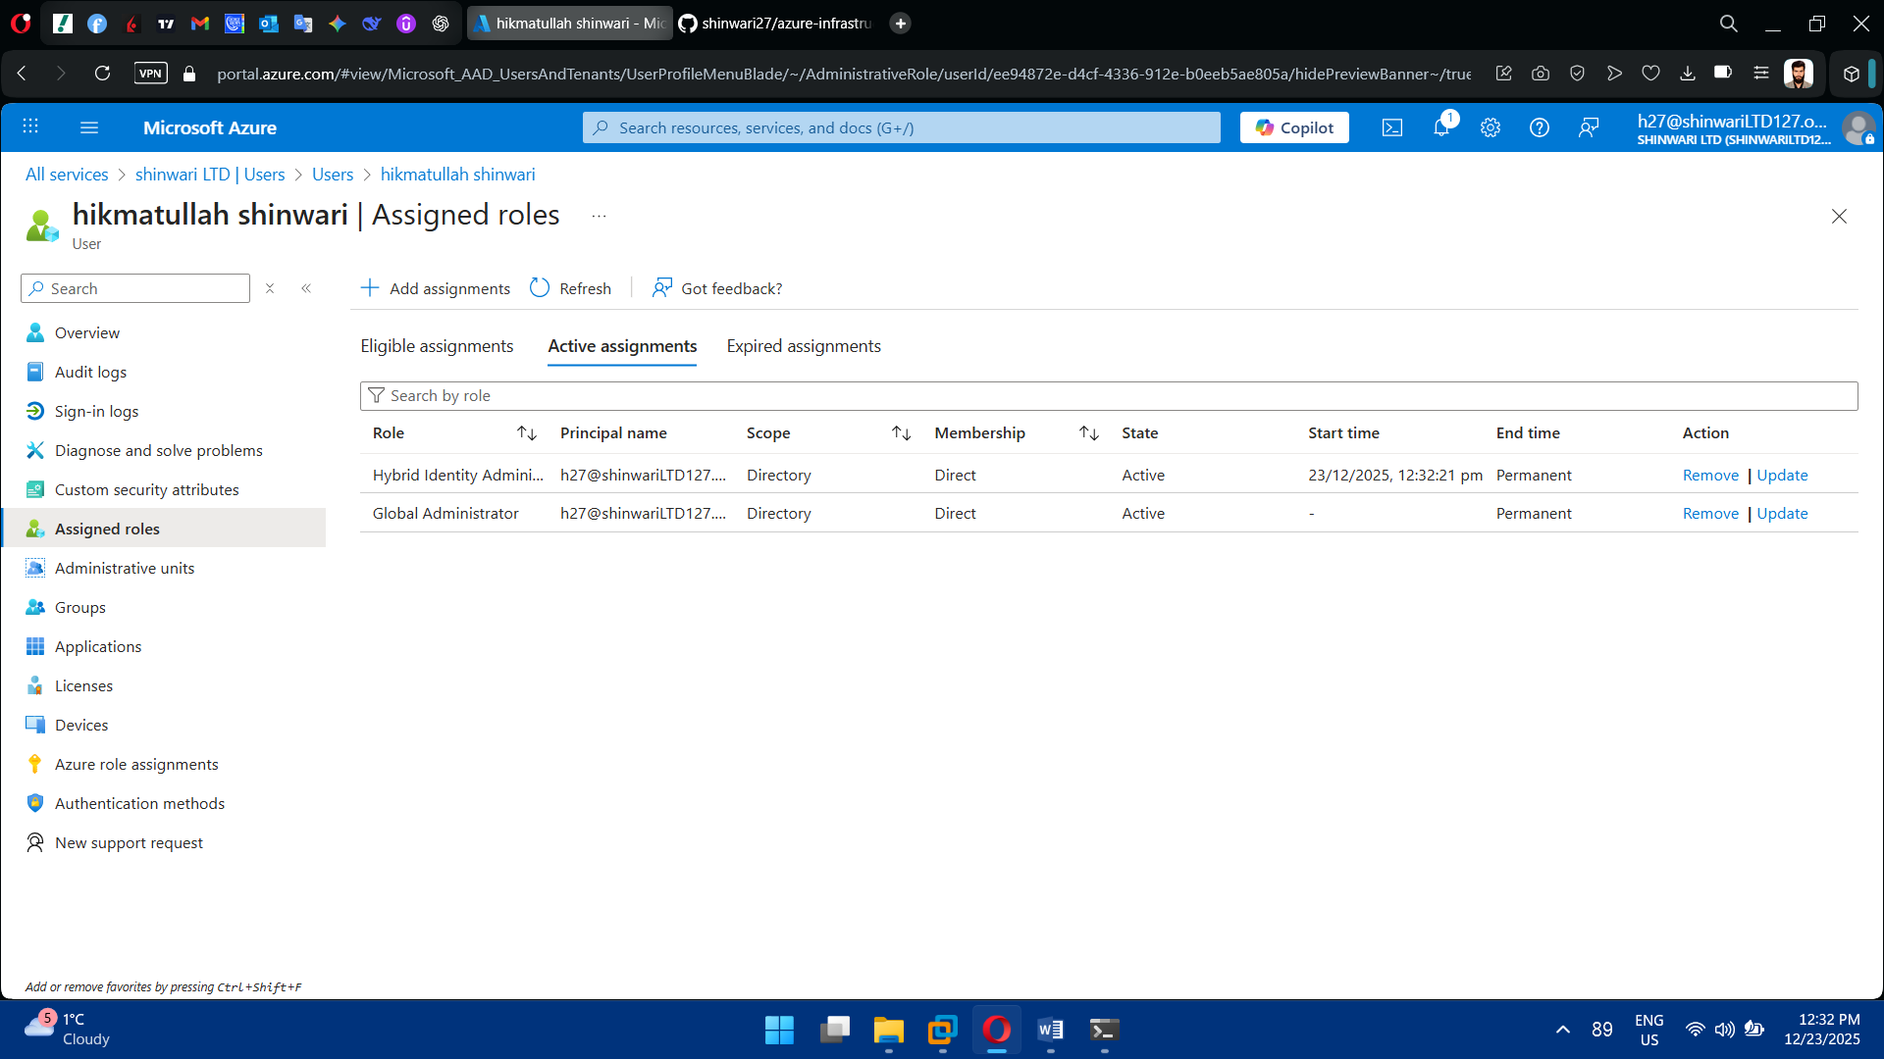

## Task 7: Azure AD Connect Installation

* Download **Azure AD Connect**
* Install on Windows Server
* Choose:
  + **Password Hash Synchronization**
  + Single forest configuration
* Configure:
  + OU filtering
  + User sign-in method

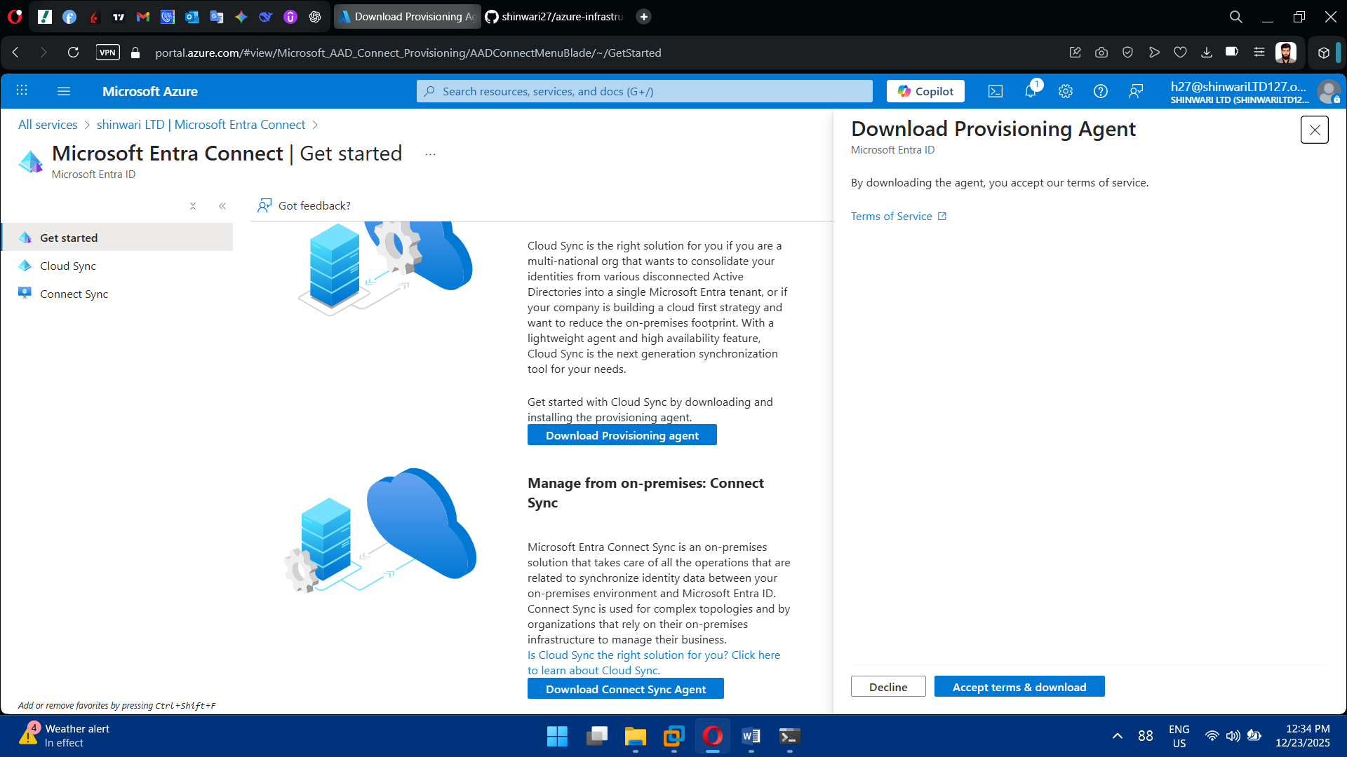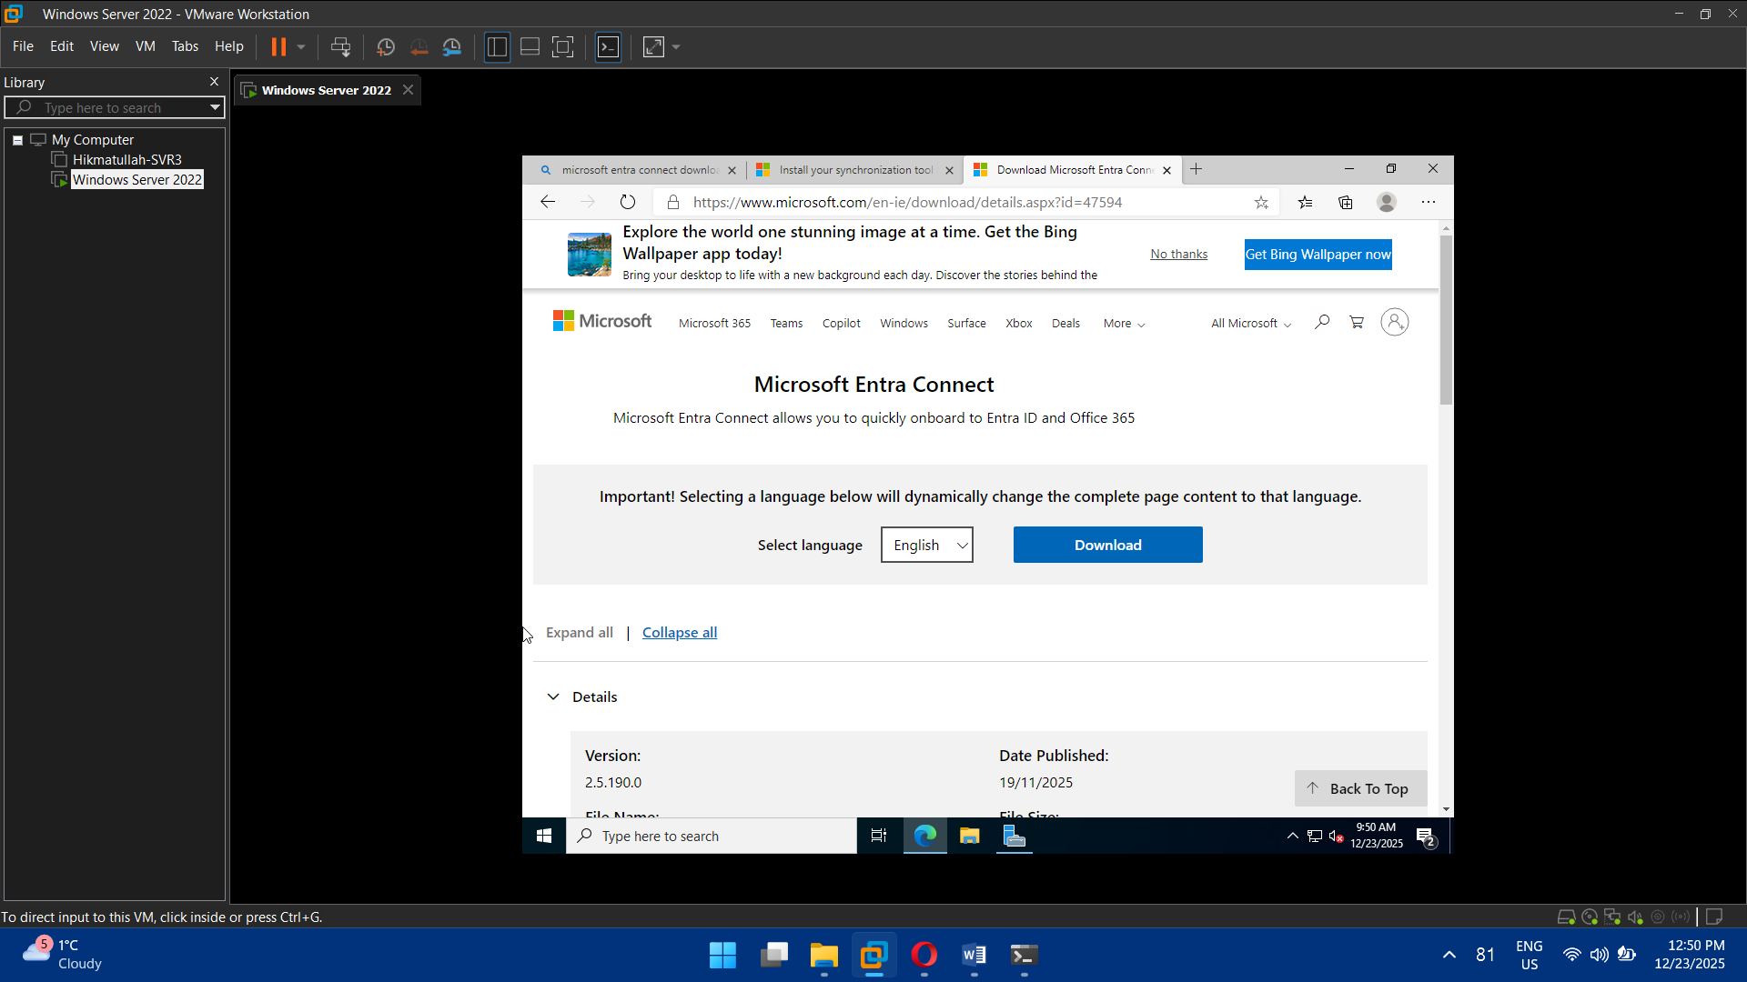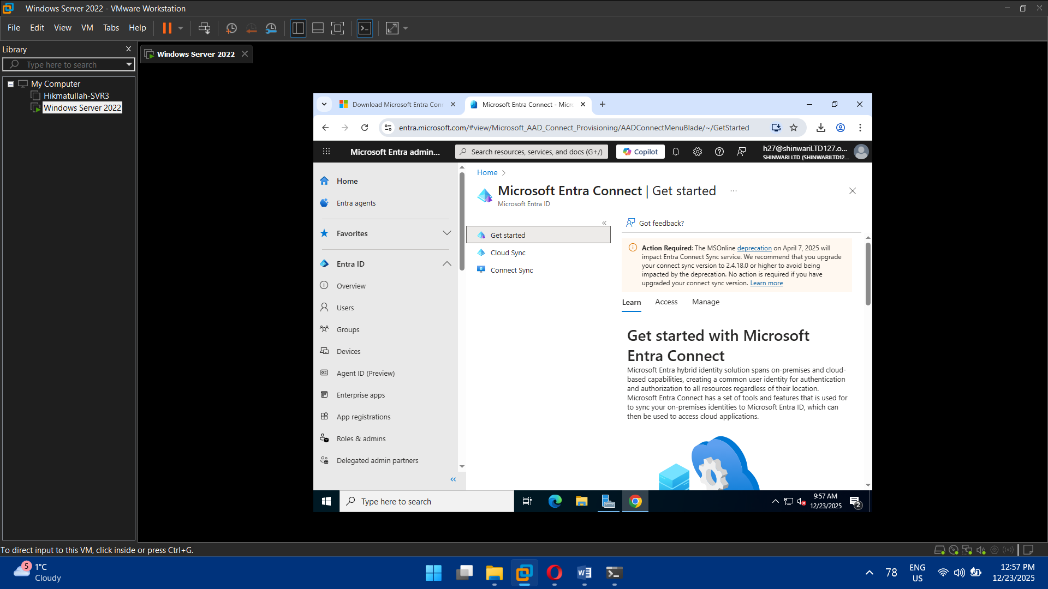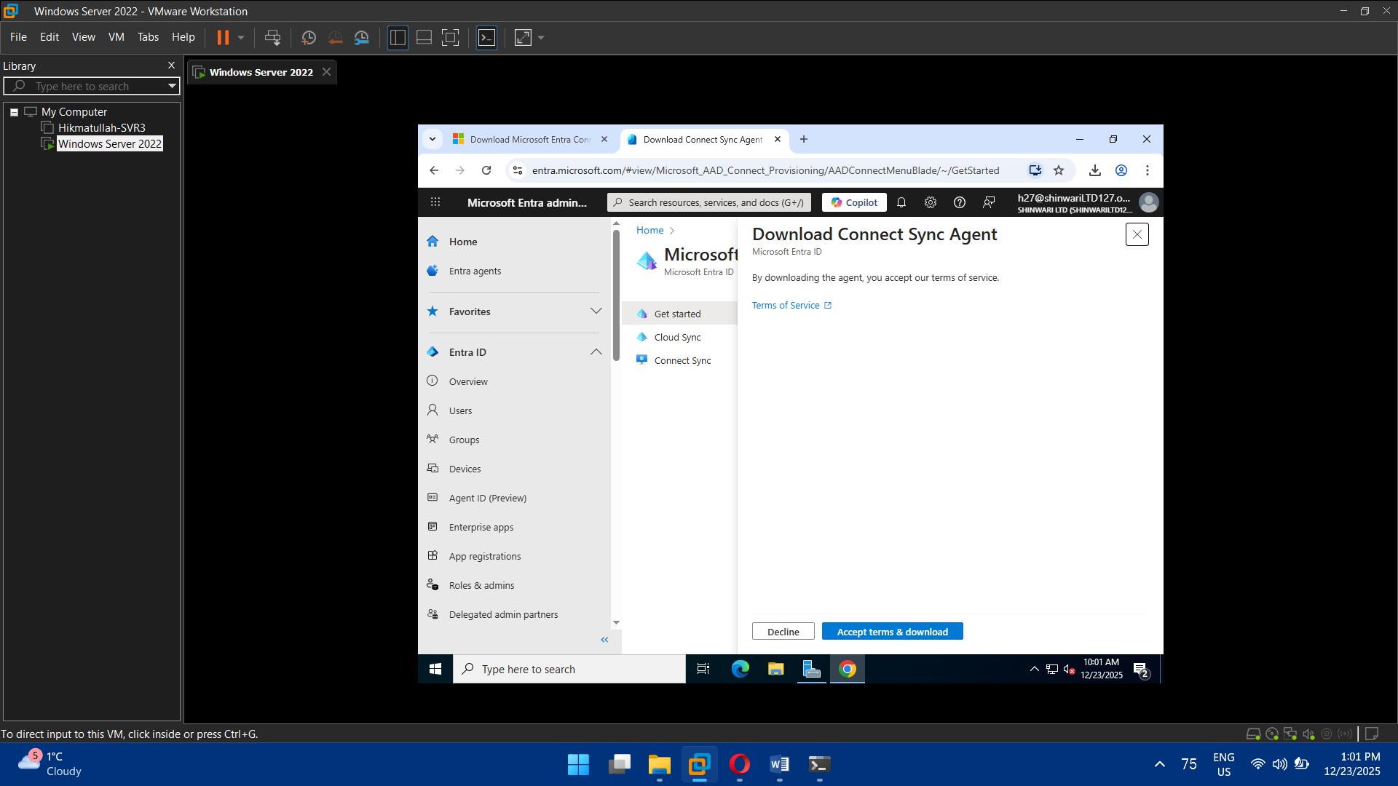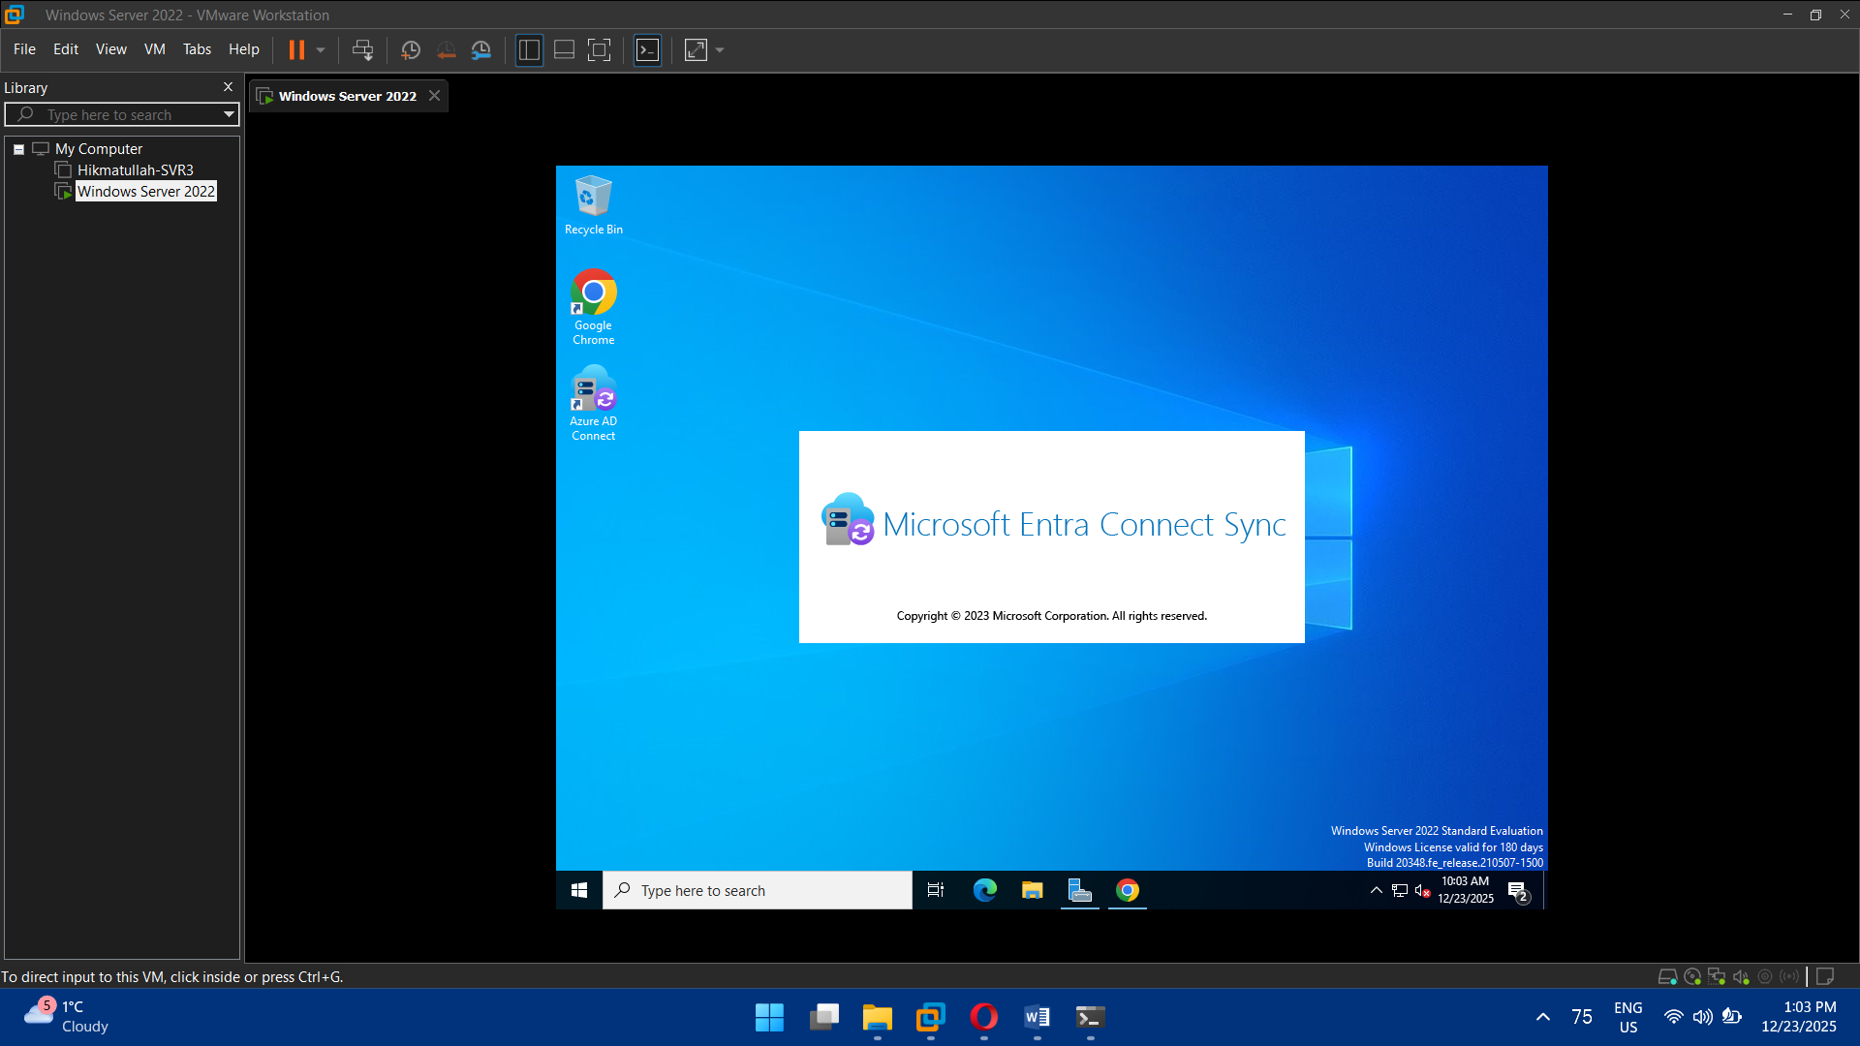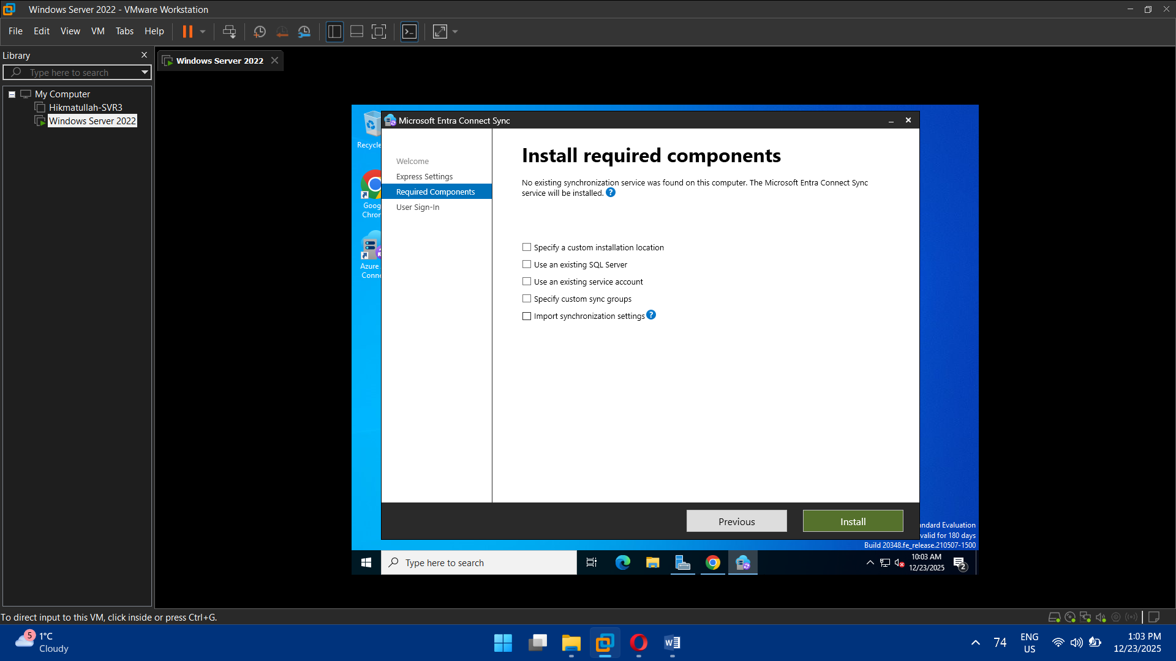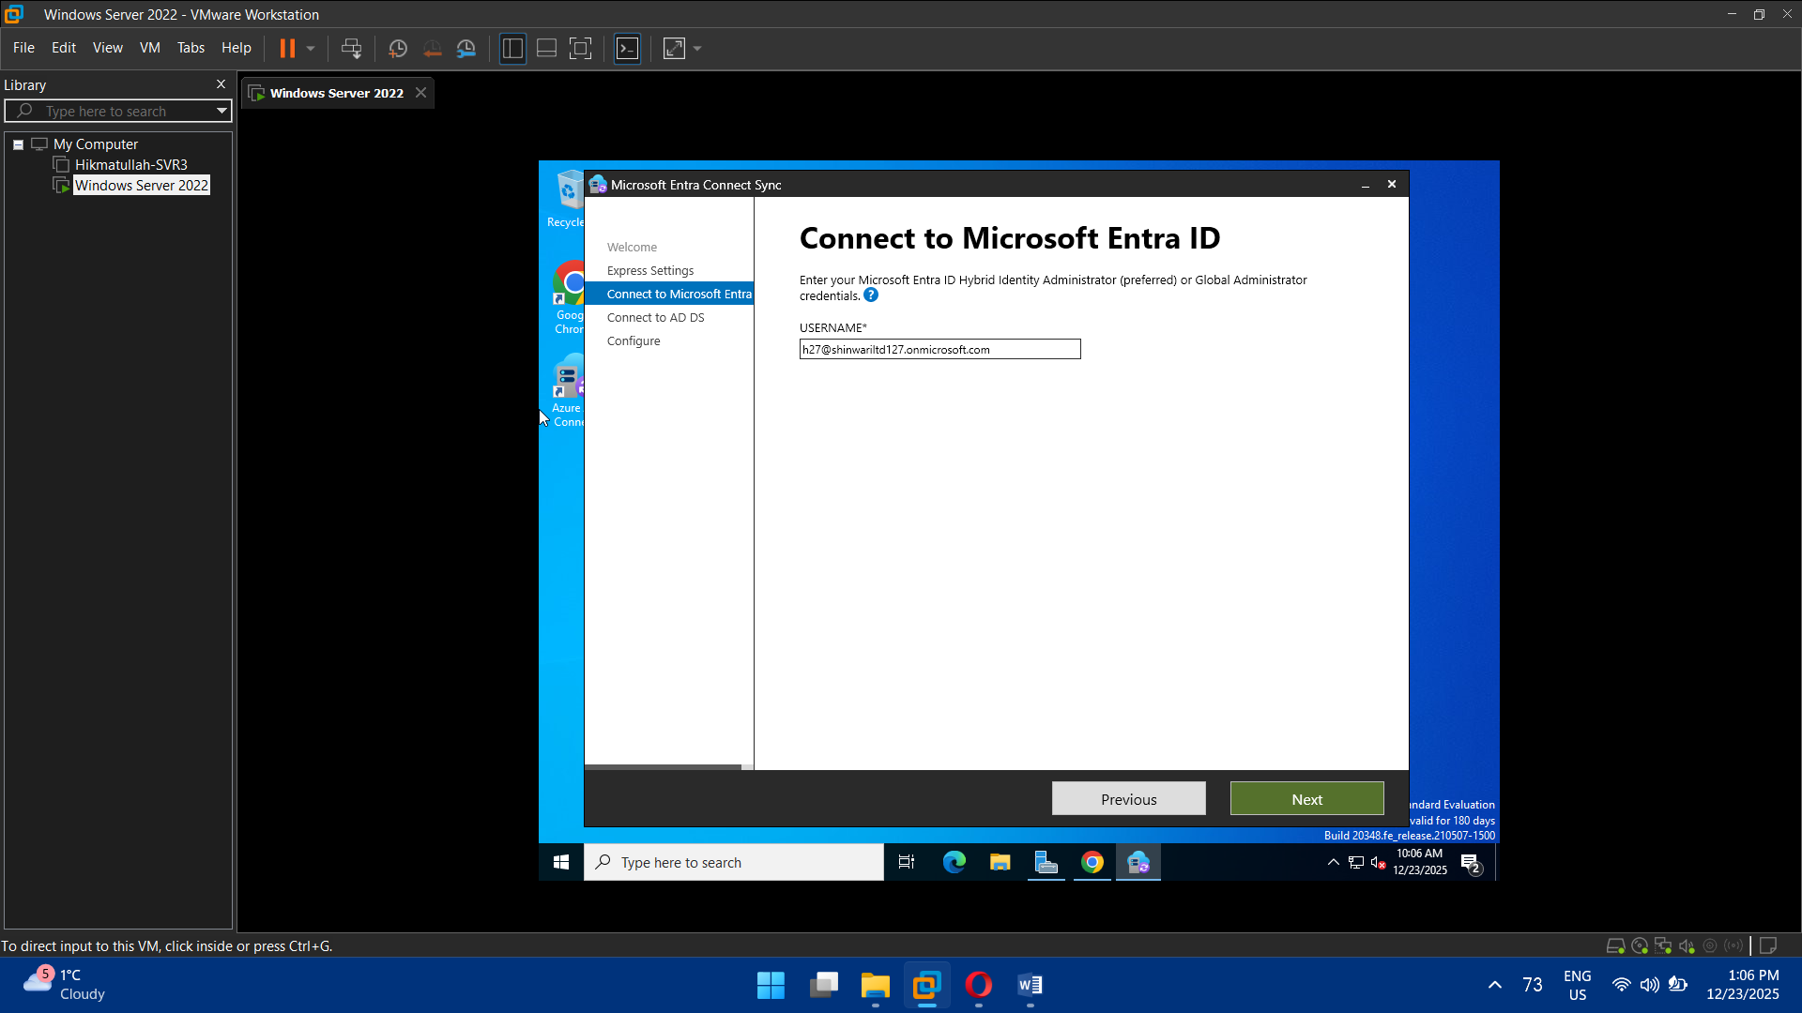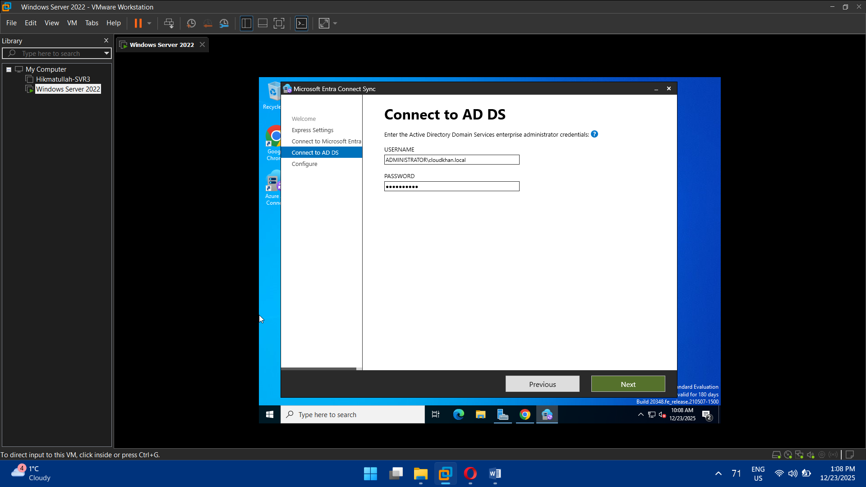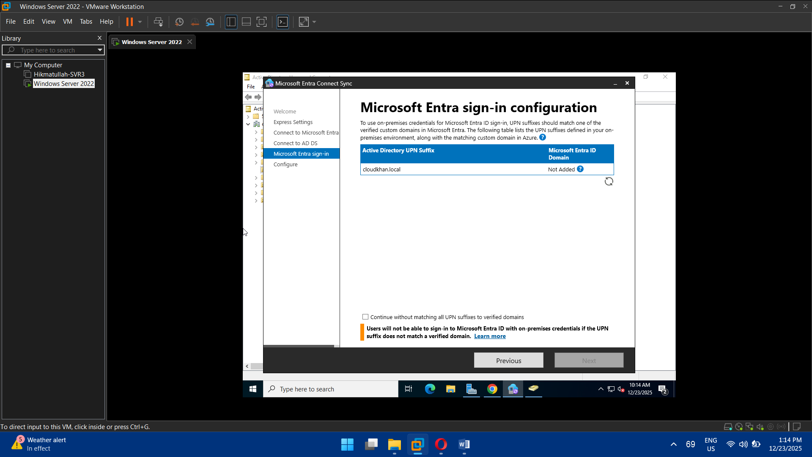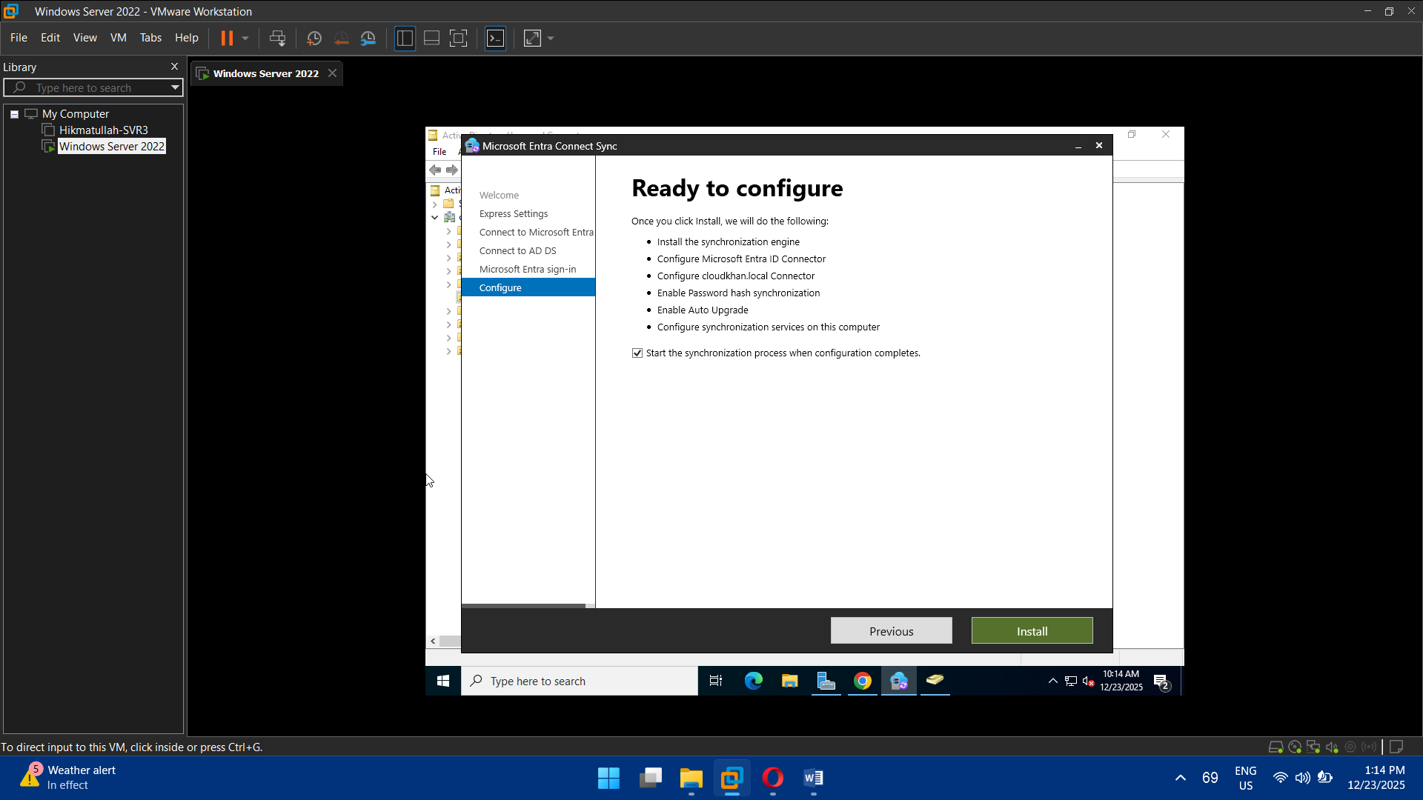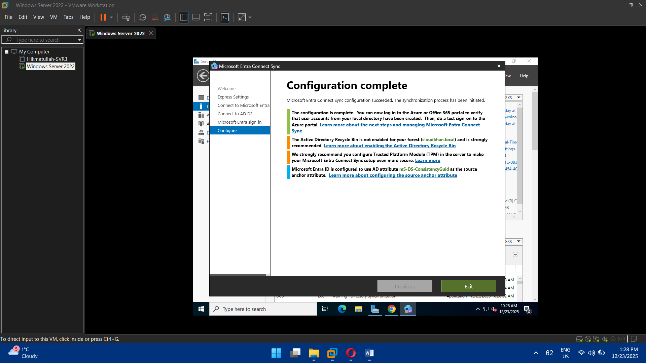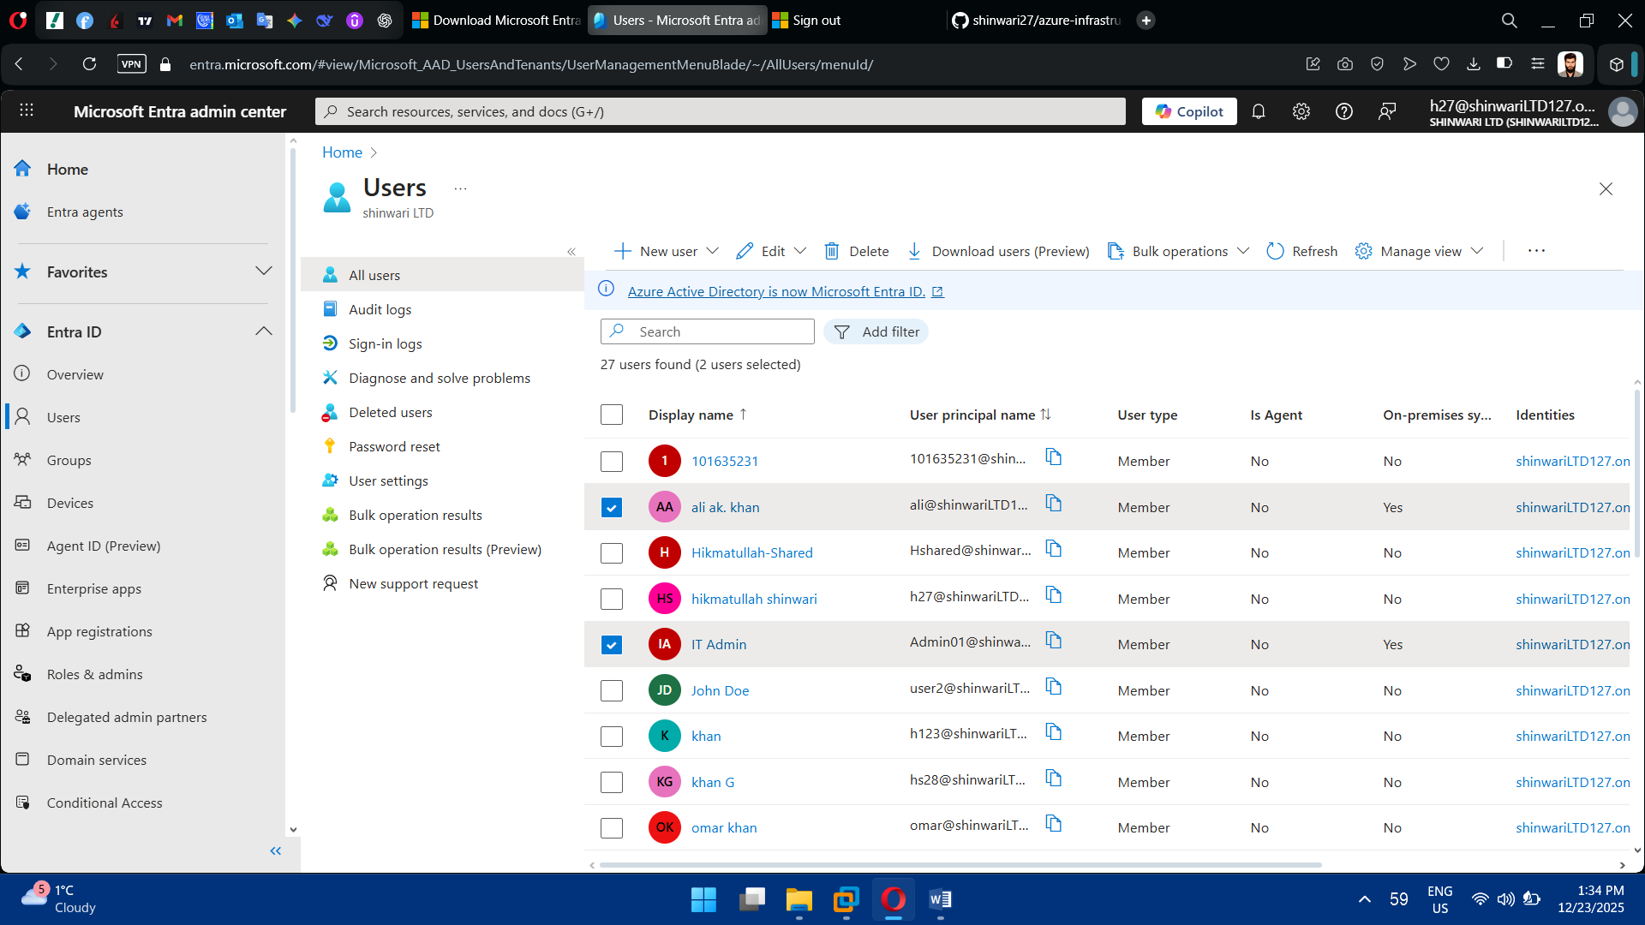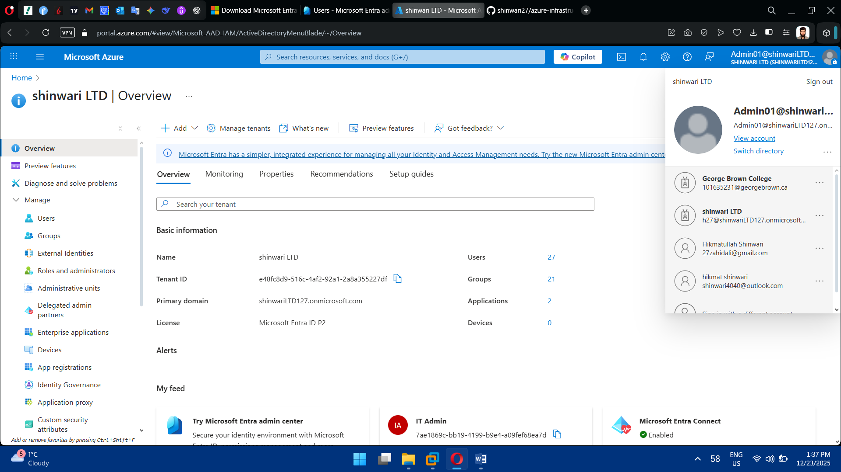

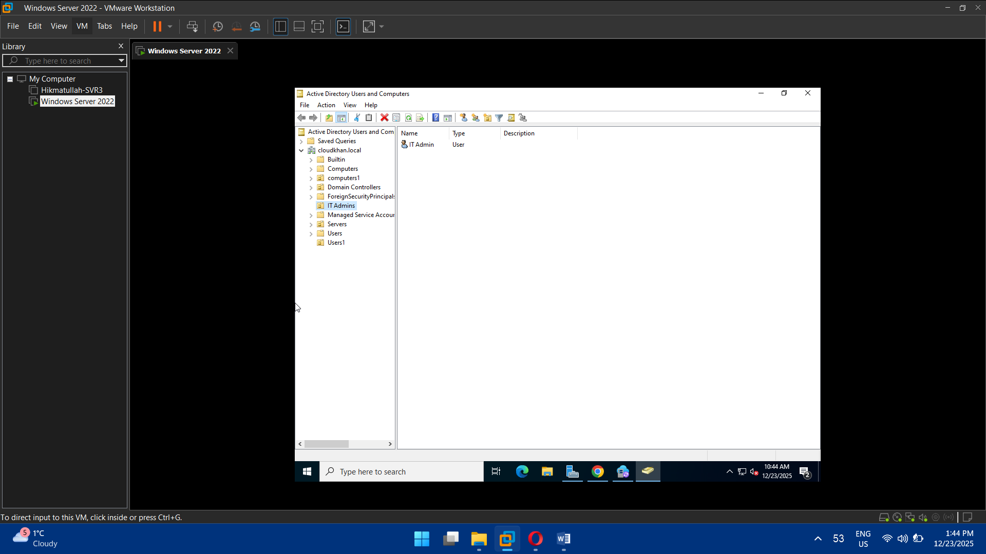

## Task 8: Hybrid Identity & Password Sync

* Verify synced users in Azure AD
* Reset password on-prem and confirm Azure sync
* Validate sign-in via:
  + portal.azure.com
  + Microsoft 365 (optional)

